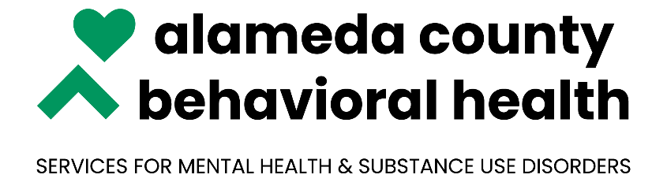

***NOABD Enclosures Tagalog:***

Attachment A: [Language Assistance Tag Lines](https://bhcsproviders.acgov.org/Providers/qa/noabd/Enclosures/Language%20Assistance%20Taglines.pdf)

Attachment B: [Your Rights Under Medical](https://bhcsproviders.acgov.org/Providers/qa/noabd/enclosures/Translated%20Beneficiary%20Enclosures/Tagalog/NOABD%20-%20Your%20Rights_TAGALOG.doc)

Attachment C: [Beneficiary Non-Discrimination Notice](https://bhcsproviders.acgov.org/Providers/qa/noabd/enclosures/Translated%20Beneficiary%20Enclosures/Tagalog/Beneficiary_Non-Discrimination_Notice-TAG.doc)

***\*Note to Providers: The above notices shall be inserted in NOABD letters to beneficiaries.***