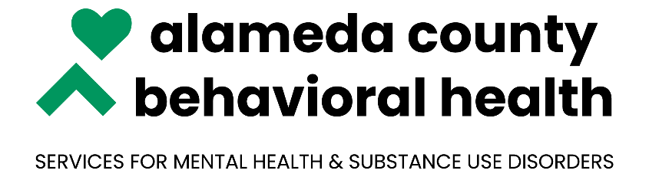

***NOABD Enclosures Spanish:***

Attachment A: [Language Assistance Tag Lines](https://bhcsproviders.acgov.org/Providers/qa/noabd/Enclosures/Language%20Assistance%20Taglines.pdf)

Attachment B: [Your Rights Under Medical](https://bhcsproviders.acgov.org/Providers/qa/noabd/enclosures/Translated%20Beneficiary%20Enclosures/Spanish/NOABD%20-%20Your%20Rights_Spanish.doc)

Attachment C: [Beneficiary Non-Discrimination Notice](https://bhcsproviders.acgov.org/Providers/qa/noabd/enclosures/Translated%20Beneficiary%20Enclosures/Spanish/Beneficiary_Non-Discrimination_Notice_ES-US.doc)

***\*Note to Providers: The above notices shall be inserted in NOABD letters to beneficiaries.***