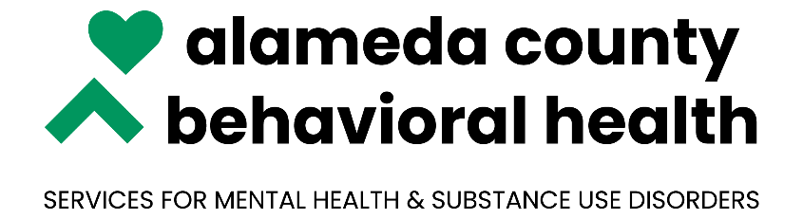

***NOABD Enclosures Vietnamese:***

Attachment A: [Language Assistance Tag Lines](http://www.acbhcs.org/Providers/qa/noabd/Enclosures/Language%20Assistance%20Taglines.pdf)

Attachment B: [Your Rights Under Medical](http://www.acbhcs.org/Providers/qa/noabd/enclosures/Translated%20Beneficiary%20Enclosures/Vietnamese/Your%20%20Rights_Vietnamese.pdf)

Attachment C: [Beneficiary Non-Discrimination Notice](http://www.acbhcs.org/Providers/qa/noabd/enclosures/Translated%20Beneficiary%20Enclosures/Vietnamese/Beneficiary_Non-Discrimination_Notice_Viet.doc)

***\*Note to Providers: The above notices shall be inserted in NOABD letters to beneficiaries.***