Greetings, ACBHD Team Members.
Please join our Executive Team as we proudly celebrate and recognize our valued colleagues who have reached milestone years of service in 2025. Each year they’ve dedicated commitment, perseverance, and a genuine contribution to our shared success. Their hard work, loyalty, and passion have helped shape and strengthen our organization and our community. Whether they have been with us for a few years or several decades, their impact is felt every day through the service they provide and the teamwork they demonstrate. We extend our sincere appreciation for their dedication and contributions to our system.
Awards will be available for pick up from Monday, February 23, 2026, through Friday, March 27, 2026. To arrange a pickup time, please contact Mr. John Altez at John.Altez2@acgov.org. Awards may be collected at the ACBHD Administration Office located at 2000 Embarcadero Cove, 4th Floor, Suite 400 in Oakland. (NOTE: An alternative delivery option can be coordinated via QIC messenger upon request).

Their recognition is our shared celebration!

5 YEARS OF SERVICE
Abibat Ajiboye
Abigail Banzon-Chente
Alyssa Choo
Annie Flynn
Araceli Huerta
Ashley Barry
Carolyn Valrey
Catherine Meas-Powell
Claudia Andrade
Clyde Lewis
Corlette Williams
Danielle Benjamin
David Martin
Denee Cox
Eduardo Lozano
Emily Claassen
Gina Zones
James Edwards
Jinzi Ye
Julia Williams
Juliene Schrick
Kawai Lau
Kripalakshmi Sooryanarayana
Lai Ieong
Linda Saelee
Lori Shalcross
Luis Martinez
Luwissa Sy
Maria Mieses
Maria Musial
Melinda Masters
Michelle Wan
Michelle Manor
Mona Shah
Natasha Mckinley
Ngoc Phan
Rachel Verduzco-Ortega
Rainia Spears-Noble
Rosalinda Gomez
Tiffany Lucero
Toki Ann Wallace
Victoria Firl
Vivian Singleton

10 YEARS OF SERVICE
Alicia Smith
Amy Walker
Candace Shockley
Charles Edwards
Dyeasha Simpson
Ebony Jacob
Isaac Mendoza
James Wagner
Janice Avery
Keith Zamora
Monica Osorio
Sanford Pearlman
Sarah Ashbrook
Siobhan Lilly
Sue Louie
Theresa Fleming
Tiffany Garcia

15 YEARS OF SERVICE
Aisha Whitmore-Love
Eric Yuan
Francisco Sanchez
Jennifer Chaffin
Krishna Henry
Linda Martinez
Sun Hyung Lee
Willie Chu
Yesenia Lott
Yikki Yi

20 YEARS OF SERVICE
Giridhar Reddy
Joie Thach
Julie Hernandez
Michael Caminero
Mohammad Sheikh
Susanna Huang
Tmothy Henry
Tracy Hazelton
Wilbur Kelly

25 YEARS OF SERVICE
Anthony Gomes
Brenda Ng
Diana Alvarez
Emily Galimba
Jacqueline Jordan
Mandy Chau
Renee Pace

30 YEARS OF SERVICE
Catherine Felisky
Grace Lee
Lea Cruz
Maureen Costello Orphanos
Shoshana Klein

If you have further questions, please reach out directly to John Altez, john.altez2@acgov.org.

Once again, we value the years you have committed through your diligent efforts.
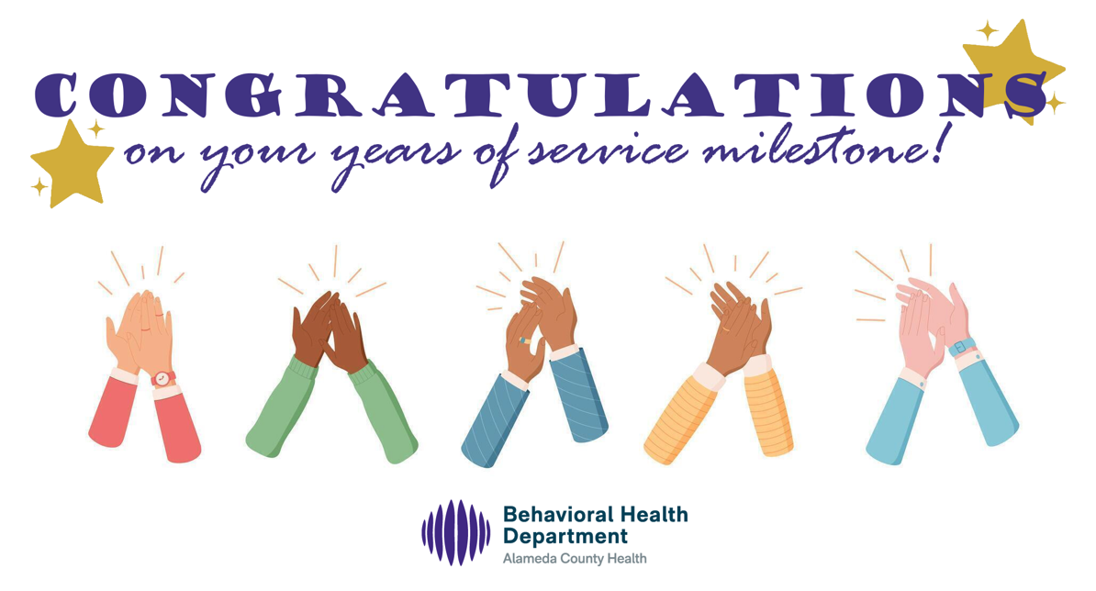

____________________________
Office of the Director
Alameda County Behavioral Health Department


2000 Embarcadero Cove, Suite 400
Oakland, CA 94606
Email: BHCSDirector@acgov.org

CONFIDENTIALITY NOTICE: This electronic mail transmission may contain privileged and/or confidential information only for use by the intended recipients. Any usage, distribution, copying or disclosure by any other person, other than the intended recipient is strictly prohibited and may be subject to civil action and/or criminal penalties. If you received this e-mail transmission in error, please notify the sender by reply e-mail or by telephone and delete the transmission.

