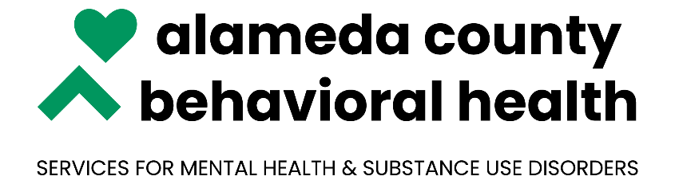

***NOABD Enclosures Korean:***

Attachment A: [Language Assistance Tag Lines](\\\\COVENAS\\PUBLIC\\POLICIES & PROCEDURES\\Draft P&Ps\\Grievance and Appeal System\\NOABD Letters and Attachments\\Enclosures\\Language Assistance Taglines.pdf)

Attachment B: [Your Rights Under Medical](../Translated%20Beneficiary%20Enclosures/Korean/NOABD%20-%20Your%20Rights_Korean.doc)

Attachment C: [Beneficiary Non-Discrimination Notice](../Translated%20Beneficiary%20Enclosures/Korean/Beneficiary_Non-Discrimination_Notice.docx)

***\*Note to Providers: The above notices shall be inserted in NOABD letters to beneficiaries.***