Alameda County

Behavioral Health Care Services

Insyst

MHS

Mini Manual

BHCS – Information System Support Services

Phone: (510) 567-8181
FAX: (510) 567-8161
E-Mail: TUISHelpDesk@acbhcsUTU.orgU
BHCS Web Site: UACBHCS.ORG/PROVIDERS
Provider Relations (800) 878-1313

Contents

Chapter 1: Getting Started

Chapter 2: Basic Client Information 9

Chapter 2a: CSI 30

Chapter 3: Client Episodes 32

Chapter 4: Direct Services 44

Chapter 5: Utilities (Printing and Mail) 60

Chapter 6: The Report Menu & Reports 68

Chapter 7: Utilization Review 82

Appendix A: Special Key Sequences 87

Appendix B: County / State / Country Codes………………………… …89

Appendix C: Episode Data Entry Codes………………………………….98

Appendix D: Service Entry Codes…………………………………… …104

Appendix E: Legal Status Codes……………………………………… ..106

10/26/06
Chapter 1
Getting Started
This chapter includes basic instructions for logging on and using InSyst’s menus and screens.

Logging Onto the Computer
You must log onto the VAX computer system before beginning work.

To log onto the computer:
1. If you are using a terminal, press Return. If you are using a personal computer, start the terminal emulation program by selecting the INSYST1 or INSYST2 Icon on your Windows Desktop.
2. Your screen displays the prompt: USERNAME: Type your Username, and press Return.
3. Then the computer prompts you for your password. Type your password and press Return. To protect its secrecy, your password is not displayed on your screen.
4. InSyst displays its Logo and any notices or messages. Press Return to display your Main Menu.

Using Gold and Control Keys
When you work with InSyst, you often have to use Gold Key sequences and Control Key combinations.
The Gold Key is the PF1 Key on Digital Equipment Corporation terminals, and the NumLock key on PCs. Other keys may be used on other terminals.

To use a Gold Key sequence:
1. Press and release the Gold Key.
2. Press and release the other key in the sequence.
For example, if the instructions say, “Press Gold-E”, you should press and release the Gold key, and then and release press “E”.

To use a Control Key combination:
1. Press the Ctrl key and hold it down.
2. Press and release the other key.
For example, if the instructions say, “Press Control/H”, you should press the Ctrl key and hold it down while you press and release “H”.
Appendix A lists all Gold Key sequences and Control Key combinations.

Using Menus
An InSyst menu is a list of items that you may select. Figure 1.1 is shows a sample Main Menu. The Main Menu is different based on data input requirements. Below is an example of a Opening Main Menu for user who is entering data for both Mental Health Services and Alcohol and Other Drugs Services. Most users don’t have this menu option.
Figure 1.1: Main Menu
The menu structure is virtually the same for the MHS and the DAS systems. Some screens are different for the two systems, and this manual will explain both. The MHS Main Menu is shown in Figure 1.2.
After you make a selection from the Main Menu, the system displays a submenu. For example, if you choose UTILITIES in the Main Menu, you will move to the Utilities Menu, with options that you select to use InSyst utilities.
- Note: Based on your User Authorization all menu options may not be activated.
Figure 1.2: MHS Main Menu
All InSyst menus let you make selections in three ways: by using the list of options in the menu selection area, or by typing an alpha or numeric option directly in the command line.

To select a command in the Menu Selection Area:
- Press the Tab key and the blinking cursor will move from the Command Line into the list of items in the Menu Selection Area of the screen. Then move the cursor up and down through the menu using the Up and Down Arrow keys.
- When you have moved the cursor to the item you want, type “X” and press Return.
At the bottom corners of the Menu Selection Area there is often a flashing “V.” This indicates that there are more items on your menu than you can see at one time. Press the Down Arrow key and the menu will scroll to display more items.
If you want to return to the Command Line, press Enter.

To select an item from the Command Line:
1. Type the name or number of the item on the Command Line. The command line is the solid bar next to the word Selection, where the cursor is when you first display the menu. You may type the entire name of the item, or just enough make it distinct from the others. For example, if you want to choose SERVICES from the Main Menu, you may type either “SERVICES” or “SER”. You may also type the number of the selection. For example, if Client Records Maintenance is the first item on the menu, you can just type “1” to select it.
2. Press Return to display the screen or sub-menu you selected.

Leaving a Menu
Press Gold-E, or enter a hyphen (-) in the Command line to move back one menu to the previous menu. For example, if you are on the Files Menu, “-” will take you back to the Utilities Menu, and a second “-” will take you back to the Main Menu.

Menu Shortcuts
You can go directly from one menu to a screen that is under another menu, rather than moving through the menu system one menu at a time. In the command line of the current menu, enter the Menu names that you would normally enter in the command lines of one menu after another.
For example, to go from the Main Menu to the Episode Opening screen, you normally enter “EP” in the Main Menu to display the Episode Records Menu, and then enter “OP” to display the screen. As a shortcut, you can enter the command “EP OP” in the Main Menu command line (Figure 1.3).
Figure 1.3: Using Menu Shortcuts

Using Screens
InSyst’s menu system displays the data screens (Figure 1.4) that let you enter, look up, change and delete information.
In Screens, data is entered or displayed in areas called fields. For example, a screen may have a field for a client’s last name and another field for address. Most screens have special fields, called key fields, that identify each record, such as the client number field that identifies each client.
Each screen has a different function—e.g., to register a client, review a client’s account, or update episode information. Screens are assigned to you based on your responsibilities.

Figure 1.4: An InSyst Screen with a List
Here, we will look at the basic keys you must use with screens. For more information on special key sequences, see Appendix A.

Moving through Fields
Use these keys to move through a screen’s fields:
- Tab: Move the cursor to the next field to enter data. (If you fill a field entirely, the cursor will move to the next field automatically).
- Control/H: (F12) Move the cursor back one field.
- Return: Skip over optional fields and move to the next required field or to the prompt used to leave the screen.

Moving Through Lists
Many screens have lists, like the list of insurance companies shown in Figure 1.4 above. To move down one item in the list, press the Tab or Down Arrow key. To move up one item in the list, press the Up Arrow key.
If a list has more items than fit in one screen, you can page through it to see more items by pressing:
- Gold-M: (More) View the next page of information.
- Gold-D: (Down Two) Go forward two pages.
- Gold-B: (Backup) View the previous page of information.
- Gold-U: (Up Two) Go back two pages of information.
To speed up performance, lists usually include only two pages of information by default. If you have to see more items than this, you should request unlimited paging by pressing Gold-A before you display the list.

Leaving a Screen
To leave a screen, press:
- Return: In most cases, pressing Return moves the cursor to the prompt used to leave the screen. (In some cases, Return skips over optional fields to the next required field.)
- Gold-E: Exits from the current screen and returns to the menu, without saving data entered in the screen.
- Gold-S: Exits from the current screen, and saves the data entered. This sequence retains the current Client and Reporting Unit, so it automatically displays it in the next screen you use.

Client Confidentiality
InSyst helps your staff in maintain confidentiality, as required by federal, state, and local regulations.
Do not let anyone else use your account. You username is stamped on some records in the database.
Each registered user has a password. Do not give out your password for use by other staff or post it near your terminal.
Do not browse through records looking for friends, acquaintances or known persons. This is illegal. You must have a legitimate purpose for looking-up a person.
Do not release data without authorization. For more information, consult your Medical Records Department.

Logging Off the Computer
To log out of InSyst, enter the word “Exit” on the command line of any menu.

Never turn off your terminal until you have seen a message confirming that you are logged off. The message includes your name, the date and time that you log off the computer.

Chapter 2
Basic Client Information

The Client Number
Before you can work with any client information, the client must have a client number. If a client is new to your program, you must determine whether the client has a number, by using the Client Locator screen, described below. If you cannot find the client number, assign a new client number using the Client Registration Screen, described later in this chapter.

Locating Clients
The Client Locator Screen lets you find out if someone has ever been a client and lets you display information about clients

To use the Client Locator Screen:
1. Choose CLIENTS from the Main Menu.
2. Choose LOCATOR from the Client Maintenance menu to display the Client Locator screen (Figure 2.1).

Figure 2.1: Client Locator Screen

Client Information Area
The top section of the screen is the Client Information Area, where you enter criteria to search for a client, and where information is displayed when the client is found.

To search for a client:
1. Make an entry in one or more fields of the Client Information Area.
2. Press Return at any time to search for a client matching the information you have entered.
The Client Information Area has the following fields:
- Client Name: Enter the client’s full name or only the first few letters of the client’s name. For example, if you enter “And” as the last name, you will find clients with the names Anders, Anderson, Andrews, etc.
- Client Number: If you know the Client Number, the fastest way to look up the client is to press Gold-C to move to the Client Number field and enter the client’s number.
- Social Security Number: If you do not have a Client Number, the Social Security Number is the fastest way to find the client. If you have the client’s Social Security Number, press the Tab key to skip the other fields and enter the SSN here. You do not need to enter “-” between the numbers.
- Note: If you enter the Social Security Number and Client Name, the computer searches on the Social Security Number and returns the client information if it finds a match. This may not be the client name you have entered, if another client has used that Social Security Number. If there is no match on Social Security Number, the search is based on name.
If there is an exact match, all fields on the top half of the screen are filled with information about the client (Figure 2.2).
If there is no match, the system displays the message: Client/Clients not found.
If there is several possible matches, they are listed in the Client Selection Area of the screen, described below.
Figure 2.2: An Exact Match in the Client Information Area

Client Selection Area
The second section of the screen is the Client Selection Area. If there is more than one possible match, records beginning with the first possible match are listed alphabetically here (Figure 2.3).

To use the Client Selection Area:
1. Move through the list using the methods described in the section on Moving Through Lists in Chapter 1.
Figure 2.3: Possible Matches in the Client Selection Area
2. Type “X” next to the client you want, and press Return. Data on that client is displayed in the Client Information Area.
You can select multiple clients on a page by putting “X” next to each, and then pressing Return. Then you display data on them by using the Previous and Next options in the Menu Selection Area (described below).
Aliases are displayed in the Client Selection Box with an asterisk (*) next to the name. They are selected like other names in the list, but the computer displays the client’s real name in the Client Information Area.
If you find the target client in this list, note the client number, so you can use it to work with the client. If you do not find the target client, you must register the client into the system.
- Gold-F: (Face Sheet) request the menu to select Face Sheets, then press F6 to complete the request. The Face Sheet is placed in your printer queue ready to print.
- Note: Before registering a new client, be sure you have tried all possible spellings of the client’s name and aliases. Press Gold-R to restart the screen and search with other spellings of the client’s name. If necessary, press Gold-A before doing the new search, so the list is not limited to 8 names.

Menu Selection Area
The lowest portion of the Locator screen is the Menu Selection Area, where you can enter commands to find more information on the client who is displayed in the Client Information Area.
As with any InSyst menu, you may select a menu item by entering the first letters of your menu choice (For Example, Figure 2.4 illustrates the choice of “E” for Episodes), or by using Tab key to move to the item you want and typing an “X” next to it.
Figure 2.4: Selecting a Menu Item
The menu gives you the following options:
- EPISODE Mini Open Episode Status: Gives you a short listing of all programs (or reporting units) at where the client is currently admitted.
- FINANCIAL Mini Financial Status: Displays current account information and charges for the client.
- STATUS Client Status Summary Report: Takes you to the Client Status Summary Report Screen, which displays the client’s current open episodes, closed crisis episodes, and current account information.
- NEXT Display Next Client: If you selected multiple clients in the Client Selection Area, this option will display data on the next one in the Client Information Area.
- PREVIOUS Display Previous Client: If you selected multiple clients in the Client Selection Area, this option will display data on the previous one in the Client Information Area.
Some of these options display data in the same area that you used for client selection, as you can see in Figure 2.4, where message status is displayed there.

Registering a New Client
If you cannot find new clients using the Client Locator Screen, you must register them to give them client numbers before you can open episodes and enter services for them.

To register a client:
1. Choose CLIENTS from the Main Menu.
2. Choose REGISTER from the Client Maintenance Menu to display the Client Registration screen (Figure 2.5). 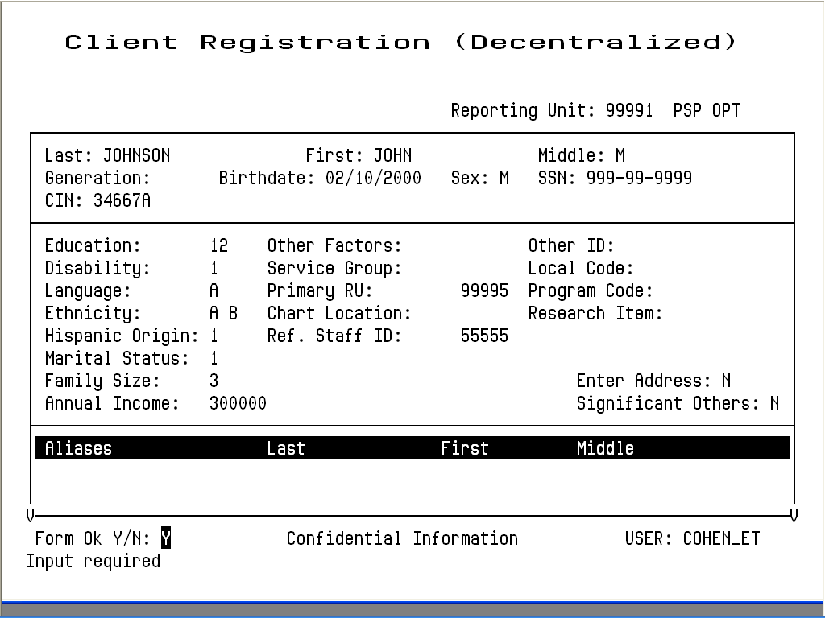
Figure 2.5: Client Registration Screen
- Note: Because the information entered in the Client Registration screen establishes the client’s identity, it is best to ask the client for a Driver’s License, Social Security Card, or other document and copy the information from it. Three critical pieces of information must be entered correctly: client name, birth date, and Social Security Number.
3. Enter data in the following fields:
- RU: Enter the Reporting Unit Number for the program where you are registering the client. This field establishes whether you are using decentralized or centralized registration. With decentralized registration, the system automatically assigns a client number and you can enter episodes and services for the client. With centralized registration, you can register a client and enter episodes, but you cannot to enter services until the registration has been evaluated by a central registration auditor. After you have entered the Reporting Unit, the screen title changes to Client Registration (Centralized) or Client Registration (Decentralized).
- Last Name: Enter a last name with up to 16 letters. Leave out apostrophes, dashes and blank spaces. For example “O’Connor” should be typed “OCONNOR”.
- First Name: Enter a first name with up to 12 letters.
- Middle Initial: Enter one letter as a middle initial, or press the Tab key or space bar to skip this field if there is no middle initial.
- Client Generation: Enter a generation title that is part of the client’s name, such as Jr., Sr., or the Roman Numerals II, III, etc.
- Birthdate: Enter the birth date in MM/DD/YYYY format.
- Sex: Enter “F” for female, “M” for male, or “U” for unknown.
- Social Security Number: Enter a nine-digit Social Security Number. It is best to copy this key information directly from the client’s Social Security Card if possible. If the client does not have one, enter all 9’s in this field.
- Client Index Number: Enter a nine-digit Client Index Number.
- Education Enter the number of the highest grade completed. For example, if the client has completed high school, enter “12”. If the highest grade is greater than 20, enter “20”. Enter “99” for unknown.
- Disability Add the number codes for all of the client’s physical disabilities, and enter the total in this field. The disability codes are on the back of the Client Registration form.
- Language Has two entries. The first entry is to report the client’s primary language, as reported by the client.. The second entry is to report the language the client prefers to speak, as reported by the client. Language codes are on the back of the Client Registration form.
- Ethnicity: There are five ethnicity fields. Enter up to five Ethnicity codes, , as reported by the client. Ethnicity codes are on the back of the Client Registration form.
- Marital Status: Enter the Marital Status code. The marital status codes are on the back of the Client Registration form. (Note that Code 1, Never Married, is used for a single person who does not live with girlfriend/boyfriend and has never been married.)
- Enter Address: This is not a data field; it is a question. The system is defaulted with “Y”, the system will jump to the Address Screen, described later in this chapter. Once you are done with that screen, the system will return you to the Registration Screen.
- Enter Significant Other This is not a data field; it is a question. The system is defaulted with “N”, the system will jump to the Significant Other Screen when set to “Y”, described later in this chapter. Once you are done with that screen, the system will return you to the Registration Screen.
- Aliases: If the client has ever used aliases, enter them here. As you add information, this section of the screen scrolls upward to allow more information to be entered. You may enter up to six aliases via the Client Registration Screen, and enter more through the Client Maintenance screen if necessary.
Birth Last Name: Enter a last name with up to 16 letters. Leave out apostrophes, dashes and blank spaces. For example “O’Connor” should be typed “OCONNOR”.
Birth First Name: Enter a first name with up to 12 letters or enter “Z2”.
Birth_County: Enter clients’s birth county. See Appendix B for codes
Birth_State: Enter clients’s birth state. See Appendix B for codes
Birth Country: Enter clients’s birth country. See Appendix B for codes
Mother’s First Name: Enter a first name with up to 12 letters.
4. The system validates the data. Then it prompts you to verify the name by re-keying the last and first names. You need to retype an exact match of the last name, first name, and middle initial. If you make a mistake, you must enter the correct spelling twice to verify the name.
5. If the registration is successful, the system assigns the client a client number, which it displays in the Client Number field at the top of the screen (Figure 2.6). To continue registering clients, enter “Y”. To leave this screen and return to the menu, enter “N”.

Error Messages
If there is a Social Security Number in the system that is the same as the one you just entered, it displays an error message and it does not let you continue. If you’re sure that the number you have entered is correct, refer the case to your supervisor.
If there is a client in the system with the same name and birth date you have just entered, it displays an error message and does not let you continue. Refer the case to your supervisor.
If two different clients do have the exact same name and birth date, a supervisor may use the Gold-A sequence to override the match, so registration can occur. You cannot override a Social Security Number match.

Maintaining Client Records

To maintain client records:
1. Choose CLIENTS from the Main menu.
2. Choose MANAGEMENT from the Client Maintenance Menu to display the Client Maintenance Screen (Figure 2.7).
3. Use the fields at the top of the screen to identify the client and maintenance type:
- Client Number: Enter the number of the client whose record you want.
- Maintenance Type: If the client number is valid, you can enter the Maintenance Type “L” (for Lookup) or “U” (for Update).
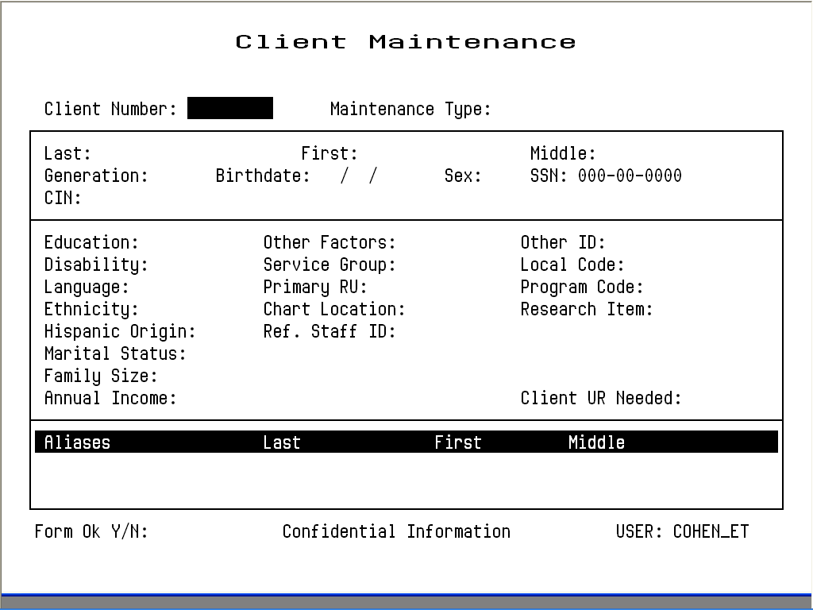
Figure 2.7: Client Maintenance Screen

Client Lookup
If you enter “L”, InSyst displays the Client Lookup Screen (Figure 2.8). This screen only lets you view information, and so it can be used by people who are not authorized to change client information.
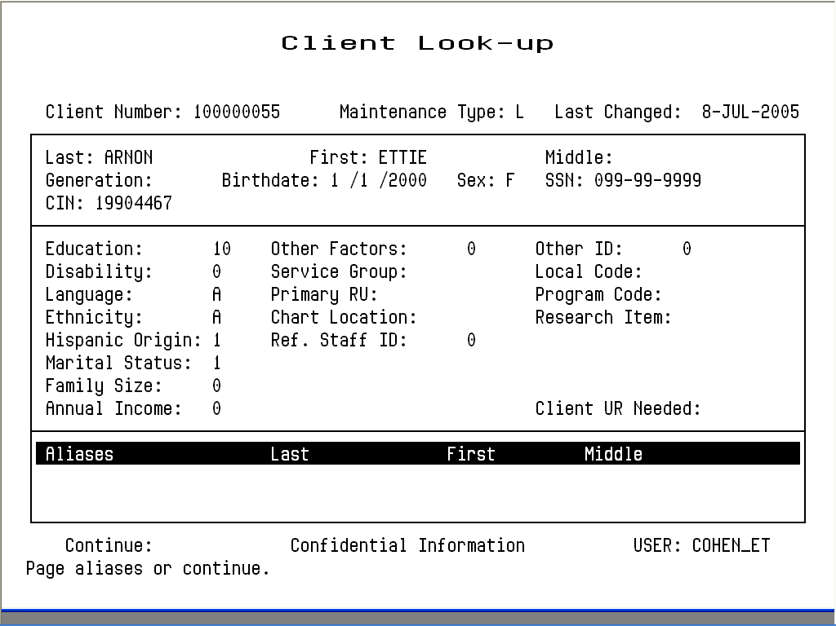Figure 2.8: Client Look-up Screen
If the client has aliases listed, you may use Gold key sequences to page through them, as described in the section on Moving Through Lists in Chapter 1.
When you are done, enter “Y” to continue looking up more clients, or press Gold-S to leave the Maintenance Screen and save the client number, so it is entered automatically in the next screen you use.

Client Update
If you enter “U”, InSyst displays the Client Update Screen (Figure 2.10).

To modify client data:
1. Press Tab to move through the fields, and edit them as necessary.
2. Tab to the Form OK prompt, and enter “Y” to save the changes, or “N” to discard them.
The data in all these fields was described in the section on the Client Registration Screen, earlier in this chapter.
The Client Number cannot be changed.

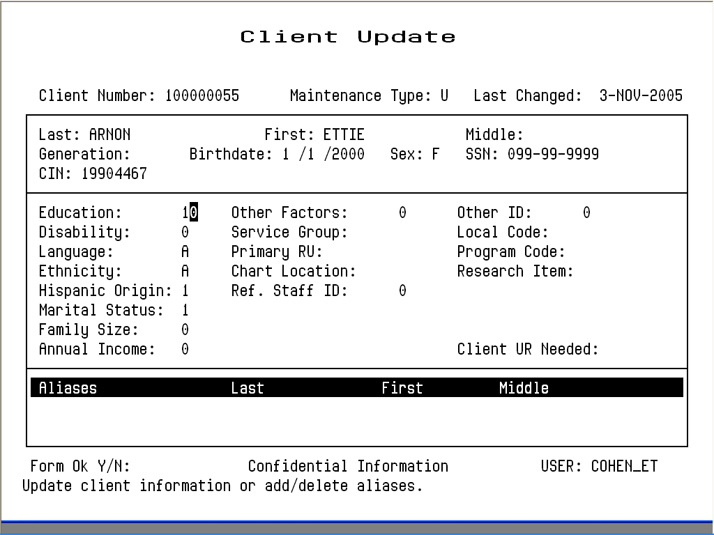
Figure 2.10: Client Update Screen
The Registration Approved field only applies to systems using centralized registration, and it can only be changed by the Central Registrar. The Client UR Needed field can only be changed by authorized staff.
Aliases cannot be changed, but any user can add new aliases or can delete an alias by entering “D” on its line.
Client Last Name, First Name, Middle Initial, Social Security Number, Birthdate, Sex can only be changed by a Supervisor. If you are authorized as a supervisor, you can press Gold-A to display the Client Update Screen in Supervisor mode (Figure 2.11).
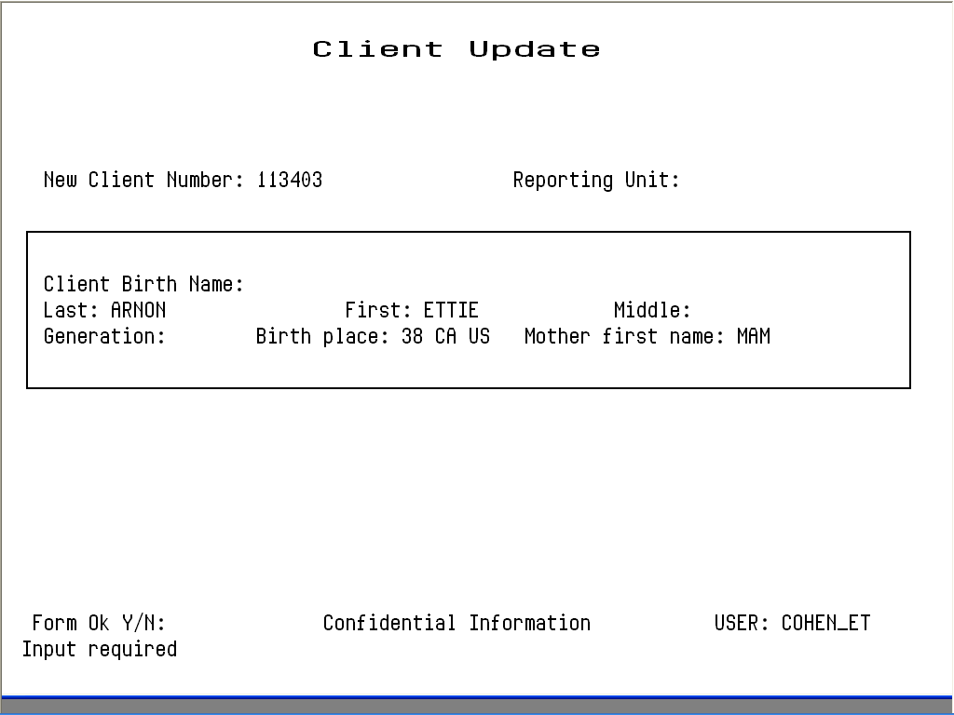
Figure 2.11: Client Update Screen: Supervisor Mode

Registration Approved
If the Client was registered using centralized Client Registration and the registration has not yet been approved, this screen will include a Registration Approved field. If you are sure the client registration information is correct, enter “Y” in this field.

Entering a New Client Address
Any authorized user can enter a new address for a client with an open episode.

To enter a new address:
1. Choose ADDRESS from the Client Maintenance Menu to display the Address Maintenance Selection Screen, as described above.
2. Press Gold-I (I stands for Insert) to display the Client Address Insert Screen
3. Enter data in the following fields:
- Client Number: Enter the number for the client whose address you want to enter. If you are already viewing a list of the client’s addresses when you press Gold-I, the Client Number is entered automatically.
- Reporting Unit: Enter the Reporting Unit Number for the program that has an open episode for the client. The Effective Date of the address you are entering must fall within this episode.
- Effective Date: By default, the Effective Date is today’s date. Only Supervisors can alter it.
- Street Number: Enter a street number with up to five (5) digits.
- Street Direction: If the address has one, enter a street direction, such as “N”, “NE”, “E”, “SE”, “S”, “SW”, “W”, “NW”.
Figure 2.15: Client Address Insert Screen
- Street Name: Enter a street name with up to twenty characters. (Do not enter “Street”, “Road”, or other street type here.)
- Street Type: Enter an abbreviation for the street type, such as “St”, “Bl”, “Rd.”, “Av”.
- Apartment: Enter up to four characters. Do not enter the symbol “#”, and do not enter a period at the end.
- City: Enter a city name with up to twenty characters.
- State: Enter the two letter abbreviation for the state name.
- Zip Code: Enter the first five numbers of the Zip Code, and the cursor moves to the plus-four digits, which you can enter if available.
- Phone Number: Enter the telephone number, if available. If you do not want to enter the Area Code, you must type three blank spaces in its place.
- Extension: Enter an extension for the telephone number, if there is one.
- County of Responsibility: If you do not make an entry here, InSyst will use your county’s code when it reports to state client data systems. To report to the state that another county is responsible, enter the two-digit county code in this field. (This section is generally used by California Mental Health Programs.)
4. Enter “Y” at the Form OK prompt to validate and save the data.

Maintaining Addresses
The Address Maintenance Selection screen is used to maintain either Client addresses or Account Addresses, the addresses that bills are sent to.

To maintain Addresses:
1. Choose ADDRESS from the Client Maintenance Menu to display the Address Maintenance Selection Screen, as described above.
2. Use the fields at the top of the screen to display a list of addresses:

- Client Number: Enter a Client Number to display that client’s addresses.
The screen lists all addresses for the client or account (Figure 2.17), with the most recent listed first.
Figure 2.17: Address Maintenance Selection Screen
3. Move through the list using the methods described in the section on Moving Through Lists in Chapter 1. Select address records to maintain by typing “L” (lookup), “U” (update), or “D” (delete) next to them. When you have finished selecting records, press Return.

Client Address Lookup
If you entered a Client Number and entered “L” next to the address, it is displayed in the Client Address Lookup screen (Figure 2.18). You cannot change the data. Press Return to display the next address, or press “N” and Return to exit.

Client Address Delete
If you entered a Client Number and entered “D” next to the address, it is displayed in the Client Address Delete screen (Figure 2.19). Enter “Y” at the Delete OK prompt and “Y” again at the confirm prompt to delete the address.

Client Address Update
If you entered a Client Number and entered “U” next to the address, it is displayed in the Client Address Update screen (Figure 2.20).
Figure 2.18: Client Address Lookup Screen
Figure 2.19: Client Address Delete Screen
You can change most of its data. However, you cannot change the Client Number, the Reporting Unit, the Effective Date, or the Address Stamp (which shows when the Address was entered). Because you cannot change the Reporting Unit, if the wrong program has been entered for an address, you must delete the record and enter a new one.

Figure 2.20: Client Address Update Screen
When you have made all changes, press Return. The next record you selected to maintain is displayed. If there are no more selected records, you return to the Address Maintenance Selection Screen.

Client Messages
The Client Message screens let staff write messages about the particular needs of clients. Messages are noted on the Locator and Client Message screens, and active Client Messages can be displayed on some reports (such as the Morning Report, Report MHS 120).
- Tip: If you are you are using the Client Locator Screen and have a client selected, you can go directly to the Client Message Selection screen by entering “M” at the Selection prompt. Then it automatically displays messages for that client.

To work with client messages:
1. Choose CLINICAL from the Main Menu.
2. Choose CLIENT_MSG from the Clinical Menu to display the Client Message Selection Screen (Figure 7.1).
You can view messages for a particular client, or messages entered by a particular user at this point, or enter new client messages.

Entering New Client Messages

To enter new client messages:
1. Choose CLIENT_MSG from the Clinical Menu to display the Client Message Selection Screen, as mentioned above.
2. Press Gold-I to insert new messages for a client. The system displays the Client Message Insert Screen, shown in Figure 7.2.

Figure 7.1: Client Message Selection Screen

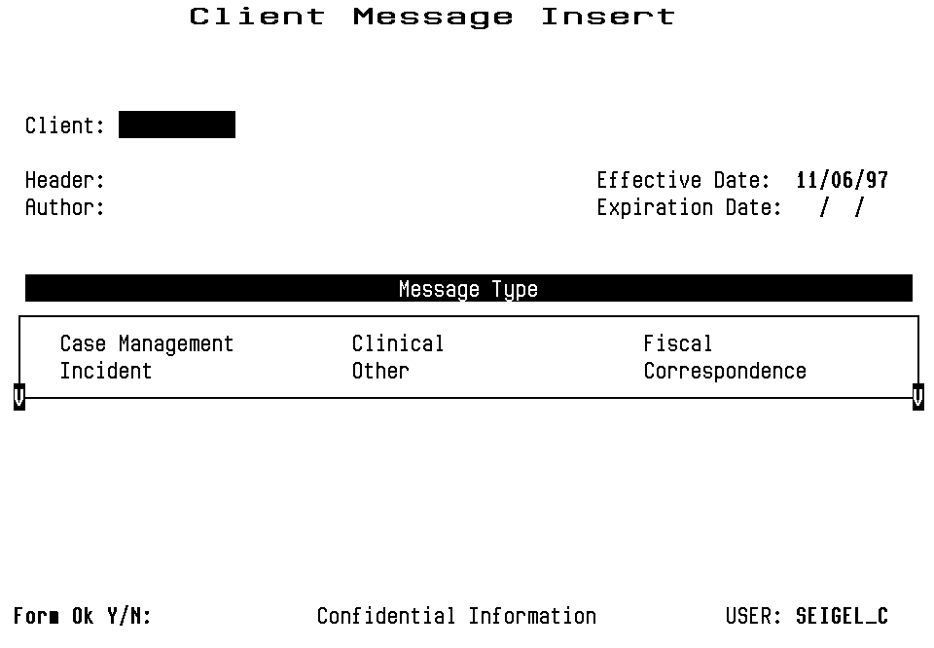
Figure 7.2: Client Message Insert Screen
3. Enter data in the following fields:
- Client: Enter the Client Number of the client the message describes.
- Message Header: Enter a title for the message, up to 40 characters long.
- Author: Enter the name of the person who is the author of the message. This may be different from the username of the person entering the message. The author might be a clinician who asked a data entry person to enter the message.
- Effective Date: Enter the date the message will begin to appear on the system. The default entry is the current date. You cannot enter a date before the current date.
- Expiration Date: Enter the date that the message will no longer appear as an active message in the Client Locator Screen. Only staff with Supervisor Authorization will be able to see the message. For most message types, the default is 45 days from the current date. You can blank the field, so there is no expiration date.
- Message Type: Type “X” next to your choice. Local Operations Staff sets up Message Types. Some common Message Types are: CLINICAL (used by clinical staff to coordinate treatment for the client), CASE MANAGEMENT (used to support the client in the community), FISCAL (used to describe the client’s account), INCIDENT (used to report incidents), OTHER (General Messages used by the entire staff).
4. Enter “Y” at the Form OK prompt to record this information about your message and to move to the Client Message text editor (Figure 7.3).

Figure 7.3: Client Message Text Editor
5. At first, the text editor screen has the Client Number and Message Header you specified at the top of the screen, and “--Last Line--” in the text editing section. Type the message, and these words scroll downward make room for it.
6. As you enter your message, do not press Return at the end of a line; the text wraps to the next line automatically. The highlighted bar at the bottom of the screen will say INSERT NEW MESSAGE to show that the screen is in Insert Mode. It may also say “Char” (Character), “Insert” or “Forward” to show the text editing mode you are using.
7. When you have completed your message, press the Control/Z to stop editing. The word EXIT will be displayed at the prompt, and you can press Return to save your message. If you do not want to save the Client Message, erase the word EXIT, replace it with QUIT and press Return.
The Client Message text editor is the same editor used for MAIL and FILES. It is covered in detail in Chapter 15, which also discusses these utilities, but the features described there are not usually needed for client short messages.
- Note: When you are using the Client Message Insert screens, you can return to the Client Message Selection Screen by pressing Gold-R.

Maintaining Client Messages

To maintain client messages:
1. Choose CLINICAL from the Main Menu.
2. Choose CLIENT_MSG from the Clinical Menu to display the Client Message Selection Screen.
3. Enter search criteria in the fields at the top of the screen:
- Client Number: Enter a Client Number to search for messages about that client.
- Username: Enter a Username to search for messages written by that user.
4. You can enter search criteria in either or both of these fields, then press Return to list messages that match.
5. Move the cursor through the list of messages. (See the section on Moving Through Lists in Chapter 1.) Select the ones you want to maintain by entering “L” (lookup), “U” (update), or “D” (delete) next to them. Press Return when you have finished selecting messages.

Figure 7.4: Client Message Selection Screen After Searching by Client
If you searched by client, as in Figure 7.4, the list includes:
- Message Header: A Message Title of up to 40 characters.
- Message Type: The type of message (e.g. Clinical, Fiscal, Incident, etc.).
- Effective Date: The date the message first began appearing.
- Entered By: The person who created the message.
If you searched by Username only, list includes:
- Message Header: A Message Title of up to 40 characters.
- Message Type: The type of message (e.g. Clinical, Fiscal, Incident, etc.).
- Client Number: The Client Number for each Message.
- Client Last Name: The Client Name for each Message.
The Message Display area shows up to six messages. You can press Gold-M to view one additional page of messages.
- Note: To list more than 12 messages, you must type Gold-A before entering a Client Number to request unlimited paging

Client Message Lookup
If you entered “L”, the message is displayed on the same screens used to enter messages. First the screen lists Client, Header, Author, Effective and Expiration Dates, and Message Type. Press Return to display the text editing screen with the message. You can not edit either the title screen or the message.
After reading the message, type Control/Z to move to the next message or return to the Client Message Selection Screen.

Client Message Delete
If you entered “D”, the Text Editing Screen is displayed, as described above, with the prompt, “Are you sure you want to delete this message?” Enter “Y” to delete the message.
- Note: You may only delete your own messages.

Client Message Update
If you entered “U”, the title screen is displayed and you may change the Message Header, Message Type, Effective or Expiration Date. Press Return to display the message in the text editing screen and make changes (Figure 7.5). Type Control/Z and press Return to save the changes.
- Note: You may only update your own messages.
Figure 7.5: Client Message Update

Supervisor Authorization
Supervisor Mode lets you update or delete any message regardless of its author, and it lets you see expired messages. If you are authorized to use Supervisor Mode, press Gold-A twice when the Client Message Selection Screen first appears.
Supervisory Staff and Operations Staff have a responsibility to monitor and service the Client Messages system. If you have Supervisor authorization, you should use Supervisor Mode.

Entering New Messages during Maintenance
If you press Gold-I while you are using the Editing screen to update, look up, or delete a message, the screen will split to let you enter a new message for the client whose message you were maintaining (Figure 7.6).
After entering the new message, press Control/Z. You will be able to enter the Message Header, Type, and Dates, as described above.

Chapter 2a
CSI Periodic Data

CSI Periodic Data entry MUST be done at EVERY Episode Opening/Closing/Annual Chart Review.

To work with the CSI Periodic Data:
1. Choose CLIENT from the Main Menu.
2. Choose CSI_PERIODIC from the Client Menu to display the CSI Periodic Selection Screen

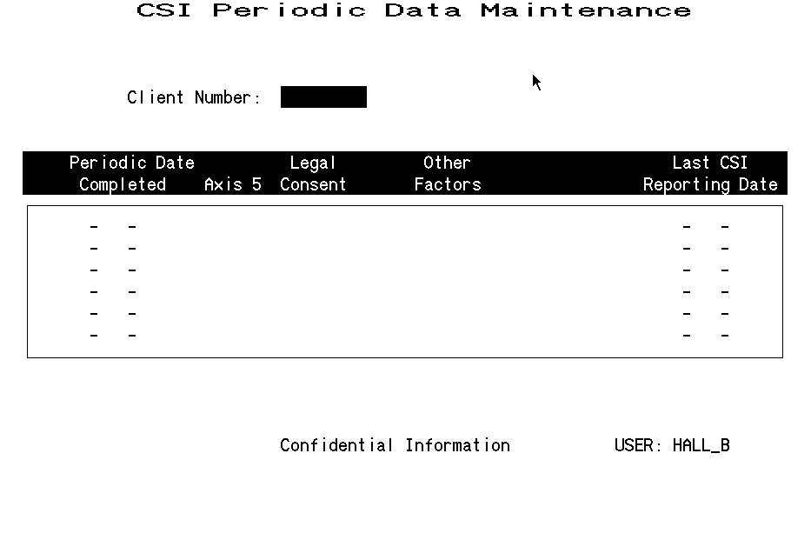

Press Gold-I to open the CSI Periodic Data Entry screen.

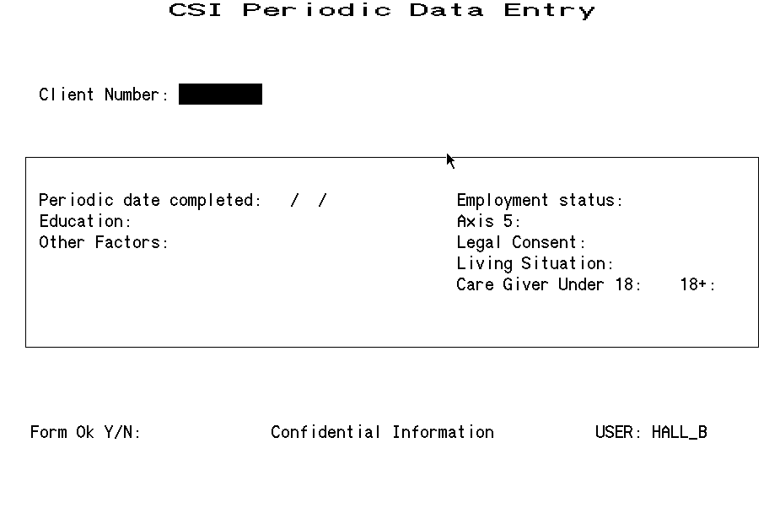

Periodic Date Completed: This is the date the Episode was Opened/Closed or the date of the annual update.
Education: The highest education achieved. Can be extracted from the Episode Opening/Closing form when a CSI Periodic entry is due to the Opening or Closing of an episode.
Employment Status: Enter the code for the client’s Employment Status. Can be extracted from the Episode Opening/Closing form when a CSI Periodic entry is due to the Opening or Closing of an episode.
Axis 5: Can be extracted from the Episode Opening/Closing form when a CSI Periodic entry is due to the Opening or Closing of an episode.
Legal Consent: Indicate what authority you have to treat minors. This field is also used for some adults. Can be extracted from the Episode Opening/Closing form when a CSI Periodic entry is due to the Opening or Closing of an episode.
Living Situation: : Enter the code for the client’s living situation. Can be extracted from the Episode Opening/Closing form when a CSI Periodic entry is due to the Opening or Closing of an episode.
Care Giver: Enter the number of people under 18 and over 18 that the client is responsible. Can be extracted from the Episode Opening/Closing form when a CSI Periodic entry is due to the Opening or Closing of an episode.

Chapter 3
Client Episodes
An Episode is a period of treatment for a client at a program. Before you can enter services for a client, there must be an open Episode for the client in the program providing the service.

Episode Screens are different in InSyst’s Mental Health and Drug and Alcohol systems. The first half of this chapter covers the screens for Mental Health programs. The second half of the chapter covers the screens for Drug and Alcohol programs.

Episodes in Mental Health Programs
First, we look at Episodes in Mental Health programs.

Opening New Episodes, Mental Health Programs

To open an Episode for a client:
1. Choose EPISODES from the Main Menu.
2. Choose OPEN from the Episode Maintenance Menu to display the Episode Opening screen (Figure 4.1).
3. To identify the record, fill in the fields at the top of the screen:
- Client Number: Enter a Client Number
- RU: Enter a Reporting Unit number representing a Mental Health program.
4. The system validates the data. It will not let you open an episode unless the Client and RU numbers exist, and it will not let you open two episodes for the same client in the same reporting unit. If these identifying fields are valid, you can enter data in the following fields:
- Opening Date: Enter today’s date or an earlier date. The system will not accept a future date. Remember that you cannot enter services that occurred before the episode’s opening date.
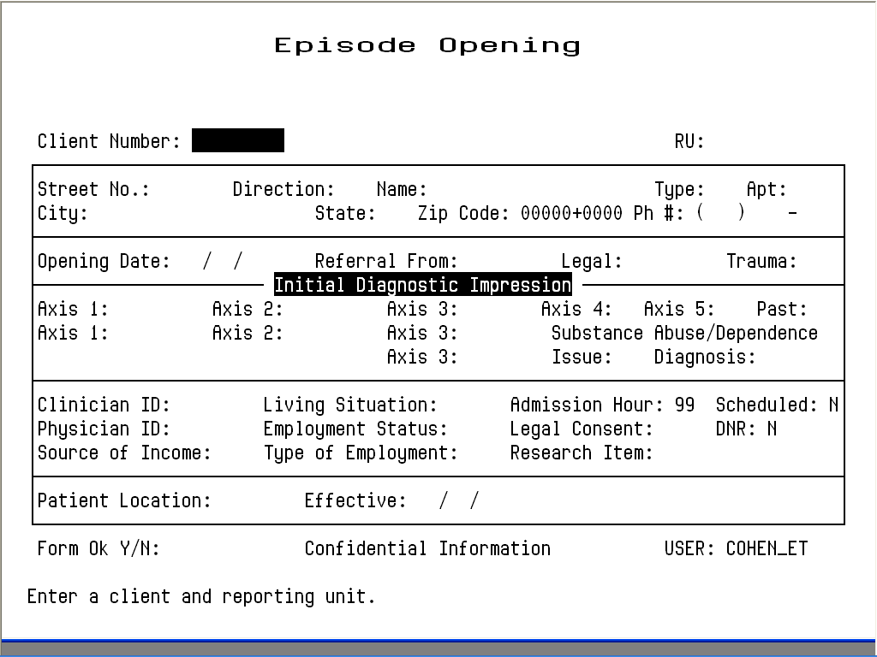
Figure 4.1: Episode Opening Screen
- Referral From: If you have the code for the reporting unit or agency that referred the patient, enter it here. Otherwise, you can enter a one or two-digit generic code numbers. The Rreferral codes are on the back of the Client Registration form.
- Legal: Enter a Legal Status code. The Legal codes are on the back of the Client Registration form.
Next, the cursor moves to the fields in the Diagnostic area. This area has two lines, the first for the main diagnoses and the second for alternative diagnoses.
- Trauma: Enter ‘Y’ - if client has experienced traumatic events, otherwise, enter ‘N’ for “No” or ‘U’ for “Unknown”.
Next, the cursor moves to the fields in the Diagnostic area. This area has two lines, the first for the main diagnoses and the second for alternative diagnoses.

To enter the main Diagnoses (line 1):
1. Press the Tab key to move through the Axis fields in line one of the Diagnostic area, and enter diagnosis numbers in them.
2. The Tab key will also move the cursor to the Principle/Secondary field next to the Axis 1 and Axis 2 fields. By default, Axis 1 is the primary and Axis 2 is the secondary diagnosis, but you can change this by pressing the Space Bar to clear these fields, and then typing “P” next to the Primary diagnosis and “S” next to the Secondary Diagnosis. Every episode must have one Primary and one Secondary Diagnosis.
The Axis fields hold the following data:
- Axis 1 and Axis 2: Enter five-digit diagnostic codes with a decimal point (period) between the third and fourth digits: for example, 296.44. Some codes have a “V” as the initial digit: for example, V71.09. Ask your system manager for the codes. You must enter data in these fields. (These two fields have “P” and “S” to their right, to indicate which is the primary and which is the secondary diagnosis.)
- Axis 3: Enter Axis 3 diagnosis code or summary code. You must enter at least one of these fields. If more than one field is entered, the entered values must be either all diagnoses or all summary codes. Mixing the two codes is not allowed.
- Axis 4: Enter a code determined by the local agency. Ask your system manager for the codes. You must enter data in this field.
- Axis 5 and Past 5: Enter assessments of the client’s current and past functioning using the Spitzer GAF Scale. Numbers from 000 to 100 are valid. You must enter data in these fields: if unknown, enter “UK”.
- Substance Abuse / Dependence Flag: Enter ‘Y’ - if client has a substance abuse/dependence issue, otherwise, enter ‘N’ for “No” or ‘U’ for “Unknown”.
- Substance Abuse / Dependece Diagnosis: Enter a DSM or an ICD diagnosis code. If diagnosis code is not available, enter “000000”.

To enter alternative diagnoses (line 2):
1. Press the Tab key to move through the fields in line two of the Diagnostic Area.
2. Fill out these fields like the fields in line one of the Diagnostic Area. These fields can hold the same codes as the Axis 1, Axis 2, and Axis 3 fields of line one, and you indicate the primary and secondary diagnosis in the same way. However, you must enter different values in these fields than you entered in line 1, since these are alternative diagnoses.
All the fields on line two are optional.

To enter data in the remaining fields:
1. After you Tab through the diagnostic fields, you enter data in the following fields:
- Clinician ID: Enter the primary clinician’s identification number. This number must be in the STAFF_MASTER table.
- Physician ID: Enter the physician’s identification number. This number must be in the STAFF_MASTER table.
- Source of Income: The Source of Income codes are on the back of the Client Registration form.
- Living Situation: Enter the code for the client’s living situation. The Living Situation codes are on the back of the Client Registration form.
- Employment Status: Enter the code for the client’s Employment Status. The Employment Status codes are on the back of the Client Registration form.
- Type of Employment: Enter the one-digit code for the occupation of the family’s primary wage earner. The Type of Employment codes are on the back of the Client Registration form.
- Legal Consent: Indicate what authority you have to treat minors. This field is also used for some adults. The Legal Consent codes are on the back of the Client Registration form.
2. At the Form OK prompt, enter “Y” to save the record (Figure 4.2).

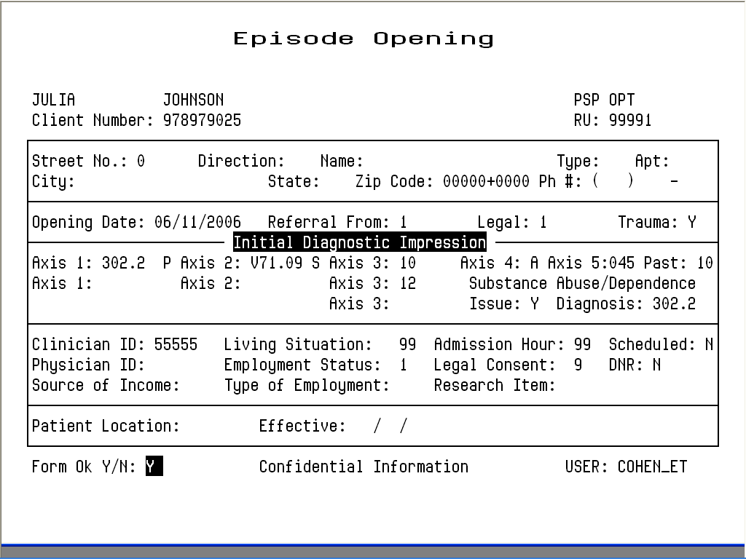
Figure 4.2: Episode Opening Screen with Data

Closing Episodes, Mental Health Programs

To close an episode for a client in a reporting unit:
1. Choose EPISODES from the Main Menu.
2. Choose CLOSE from the Episode Maintenance Menu to display the Episode Closing screen (Figure 4.3). This screen is similar to the Client Episode Opening Screen, with a few exceptions. In addition to Opening Date, it has Closing Date. Instead of Referral From, you can enter Referral To codes. A number of fields are not included, since that data is collected at Episode Opening only.
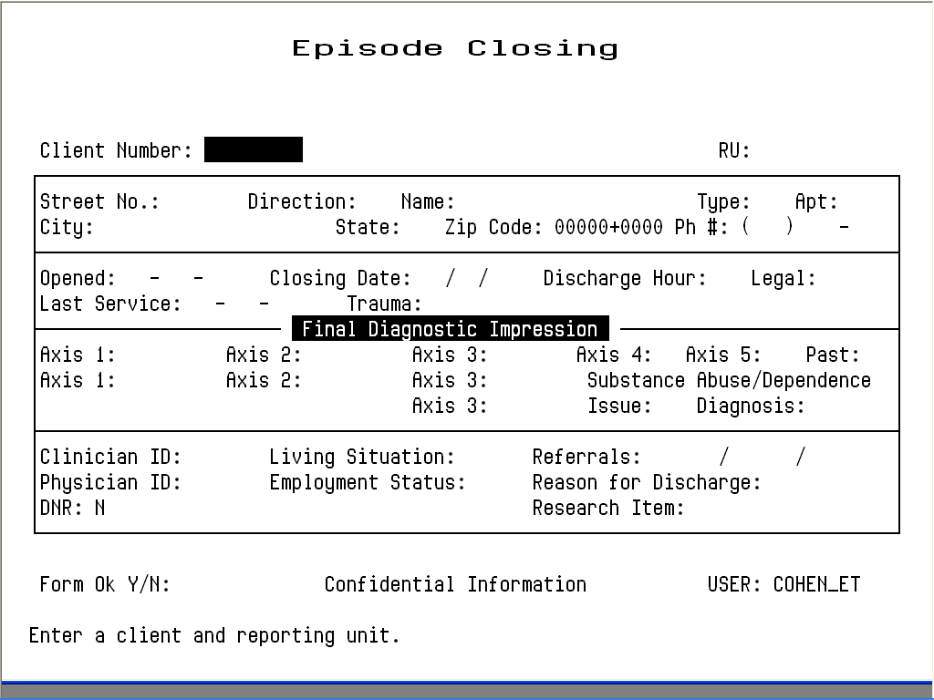
Figure 4.3: Episode Closing Screen
- Note: Some 24 Hour programs cannot close an episode unless there is a recorded service for every day of the episode. Ask your Operations Staff for more information about this.
3. Use the fields at the top of the panel to identify the record:
- Client Number: Enter the Client Number
- RU: Enter the Reporting Unit Number for the program.
4. The system displays an error message if it cannot find an open episode for this client in this reporting unit, or if you are not authorized to close episodes in this reporting unit. If it finds the open episode for the client, it displays the current data as defaults for closing. You use the following fields:
- Closing Date: You must enter a closing date, and you cannot enter a future date or a date before the last service. The current date as the default.
- Last Service Date: This field is displayed, but you cannot edit it. Usually, will want make the Closing Date the same as the Last Service Date.
- Diagnostic, Clinician, Physician, Living Situation and Employment: Update these fields if necessary, or just press the Tab key to move through them.
- Referrals: Enter codes for up to three referral destinations. Use one or two-digit generic codes or the codes for programs or agencies.
- Reason For Discharge: Enter a Reason for Discharge code. The Reason for Discharge codes are on the back of the Client Registration form.
4. Enter “Y” at the Form OK prompt to save the data. After validating the data, the system closes the episode (Figure 4.4).

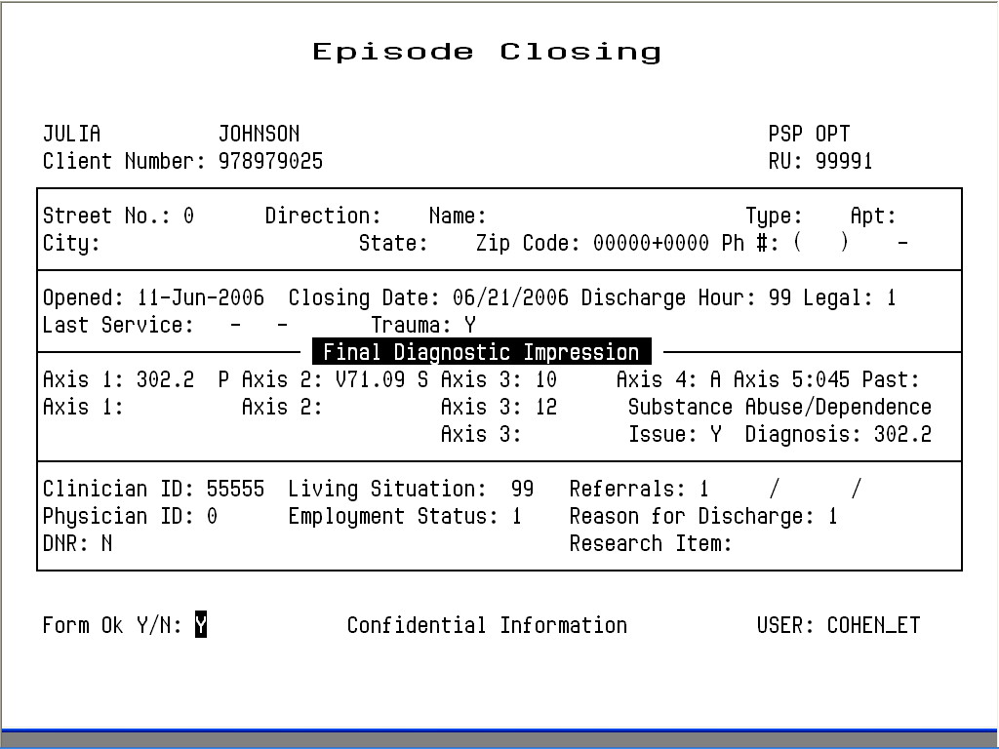
Figure 4.4: Episode Closing Screen with Data

Maintaining Episodes, Mental Health Programs

To maintain Episode records:
1. Choose EPISODES from the Main Menu.
2. Choose MANAGEMENT from the Episode Maintenance Menu to display the Episode Maintenance Selection screen (Figure 4.5).

Figure 4.5: Episode Maintenance Selection Screen
3. Enter search criteria in the fields at the top of the screen:
- Client Number: You must enter a Client Number.
- Reporting Unit: Optionally, you can enter a Reporting Unit number to display only the client’s episodes in that program.
- Opening Date: Optionally, you can enter a date to display only episodes that were open at that time. (Enter just a month and year to get a list of episodes with opening dates in that month.)
4. Press Return, and the screen lists all Episodes that match the search criteria, with the most recent Episodes first.
5. To select episodes on the list for maintenance, move the cursor through the list (as described in the section on Moving Through Lists in Chapter 1). Next to the records you want to maintain, enter “L” (lookup), “D” (delete), or “U” (update), as shown in Figure 4.6.

Figure 4.6: Episode Maintenance Selection Screen with Episodes Listed
6. Select up to sixteen records. Then press Return to display these records for maintenance.

Episode Lookup
- Tip: For a detailed history of a client, it is usually best to use Report MHS 118, the Client Episode History report, which is described in the Reports Manual.

If you entered “L”, the system displays the Episode Lookup Screen (Figure 4.7). You can view the data for the Episode but cannot change it.
Press Return to display the next record selected for maintenance. Type “N” and press Return to go back to the Client Episode Maintenance Selection Screen.

Episode Delete
If you entered “D”, the system displays the Episode Deletion Screen (Figure 4.8). If you are authorized, you can enter “Y” at the Delete OK prompt and again at the confirm prompt to delete all information about this episode.
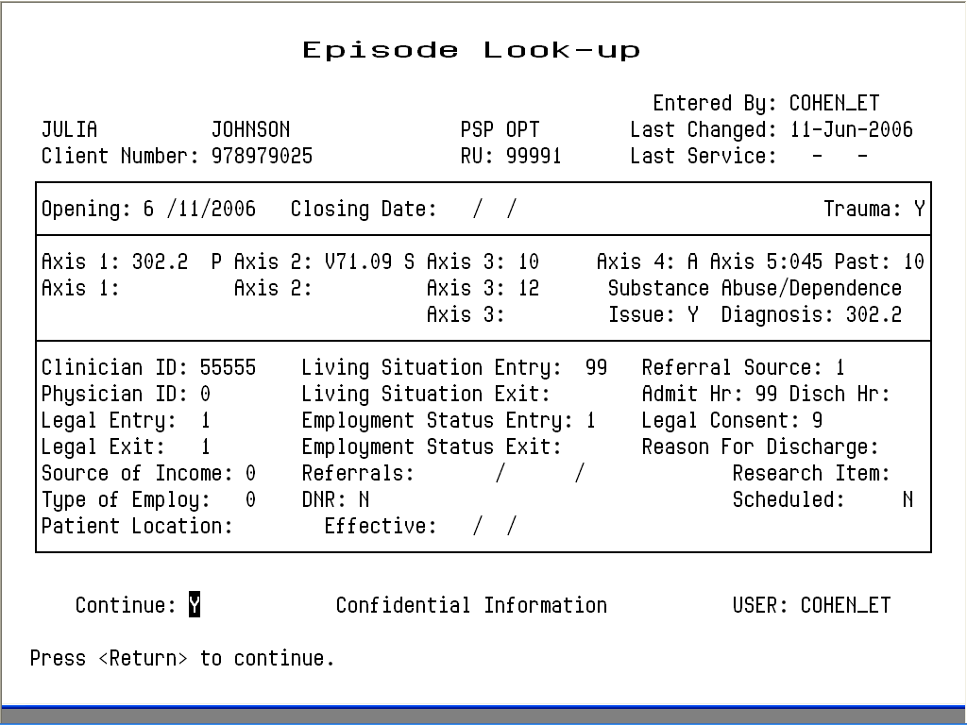
Figure 4.7: Episode Look-up Screen
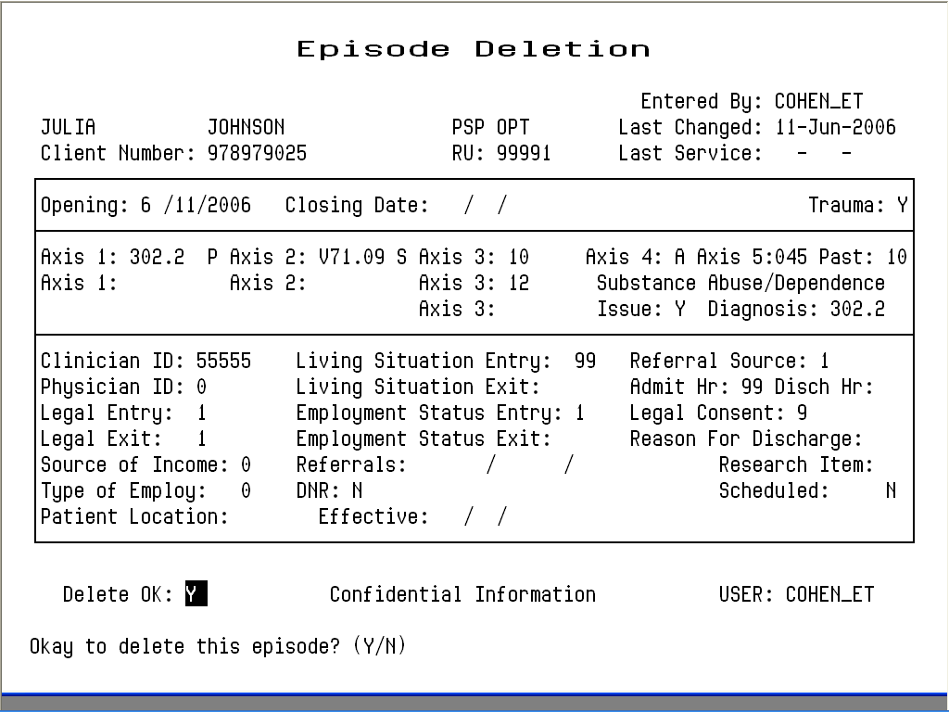
Figure 4.8: Episode Deletion Screen
If services have been recorded for a client, the Episode may not be deleted. The screen displays the message “Services found for this Episode. No deletion possible”.

Episode Update
If you entered “U”, the system displays the Episode Update Screen (Figure 4.9). Only Supervisors can change the episode boundaries (e.g., Opening Date). Any authorized user can change the data below these fields.
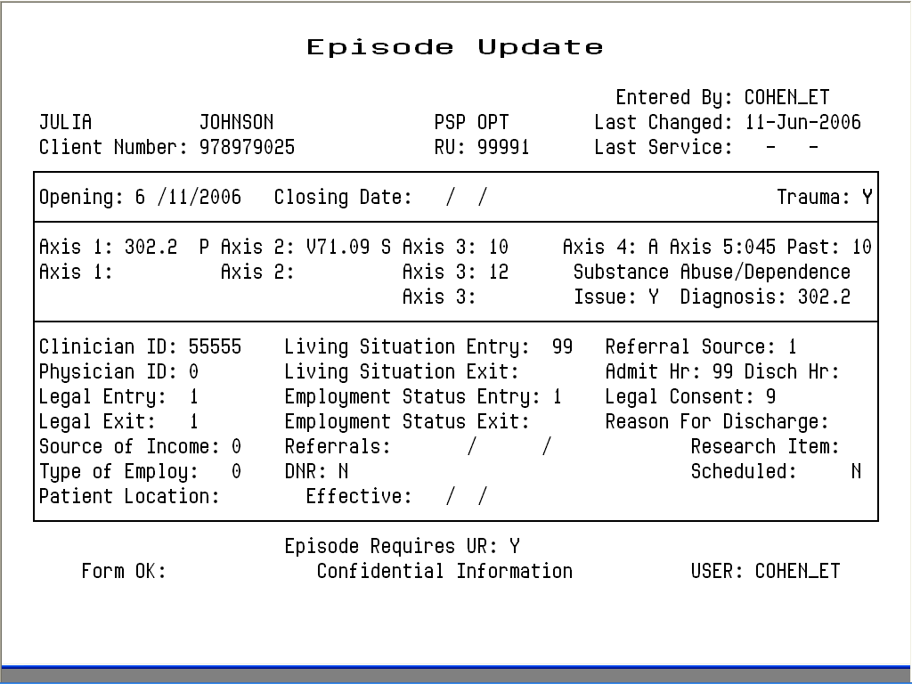
Figure 4.9: Episode Update Screen
Press Tab to move through the fields and edit the data. Press Return at any time to move to the Form OK prompt, and enter “Y” to save the changes. The system validates the data: if there are errors, it displays a message and returns the cursor to the field that needs to be corrected.
After you have updated the record, press Return to display the next Episode selected for maintenance, or if none are left, to return to the Client Episode Maintenance Selection screen.

Episode Update, Supervisor Authorization
Authorized users can display the screen in Supervisor mode (Figure 4.10).

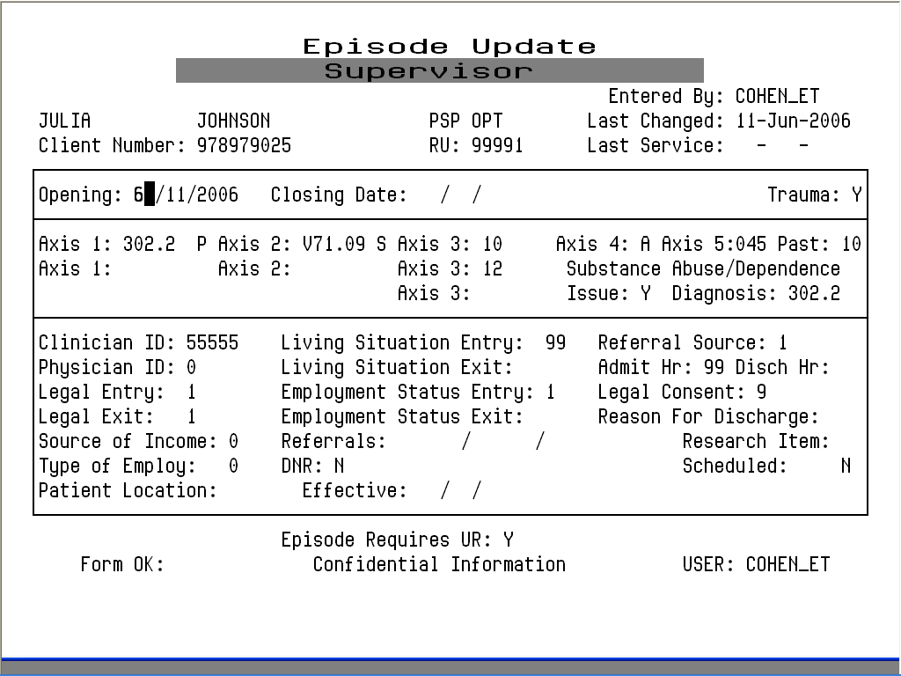
Figure 4.10: Episode Update Screen, Supervisor Mode

To display the screen in Supervisor mode:
1. Display the Episode Update screen, as described above.
2. Press Gold-A to display the screen in Supervisor mode.
With this screen, you can change the opening and the closing date of the episode.

If the episode is closed, you can enter “Y” in the Re-open Episode field to open it. Do this if you have closed an episode for a client and then find that the client receives more services after the closing date.

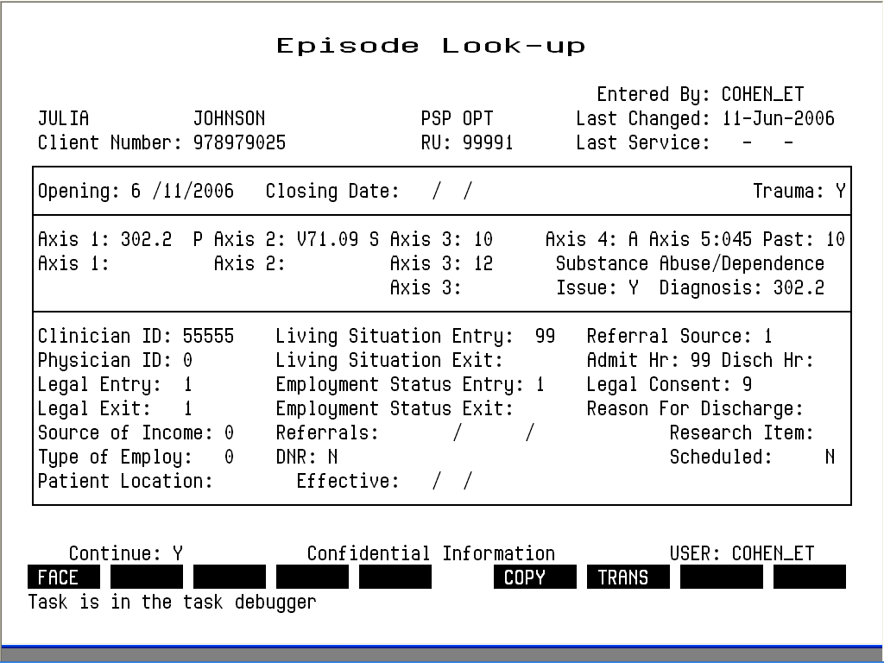
Figure 4.11: Function Key Map of Episode Maintenance Functions
This map corresponds to function keys F6-F14 on a Digital Equipment Corporation terminal. It means that you can press F6 to print a Client Face.
If you are not using a DEC terminal, you may have to use different keys instead of these Function keys. Ask your System Manager or Operations Staff how your keyboard is mapped to the DEC keyboard.

Chapter 4
Direct Services
This chapter covers the different ways to record services provided by programs directly to clients. It ends with a section on substance abuse services, which use some additional data entry screens. All of these screens are on the Service Maintenance Menu.
Before services can be recorded, the client must be registered and there must be an Episode open for the client in the program providing the service on the date being recorded. See Chapter 2 for information on registering clients, and see Chapter 4 for information on opening episodes.

Entering New Direct Services
InSyst gives you based on your User Authorization and Program Site several ways of entering services:
- Single Service Entry for all programs
- Daily Service Entry for day programs and 24-hour programs
- Weekly Service Entry for day programs and 24-hour programs
- Multiple Service Entry to enter the same information for a number of services
Single Service entry is most common, and the other methods can sometimes save you time in data entry.

Single Service Entry
Most programs enter services daily using single service entry.

To do single service entry:
1. Choose SERVICES from the Main Menu.
2. Choose SINGLE from the Service Maintenance Menu to display the Single Service Entry Screen (Figure 5.1).

Figure 5.1: Single Service Entry Screen
3. Enter data in the following fields:
- RU: Enter the reporting unit number for your program and press Return. The system validates the number and displays the program’s name.
- Client Number: Enter the Client Number. When all the data has been entered, the system will display the name of the client. At that time, review the client name to be sure you are entering services for the correct client.
- Date: Enter a date in the format MM/DD/YY. You cannot enter a future date. You must enter a date when the client’s episode is open and the program operates.
- Procedure: Enter a three-digit procedure code. It must be a valid procedure for the program.
- Staff: Enter a staff identification number. The staff number will be validated for authorization to perform the services you are entering.
- Co-Staff: If there was co-staff, enter the staff identification number. You may only enter one co-staff in this system.
- Staff Duration: Enter the number of hours and minutes this staff person spent in this service. Enter up to twenty-three hours and up to fifty-nine minutes in the two portions of this field. There is a fixed minimum and maximum time for some services.
- Co-Staff Duration: If there was co-staff, enter the time they spent on the service, in the same way as Staff Duration.
- Number in Group: Enter a number from 1 to 99 indicating how many clients were involved in the service. The default is 01, for an individual service. If you are recording group services, enter the number of clients in the group. (For example, if Staff Person A and B have a group with 10 members that met today for 1 hour with all members present, enter 10 here. InSyst will record a service for each client number, with the staff numbers of A and B, the procedure code for a group, a group count of 10, and the time each staff person spent in the service. Each client will be billed correctly for the group service, and each staff person will be credited correctly for the time spent in the service.)
- Location: Enter a location code from 1 to 6: 1 = Office, 2 = Field, 3 = Phone, 4 = Home, 5 = Satellite School, 6 = Satellite Clinic, 9 = Inpatient. The default is 1 for Office.

You UMUSTU use location “9” entering Inpatient Services on the Multiple or Single Entry screens.

4. When you are done, enter “Y” at the Form OK prompt. The system validates the data and displays the client’s name. If there are incorrect values in any field, it will display an error message and return the cursor to that field.
5. Once the data is correct, the system will ask for confirmation before saving it (Figure 5.2). Enter “Y” at the Confirm prompt to save the entry.

Figure 5.2: Single Service Entry Screen with Data
If you are using the Utilization Control system, the system will display messages for clients who are Medicaid eligible, which say whether the client has a current Utilization Control authorization and whether the service is authorized.
After service entry has ended, the cursor returns to the Client Number field. You may enter a new Client Number and Date to continue entering services. If you want to enter services for another reporting unit, press Gold-P to move to the RU field.

Special Authorizations for the Single Service Entry Screens
Authorized personnel can use these special features of the Single Service Entry Screen.
- Late Entry: Press Gold-A once to invoke Late Entry authorization. For example, if data entry for April is closed on May 10, Late Entry authorization lets you enter services after that time.
- Supervisor: Press Gold-A twice to invoke Supervisor authorization, which lets you override system validations in the Staff, Co-Staff, Group Count, Staff Duration, Co-Staff Duration and Location fields, but not episode boundaries. This is useful for recording unusual services.
- Supervisor and Late Entry: Press Gold-A three times to invoke both Supervisor and Late Entry authorization.

Using the Single Service Entry Screen for Day Treatment
Day Treatment services are normally entered using the Weekly or Daily Entry Screen, but sometimes you should use the Single Service Entry screen.
In InSyst, Day Treatment days or services are not associated with a particular staff member, and your system will not let you enter a staff person, but will let you enter a “0” for Staff Number.
Some Day Treatment programs can bill Medicare for incident-to services, and sometimes they are required to enter some outpatient-type services. These can be entered using the Single Service Entry Screen.

Using the Single Service Entry Screen for Inpatient and other 24 Hour Programs
Inpatient services are normally entered using the Daily Entry Screen, but sometimes you should use the Single Service Entry screen.
In InSyst, inpatient days or services are not associated with a particular staff member, and are assumed to be twenty-four hours in length. In most cases, your system will not let you enter a staff person, but will let you enter “0” for Staff Number. For duration, the system may make you enter 24 hours. You can enter staff numbers and other durations using the Single Service Entry Screen.

Daily Service Entry
You can enter services for all the clients in Inpatient and Residential programs using a single screen.

To do daily service entry:
1. Choose SERVICES from the Main Menu.
2. Choose DAILY from the Service Maintenance Menu to display the Daily Service Entry screen.
3. Fill in the fields at the top of the screen:
- Service Date: The default is the current date, but you can also use a past date if there are services still to be entered for that day.
- Note: It is best to use this screen is to enter services every day, but there may be times when you put off data entry and then enter several days at a time. When you do this, you must enter services chronologically. For example, if you need to enter data for Tuesday, March 1, Wednesday, March 2, and Thursday, March 3, then you must enter services for Tuesday first, then for Wednesday, then for Thursday. If you accidentally enter services for March 3, you cannot use this screen for March 1 and 2; you must use the Single Service Entry Screen.
- RU: Enter a Reporting Unit Number. If it can enter services using this Screen, the name of the program is displayed above the number.
When you press Return, the system lists all clients open on this date in this program, twenty-five clients at a time, in alphabetical order. If there are more than twenty-five clients, it displays the message: “Enter services for 25 clients. More clients may exist”. After you enter the first twenty-five services, the cursor returns to the date field: press Return to accept the date and reporting unit for a second time (or more) and display the next 25 clients.
Depending on local policy, the program may display the screen without a column to enter time, as shown in Figure 5.3 below, or the screen with a column to enter time, as shown in Figure 5.4 below. Many residential programs use the screen without a column to enter time.
- Note: Some Programs use the Weekly Service Entry Screen (covered below) instead of the Daily Service Entry Screen.

Daily Service Entry without Time
If local policy for this Reporting Unit is not to enter time, the screen is displayed as shown in Figure 5.3.

Figure 5.3: Daily Service Entry Screen without Time

To do daily service entry without time:
1. The Client Number, Name, and Opening Date is listed for each client. For each client, you must enter:
- Procedure Code: Enter one of the twenty-four hour type procedures codes authorized by your local agency. A default procedure code is displayed if specified by local policy. The user can accept or change this default, or can enter “000” to skip this client; later, you can use the Single Service Entry Screen to record services for clients you skipped by entering “000”.
2. After you have entered the last procedure code, enter “Y” at the Form OK prompt to save your entries.
If there are clients who have a Pending registration, they are noted, but you cannot enter services until the registration has been updated. For more information on Pending Registration, see the section on Client Registration in Chapter 2.
If there are clients whose services have already been entered for the Service Date (for example, through the Single Entry Screen), they are not listed on the screen. This screen does not allow duplicate services.
If you have skipped over clients during your data entry, you can redisplay them by pressing Gold-E key to leave the screen. Then use the menu to display the screen, re-enter the date and reporting unit number, and the skipped clients are included in the list.

Daily Service Entry with Time
If local policy for this Reporting Unit is to enter time, the screen is displayed as shown in Figure 5.4.

To do daily service entry with time:
1. The Client Number, Name, and Opening Date is listed for each client, and you must enter:
- Procedure Code: The screen displays the default procedure code for your program; no other entry is valid in this field. If your program can give clients two different kinds of service in one day—for example, a program that has an rehabilitative day care service and a vocational rehabilitative service—you can enter only one service for each client. You must use the Single Service Entry Screen to enter the second service.
- Duration: Enter the number of hours and number of minutes the client attended the program.
- OK: If the client was present, type “W” in this field to write the service. If the client was not present, or you wish to skip over the patient for now, type “S”.
2. After you have entered the last procedure code, enter “Y” at the Form OK prompt to save your entries.
Figure 5.4: Daily Service Entry Screen with Time

Multiple Service Entry
The Multiple Service Entry Screen makes it easy to enter repetitive data—for example, to enter a number of services for one client or one staff person, or to enter all of one type of service for a day. It lets you create user-defined defaults that enter the repetitive data automatically.

To do multiple service entry:
1. Choose SERVICES from the Main Menu.
2. Choose MULTIPLE from the Service Maintenance Menu to display the Multiple Service Entry screen (Figure 5.10). This screen resembles the Single Service Entry screen.

- Tip: There is also a Multiple Service Entry screen without a column for Co-Staff, which is used like the screen described. Local Operations Staff decides which screen is displayed.

Figure 5.10: Multiple Service Entry Screen
3. To identify the program you are doing data entry for, enter:
- Reporting Unit: Enter the Reporting Unit Number for the program, and the screen displays its name. (To enter services for a different program during the same session, press Gold-P to move the cursor back the RU field, or press Gold-R to restart the screen.)
4. The cursor moves to the Defaults box (Figure 5.11). Data you enter here will be repeated for every service you enter in the list below, until you enter new defaults. You can enter default data for one or more of the following fields:
- Client Number: Enter a client number.

Figure 5.11: Multiple Service Entry Screen, Entering Defaults
- Service Date: Enter a date in the format MM/DD/YY.
- Procedure: Enter a three-digit procedure code. The field accepts only direct service procedure codes that are valid for your program.
- Staff: Enter a staff identification number. It will be validated for authorization to perform the services you enter.
- Duration: Enter the number of hours (up to 23) and minutes (up to 59) the staff person spent in this service. Counties set fixed time ranges for some services.
- Co-Staff: Enter the Co-staff identification number, if there is one. It will also be validated for authorization to perform the services you enter. (Your screen may not include this column.)
- Number in Group: Enter a number from 1 to 99 indicating how many clients were involved in the service. The default is “01” for an individual session.
- Location: Enter the location code, from the following options: 1 = Office, 2 = Field, 3 = Phone, 4 = Home, 5 = Satellite School, 6 = Satellite Clinic, 9 = Inpatient. Use the location where the most basic component of the service occurred. The default is “1” for office.

You UMUSTU use location “9” entering Inpatient Services on the Multiple or Single Entry screens.

5. After you have entered defaults, enter “Y” at the Form OK prompt (Figure 5.12). The system validates data and prompts you to correct any errors.

Figure 5.12: Multiple Service Entry Screen, Defaults Entered
6. Now, you can use the defaults to enter up to 20 services using the default information. The information you entered in the default box is displayed automatically as you enter data in the screen’s service entry lines (Figure 5.13). You can modify the default data, if necessary, or just press Tab to accept the default value and move to the next field. At the end of each line you want to save, you must enter “W” to write the service.
Figure 5.13: Multiple Service Entry Screen, Data Entry Using Defaults
7. When you are done entering service data, press Return to move to the Form OK prompt and enter “Y” to accept the data. After the system validates the data, enter “Y” at the Confirm prompt to save the data.
The screen is cleared and the cursor moves back to the defaults line, so you can enter additional services or change the defaults.
You can imagine how useful this screen would be, for example, if you had to enter the same service for a client for a large number of service dates. You could just change the date and accept the defaults for all the other fields.

Maintaining Direct Services

To maintain direct services:
1. Choose SERVICES from the Main Menu.
2. Choose MANAGEMENT from the Service Maintenance Menu to display the Service Maintenance Selection Screen (Figure 5.15).
3. To display a list of services, enter:
- Client Number: You must enter the number of the client who received the services.
- Reporting Unit: To narrow the search, you may also enter a Reporting Unit number.
- Service Date: To narrow the search, you may also enter a complete date or a partial date that is just a month or year. If you leave out the year, the system uses the current year.
Figure 5.15: Service Maintenance Selection Screen
4. The Screen displays the Client Name and all the services for the client that match the criteria entered, listed with the most recent services first (Figure 5.16). Move through the list using the methods described in the section on Moving Through Lists in Chapter 1. Enter “L” (lookup), “D” (delete), or “U” (update) next to the services you want to maintain (Figure 5.17).

Figure 5.16: Service Maintenance Selection Screen with Services Listed
5. You may select up to 24 services. When you are done, press Return to display them for maintenance.

Figure 5.17: Service Maintenance Selection Screen, Selecting Services for Maintenance

Direct Service Lookup
If you entered “L” next to a service, it is displayed in the Service Look-up screen (Figure 5.18). The data cannot be changed.

Figure 5.18: Service Look-up Screen
In addition to the data in the Service Maintenance selection screen, this screen displays:
- Last Changed: The date that the displayed record was last modified by a user or system program.
- Cost: The amount charged for the displayed service.
- Service Stamp: The date that the service was originally entered into the system.
Press Return to display the next record selected in the Service Maintenance Selection Screen. Type “N” and press Return to go back to the Service Maintenance Selection Screen.

Direct Service Delete
If you entered “D” next to a service, it is displayed in the Service Delete Screen (Figure 5.19). If you are authorized, you can enter “Y” at the Delete OK prompt and “Y” again at the confirm prompt to delete the service.

Figure 5.19: Service Delete Screen
If a service has been posted in the billing system, the service may not be deleted unless you have the correct authorization. If this occurs, tell your supervisor.

Direct Service Update
If you entered “U” next to a service, it is displayed in the Service Update Screen (Figure 5.20).
If a service has not been processed and you are authorized, you can Tab through the fields and edit them:
- You can change Staff, Co-Staff, Duration, Number in Group, and Location.
- You cannot change Client Number, Reporting Unit Number, Last Changed Date, Service Cost, or Service Stamp.
- If you have supervisor authorization, you can change Service Date and Procedure.
If the service has already been billed to the client or to a third party payor, you cannot change some fields through this screen without making an adjustment to the client’s account. If a service cannot be changed through this screen, the cursor automatically moves to the Form OK prompt.
You can press Return at any time to move to the Form OK prompt. Enter “Y” to save the changes. The system validates the data before saving it.

Figure 5.20: Service Update Screen

Late Entry, and Supervisor Authorization
Late Entry and Supervisor Authorization are available in all three of the Maintenance Screens.
In the Update screen (Figure 5.21), Supervisor Authorization lets you change Service Date and Procedure.
In the Lookup and Update Screens, Supervisor Authorization lets you view these additional fields:
- Service/Client Acct: The Service and/or Client Account to which this service has been billed. Because of Client Merge Adjustments and other Client/Account Adjustments the service could be posted to an Account different from the Client’s current Account.
- Posting Status: The service status within the billing system.
- UR Status: Whether or not this service has been authorized by a Utilization Review Action. Unauthorized services are “99”.

Figure 5.21: Service Update Screen, Supervisor Mode
- UR Posted: The date when Utilization Review action authorized the service. You can use this date to find the correct UR Action using the UR Status Inquiry Screen.
- Component UID: The identification number for this service if it is a contact-based service entered on the Component Service Entry Screen.
- Original FRC: All payor sources (Medicaid, Medicare, County, Insurance, Patient) that can be billed for this type of service in your system.
- Potential FRC: All payor sources (Medicaid, Medicare, County, Insurance, Patient) that can be billed for this particular service.
- Tried FRC: Payor sources (Medicaid, Medicare, County, Insurance, Patient) that you have tried to bill for the service.
- Actual FRC: Payor sources (Medicaid, Medicare, Short-Doyle, Insurance, Patient) that have actually been billed for the service.
- Episode Stamp: The Episode to which the Service is attached. Episodes can be positively identified by their Key Entry Date which is referred to here as Episode Stamp.
- Clearances: The Clearances Flagword in the database. This code will identify which systems have processed this service (POSTING, BILLING, CDS, UR, POE).
- Screen Source: The screen used to enter the service.
- CDS Date: The date the service was reported to the state.
In the Delete Screen, the Supervisor Authorization lets you delete a service that has been posted by the billing system. In this case, the Delete Screen deletes the service and also writes an adjustment to the client’s account. Supervisor Authorization alone does not allow you to delete a service that has been claimed to a payor source: you must also have additional authorization.

To use late entry and Supervisor authorization:
1. Display the Service Lookup, Delete or Update screen.
2. Press Gold-A to display the screen in Late Entry mode, to enter data for a time period whose deadline has passed.
3. Press Gold-A a second time to display the screen in Supervisor mode.
4. Press Gold-A a third time to display the screen in both Supervisor and Late Entry mode.

Chapter 5
Utilities
Use the Utilities Menu to send and receive e-mail, manipulate files, manage the printer queue, and maintain your logon password.

E-Mail
- Tip: To learn more about Mail, at the MAIL> prompt, enter “Help” or press the Help key. The system displays a list of topics. At the Topic Prompt, enter the subject you want information on.

When you log on or when you are working on the computer system, your terminal may display a message such as, “You have 3 new Mail messages”. This section covers the basics of sending, reading, and deleting Mail.

To use e-mail:
1. Choose UTILITIES from the Main Menu.
2. Choose MAIL from the Utilities Menu to display the prompt: “MAIL>”.
3. At this prompt, enter the commands described below.

Reading Mail

To read mail:
1. Choose MAIL from the Utilities Menu.
2. Enter “Read” at the MAIL> prompt.
If you have new messages, they are displayed in the order they were received. If you have no new messages, old messages are displayed in the order they were stored. If a message is too long to display on one screen, press Return to display the next screen of text.

To read only one message:
1. Enter “Directory” or “Dir” at the MAIL> prompt. The system displays a list of messages: each has a number and the author, date, and subject of the message.
2. Enter the Read command with the number of the message you want to read. For example, enter “Read 2” to read message number 2.

Sending Mail

To send mail:
1. Enter “Send” at the MAIL> prompt. The system prompts you for the recipient and the subject and then lets you type the text, as follows:
2. At the TO prompt, type the Username of the person the message is going to. To send a message to more than one user, list multiple Usernames separated by commas. If you give a name that is not a Username (which might mean that you have misspelled the Username) the system displays an error message.
3. At the SUBJ prompt, type a title for the message, which will be listed in the recipient’s directory of Mail messages, and will help him/her to know what a message contains without reading the whole message.
4. The system displays the End Of File mark when you are using the editor. Type the message, and this line moves down to make room for what you type. The editor’s advanced features are discussed at the end of this chapter, but you can just type an e-mail message without using these features.
5. When you finish your message, type Control/Z. Then enter the word “Exit” to send the message, or the word “Quit” to discard the message. In either case, you are returned to the MAIL> prompt.

Replying to a Message

To reply to a message:
1. Enter “Reply” at the MAIL> prompt.
2. The system displays the editor to let you send the message. Use this the same way you do to send a message, as described above. The only difference is that you do not need to enter a recipient or subject.

Forwarding a Message

To forward the message you are reading to someone else:
1. Enter “Forward” at the MAIL> prompt.
2. The system displays the TO and SUBJ prompts. Use them to enter the recipient and subject, in the same way you do to send a message, as described above.
The whole message is sent, including the Header information (FROM, TO, and SUBJ) on the message you received, and the new Header information that you entered at the TO and SUBJ prompts.

Deleting a Message
To prevent your mailbox from getting crowded, you should delete mail messages as soon as you know you will not need them again.

To delete a message while you are reading it:
1. Enter “Delete” at the MAIL> prompt.

To delete a message you are not reading:
1. Enter “Directory” or “Dir” at the MAIL> prompt. The system displays a list of messages: each has a number and the author, date, and subject of the message.
2. Enter the Delete command with the number of the message you want to delete. For example, enter “Delete 2” to delete message number 2.

To delete a group of messages
1. Use the Select command with the /BEFORE or /SINCE qualifier to define a group of messages to delete, as follows:
- MAIL> SELECT /BEFORE= <date> Selects those messages received before the date specified. Dates are specified like this: 2-FEB-85, 10-APR-85.)
- MAIL> SELECT /SINCE= <date> Selects those messages received since the specified date.
2. After selecting a group of messages, enter the command DELETE /ALL qualifier to delete them.
For example, the two commands:
MAIL> SELECT /BEFORE=2-APR-97
MAIL> DELETE /ALL
delete all messages in the Mail file which were received before April 2, 1997.

Customizing Your Mailbox
You may find these commands helpful:
- MAIL> SET PERSONAL_NAME <My Name> Includes your personal name in all mail messages.
- MAIL> SET COPY_SELF SEND REPLY FORWARD Sends yourself a copy of the e-mail you send.
- MAIL> SET CC_PROMPT Displays a prompt that lets you send a CC to someone else.
- MAIL> SET QUEUE <Printer Queue Name> Lets you print your mail. Messages can be printed at your local clinic printer.

Passwords
When you log on to the computer system, you must enter your Username and your Password. Passwords are vital to system security. Passwords expire every sixty days. Two or three days earlier, you will receiving warnings that your Password is about to expire.
- Warning! If you log on to the system after your Password has expired you will be prompted for a new Password. If you bypass these prompts, you will not be able to log on again and will need call the Support Services at (510)567-8181

To change your Password:
1. Choose UTILITIES from the Main Menu.
2. Choose PASSWORD from the Utilities Menu to display the Password Menu. This has only two options: Primary Password and Secondary Password.
You may have only one password, the Primary Password. Only change your Primary Password.

To change your Primary Password:
1. Choose PASSWORD from the Utilities Menu.
2. Choose Primary Password from the Password Menu.
3. The system displays the prompt: CHANGE PRIMARY LOGON PASSWORD Allow system to generate a password? <yes>: If you enter “Yes” or press Return, the system will asks you for your old password and then displays a list of nonsense words. You can use one of these options as your password or ask the system to generate another list of words. If you enter “No”, the system lets you enter your own new password later.
4. The system displays the prompt: Old Password: Enter your current Password.
5. The system displays the prompt: New Password: Enter your new password.
6. The system displays the prompt: Verification: Re-type your new password. If this is not the same as the new password you entered originally, the system displays the message “password verification error”, and returns you to the previous menu. To change your password, you must start again.
Passwords that you type are not displayed on the screen. After you change your password successfully, you are returned to the previous menu with no message.
To exit, type Control/Z at any time.

Printer and Queue Management
The Department assigns a name to the printer attached to your terminal, such as PQ_CHILDRENS, or SONOMA. The queue refers to the waiting line for the printer. If there are no items to be printed, the queue is empty. When you print an item, it is sent to your printer queue.
The Printer and Queue Management menu lets you manage print jobs.

Show Queue

To view the printer queue:
1. Choose UTILITIES from the Main Menu.
2. Choose PRINTER from the Utility Menu.
3. Choose SHOW from the Printer and Queue Management Menu to display the Show Queue Screen.
4. Use the field at the top to identify the queue:
- Queue Name: Enter the name of a print queue, or press Return to select your print queue. The screen lists all the jobs waiting in your queue to be printed, in the order that they will be printed. (Figure 15.9).
5. After viewing the Queue, press Return to go back to the Printer and Queue Management Menu.
The statuses of jobs in the queue are:
- Pending: a job waiting to be printed.
- Holding: a job put on hold, or delayed. In some cases, a time can be associated with this status, e.g. “holding until 15-Jun-1987 02:00”.
- Printing: a job now printing.
- Paused: a job delayed in the midst of printing.
- Aborted: a job deleted in the midst of printing.
Figure 15.9: Show Queue Screen

Start Printer Queue
Use Start Printer Queue to print everything that waiting to be printed is printed, in the order that it is listed. If there is nothing to be printed, the printer readies itself.

To start the printer queue:
1. Choose UTILITIES from the Main Menu.
2. Choose PRINTER from the Utility Menu.
3. Choose START from the Printer and Queue Management Menu to display the Start Printer Queue screen (Figure 15.10). It has the following fields:

Figure 15.10: Start Printer Queue Screen
- Queue Name: To start your printer, enter its name here, or just press Return to accept the default printer.
- Form Mounted: This is not currently implemented. The only forms in use are standard 8 1/2 by 11 sheets of paper.
- Characteristics: This is not currently implemented. Your printer will print as designated by the document.
4. After you have indicated which printer you are using, the system displays the message shown in Figure 15.11. Make sure the paper is properly aligned. Then type “C” to Continue, “S” to Stop printing, or “R” to retry the page.

Figure 15.11: Start Printer Queue Screen Asks for Confirmation
The system continues printing all jobs on the queue.

To stop the printer:
1. Press the Spacebar key. Do not press Spacebar more than once. Do not turn off your printer. If several people are using the computer system, it can take a couple of minutes to stop printing.
2. After you have stopped the printer, the system displays a message asking what it should do with the current print job. You must choose one of the options within 30 seconds, or the system will continue printing the current job. You have the following options:
- Delay: Moves the current job to the end of the queue. The next job begins printing. When the delayed job starts printing again, it begins on the page it was printing when the Delay command was given.
- Delete: Deletes the current job without it being completed. The job is removed from the printer queue. The next job begins printing.
- Restart: Restarts the current job at the beginning.
- Stop: Stops the printer. When you start the printer again, the job continues printing.
- Wait: Stops the printer temporarily.
- Continue: Continues printing the current job to continue printing where it left off.

Restarting Stopped Print Jobs
If you use the Stop Command while printing a file, the printer is stopped and you are returned to the menu.

To continue printing that job:
1. Choose START from the Printer and Queue Management Menu.
2. Use the Start Printer Queue screen to start the printer, as described above.
3. The system displays the prompt: Stop before next entry. Press Return to accept the default “N” to print all jobs on the queue, or enter “Y” to print only this job and stop again. The system displays the prompt: Continue printing this entry. Press Return to continue the job.

Chapter 6
The Report Menu
Reports available are based on your User Authorizations and Program Site. The main two types of Reports available are Caseload and Service.

To run a report:
1. Choose REPORTS from the Main Menu.
2. Choose one of the submenu options of the Report Menu (Figure 17.1). As you can see, this menu lets you choose submenus with reports that are used for different purposes.

Figure 17.1: A Typical Report Menu
3. Choose the report from the submenu.
Your local Operations Staff controls how these submenus are organized, and you should ask them which menus you should have and where specific reports are.
The standard InSyst package includes these submenus for reports:
- Caseload Reports: contains reports on the management of the workload at the clinic level: staff caseload reports, clinic caseload reports, productivity reports, etc.
- Service Reports: contains staff productivity, service audit and program productivity reports.

Running Reports
Once you select a report from one of the Reports Menu, you may be prompted for information needed to produce the report. First the system will ask you questions about when the report will be created, or where the report will be printed. After that, it will ask you questions that control the content of the report, such as client number, reporting unit number, or date range that it will report on.
The following example (Figure 17.2) shows the dialogue similar to what you may see on the screen when you produce a report. The symbol <RETURN> means that pressing Return will accept the default answer to the question.
REPORT_PSP118
This report may only be run in “BATCH” mode
Specify when the report generation should start up:
time = hold until specified date/time (DD-MMM-YYYY:HH:MM)
<RETURN> = start up immediately
?
Specify print destination
NOPRINT = do not print report (save as disk file)
queue name = name of printer queue (e.g.. COMMON)
<RETURN> = print on the default printer: pq_myprinter
?
Specify number of copies
number = number of times to print this report
<RETURN> = 1 copy
?
Specify print setup/form
examples:
CONDENSE = print 132 columns on 80 column paper
DRAFT = print in normal ‘FAST’ mode
LETTER = print in slower ‘LETTER QUALITY’ mode
<RETURN> = print using the default
?
Send mail notification when report has completed?:
YES/NO = send mail/do not send mail
<RETURN> = do not send mail
?
Parameters selected:
Send to batch (release terminal)
,start report generation immediately
,use printer: CHANATE
,print 1 copy of report
,default printer form/setup
,no mail notification
OK to continue? <Y/N> Y
Enter Case Number for Episode History Report
? 10000015
Submitting report REPORT_PSP118 to run in batch mode on REPORT_MHS$BATCH
Job REPORT_PSP118 SMITH (queue REPORT_MHS$BATCH, entry 1) started on REPORT_MHS$BATCH
Jobname Username Entry Blocks Status
------- -------- ----- ------ ------
REPORT_PSP118 SMITH
SP_SNMHS_RPT 1 Executing
On batch queue REPORT_MHS$BATCH
****************************** all done *******************************
press <RETURN> to return to Menu
Figure 17.2: Sample Report Dialogue
- Note: You can terminate your report request at any time by typing Control/Z. The report dialogue will terminate itself if you do not respond after a short time.
After you finished the dialog, the system displays all the options you have chosen and displays the prompt: OK to continue. Enter “Y” to produce the report, or if an option is incorrect, enter “N” to use the dialog again.

Report Dialog Questions
This section explains some questions the system may ask you. Which questions are displayed depends on the report and your level of authorization. Here is an explanation of some questions commonly used in dialogs.

Specify when the report generation should start up:
Enter a date and time, such as 19-SEP-1997:18 (September 19th at 6:00 PM), or just a time, such as 19 (today at 7:00 PM).
Some reports can be run at any time during the day. Some reports that use system resources heavily, can only be run in the evening or weekends. If you try to run a report immediately, the system may display a message with the times you can run the report.

Automatically distribute reports to program printers?:
Some reports are automatically sent to the correct printer for each reporting unit. Instead of the printer section of the dialogue show above, the dialog might say:
Automatically distribute reports to program printers?:
YES/NO = distribute reports/do not distribute reports
<RETURN> = distribute reports?
If you select this option, the system will send the needed version of the report to the printer for each reporting unit.

Specify print destination
Enter a printer name. If the report is set up to print at the printer assigned to the person requesting it, this printer’s name will be displayed as the default. If the report is set up to print at a specific printer, this question is not asked.

Specify number of copies
Enter a number to print more than one copy of the report.

Send mail notification when report has completed?:
Enter Yes to have the system send you e-mail message when the report is completed and ready for printing. Because you generally are only notified of mail messages when you log on, this option may not be effective for most users.

Enter the Reporting Unit Number for your program
Enter the six digit reporting unit number for your program, or enter “*” for all reporting units.

Enter a starting date for the report
For service and productivity reports, you enter a date range. At this prompt, enter the first day of the range.

Enter an ending date for the report
For service and productivity reports, you enter a date range. At this prompt, enter the last day of the range.

Enter a client number
For client oriented reports, enter the client number.

Report PSP 100
Primary Staff Caseload Report

Report Description:
This report shows all clients currently assigned to each clinician in a reporting unit. It lists client name and number, episode opening date, age, primary diagnosis, last service date, and primary physician if one has been assigned. It also lists other reporting unit and staff who have open episodes for each client. It provides a total count for each staff member.

Running the Report:
Operations Staff should use the Report menu to run this report regularly—monthly or more frequently as needed—and to send the output to each Reporting Unit’s printer. If you do not receive this report regularly, contact your local Operations Staff.

Using the Report:
This report gives clinicians a list of all clients for whom they are primary therapist, with basic information on each client.
Review it for accuracy. It is very important to keep the clients’ Primary Therapist up to date, so reports go to the correct staff person.

Output File:
MHS_OUTPUT_REPORT:
STAFF_CASELOAD_PSP100.******_LIS.

Primary Staff Active Caseload 20-May-1993
Page 1
Report PSP 100
Vineland County Mental Health
VLD OUTPATIENT (89027)

Caseload for: AGUILAR ADELIA
Cases active as of: 3-Jan-1993

A Last Other
Client G Primary Service RU
Client Name Number Opening Date E Diagnosis Date Physician Staff

RHONDA BARTLETT 000987605 2/08/85 39 308.30 9/29/92 BRYSON

PAULINE BERGGREN 009876284 5/27/92 64 295.62 2/04/93 DAVIS
Also Open At: VLD CMT 5/20/92 295.62 11/03/92 AGUILAR
Also Open At: VLD ADT 6/04/92 295.62 1/28/93 MERCADO

LINDA BOEDING 000987787 8/18/92 53 295.92 9/18/92 BRYSON

LOUISE BORDEN 000988871 5/07/91 25 296.60 1/22/93 STAFF
Also Open At: VLD CMT 12/07/92 296.60 2/04/93 AGUILAR

ELLA BRINKLEY 000656648 10/06/92 47 296.60 1/20/93 BRYSON

THOMAS BUTTERFIELD 000656614 7/02/92 45 296.45 2/24/93 BRYSON
Also Open At: VLD CMT 11/01/92 296.45 11/02/92 AGUILAR

CHRIS CARADCHECK 006566642 10/01/90 25 295.32 7/09/92 WILLIAMS
Also Open At: VLD CMT 1/03/91 295.32 1/04/93 AGUILAR

MARY COX 000656689 9/05/90 23 300.40 12/15/92 BRYSON

FRANK EDDINGTON 000656566 8/11/92 32 295.32 1/13/93 BRYSON

GARY FOWLER 007878003 3/06/90 30 295.30 DAVIS
Also Open At: WSOP 3/18/92 296.44 9/11/92 NOLAN

JENNIFER GERBIL 000788534 2/04/92 25 295.90 1/18/93 STAFF

MARY HARDESTY 008775670 12/06/90 42 295.70 2/09/93 WILLIAMS
Also Open At: VLD CMT 12/06/90 295.70 AGUILAR
Also Open At: VLD ADT 1/28/91 295.32 1/25/93 MERCADO

IRIS HARRIS 000788895 8/31/90 77 290.20 11/17/92 STAFF
Also Open At: CMT-SUPPORT 11/02/90 290.20 AGUILAR
Also Open At: VLD CMT 6/05/90 290.20 1/13/93 AGUILAR

JESUS HERRERA 008788254 9/08/92 35 295.92 2/18/93 BRYSON

KIMBERLY HILLEY 008788083 6/29/92 30 296.46 2/11/93 DAVIS

DAVID HUMPHRIES 000878833 3/01/89 51 296.40 1/12/93 STAFF
Also Open At: VLD CMT 6/27/91 296.70 7/13/92 AGUILAR
Also Open At: VLD ADT 10/13/92 296.70 1/12/93 MERCADO

*************************
Confidential Information
*************************

Report PSP 101
Service Detail Report

Report Description:
This report shows the services that each clinician provided during the specified time period. It lists clinician, clients served, client’s address, Axis I, II and III diagnoses, procedures, service date, service date, service cost and treatment location.
It is formatted differently for outpatient programs and inpatient programs.

Running the Report:
Operations Staff runs this report regularly, usually monthly, and enters the starting and ending dates that the report covers. The output for each Reporting Unit is sent to that Unit’s printer.

Using the Report:
Review the report for accuracy, and make needed corrections. For example, update or enter new services if necessary.
This report can also be used by contract programs as a basis for tracking services and submitting monthly claims.

Output File:
MHS_OUTPUT_REPORT:
SERVICE_DETAIL_PSP101A.******_LIS
(for Outpatient and Case Management programs)
SERVICE_DETAIL_PSP101B.******_LIS
(for Day Treatment, Residential and Inpatient programs)

Service Detail Report For Mode 15, 50, and 60 Programs 21-Mar-1994
Page 1

Report PSP101A
PSP Outpatient (99991)
From: 1-Jan-1993
To: 31-Dec-1993

Primary Therapist: ARNOLD SMITH
___________________________________________________________________________________________________________________
Client Name: RUTH TESTA Birth Date: 12-Dec-1935 Sex: F Ethnicity: White
Case #: 1000013 SSN: 113456789 Account Number: 0
Medicaid : Address: 1700 BROADWAY #800 OAKLAND, CA 94612-2116

Diagnosis codes for the following services: Dx I: 296.44 Bipolar Disorder, Manic w/Psych
Dx II: V71.09 No current diagnosis Dx III: A Unknown label

Primary Co
Service Proc Service Staff Staff Cost of Tmt
Date code Procedure Primary Staff Time Co - Staff Time Service Loc

10/19/93 351 CM Monitoring w/Coll SMITH (55555) 03:00 (0) 00:00 96.00 1

Sub Total For RUTH TESTA = 1 96.00
___________________________________________________________________________________________________________________
Client Name: RYDER TESTB Birth Date: 15-Aug-1948 Sex: M Ethnicity: Other Spanish
Case #: 1000018 SSN: 118901234 Account Number: 0
Medicaid : Address: 1700 BROADWAY #800 OAKLAND, CA 94612-2116

Disgnosis codes for the following services: Dx I: 307.60 functional enuresis
Dx II: 315.90 SPECIFIC DEV’TAL DISORDER NOS Dx III: Unknown label

Primary Co
Service Proc Service Staff Staff Cost of Tmt
Date code Procedure Primary Staff Time Co - Staff Time Service Loc

10/19/93 351 CM Monitoring w/Coll SMITH (55555) 03:00 (0) 00:00 96.00 1

Sub Total For RYDER TESTB = 1 96.00
___________________________________________________________________________________________________________________
Client Name: BLABBER TESTC Birth Date: 16-Aug-1942 Sex: M Ethnicity: White
Case #: 1000020 SSN: 111569841 Account Number: 0
Medicaid : Address: 1700 BROADWAY #800 OAKLAND, CA 94612-2116

Disgnosis codes for the following services: Dx I: 307.23 movement disorder - Tourette’s
Dx II: 315.90 SPECIFIC DEV’TAL DISORDER NOS Dx III: Unknown label

Primary Co
Service Proc Service Staff Staff Cost of Tmt
Date code Procedure Primary Staff Time Co - Staff Time Service Loc

10/19/93 351 CM Monitoring w/Coll SMITH (55555) 03:00 (0) 00:00 96.00 1

Sub Total For BLABBER TESTC = 1 96.00

************************
Confidential Information
************************

Service Detail Report For Mode 10 and Mode 5 Programs 21-Mar-1994
Page 2

Report PSP101B
Mythic County
Harbor View Day Care Center (99996)
From: 1-Jan-1993
To: 31-Dec-1993
Client Name: GIBREEL TESTD Birth Date: 7-Oct-1948 Sex: M Ethnicity: Other Asian
Case #: 1000036 SSN: 210987654 Account Number: 1055
Medicaid : Address: 1700 BROADWAY #800 OAKLAND, CA 94612-2116

Disgnosis codes for the following services: Dx I: 295.10 Schizophrenia, Disorganized
Dx II: V71.09 No current diagnosis Dx III: Unknown label

Cost
of Tmt
Date Service Procedure Hours Service Loc

10/14/93 291 DAY TREATMENT DAY 04:00 75.00 1
10/18/93 291 DAY TREATMENT DAY 06:00 75.00 1
10/19/93 291 DAY TREATMENT DAY 08:00 75.00 1
10/20/93 291 DAY TREATMENT DAY 08:00 75.00 1
10/21/93 291 DAY TREATMENT DAY 04:00 75.00 1
10/25/93 291 DAY TREATMENT DAY 08:00 75.00 1
10/26/93 291 DAY TREATMENT DAY 00:08 75.00

Sub Total For GIBREEL TESTD = 7 525.00
___________________________________________________________________________________________________________________

************************
Confidential Information
************************

Report PSP 121
Program Caseload Report

Report Description:
This report lists all the clients with open cases for each reporting unit. It includes client number, name, opening date, age, primary diagnosis, and primary staff.

Running the Report:
Operations Staff runs this report monthly or more frequently if needed. It is routed to each Reporting Unit’s printer. If you do not receive this report, contact local Operations Staff.
Users can also run this report using the Report menu.
It prompts you to enter a Reporting Unit (or enter “*” for all units) and to enter a target date. The report finds all clients open on the target date.

Using the Report:
The report is used as a management tool by program managers, to balance the work among staff or to quickly review the types of client being served. It is also used to direct the distribution of other reports, such as the Utilization Review reports.
The report might also show that it is necessary to improve the data entry process. Any duplicate clients should be reported to Operations Staff.

Output File:
MHS_OUTPUT_REPORT:
PROGRAM_CASELOAD_PSP121.******_LIS

Program Caseload 25-Dec-1992
Page 1

Report PSP121
Day Treatment (99433)
Cases active as of: 25-Dec-1992

A
Client Opening G Primary Primary Account
Client Name Number Date E Diagnosis Staff Physician Status

SHEILA A_CLIENT 90200122 7/24/92 21 295.92 ANDERSON MILLER 748828
PHILLIP B_CLIENT 90200192 12/01/86 21 296.70 ARGOUNT ROBERTSON 752885
JAMES C_CLIENT 90000015 7/01/92 26 295.40 ARGOUNT ROBERTSON 756104
MICHAEL D_CLIENT 90000001 9/01/92 31 295.35 ANDERSON MILLER 1029321
MAXINE CLIENT 95700048 9/11/92 28 295.92 ANDERSON MILLER 1033654
IRENE CLIENT 90000045 9/01/92 22 295.40 ANDERSON STAFF 1038133
BERNADETTE CLIENT 91900031 9/01/86 38 295.90 ARGOUNT ROBERTSON 1010425
ANDREW CLIENT 90000070 9/24/92 55 296.60 ANDERSON MILLER 756612
MIKE CLIENT 02390198 7/10/92 22 302.20 ARGOUNT STAFF 0
JOSEPH CLIENT 00390027 4/10/86 57 295.92 ARGOUNT MILLER 320539
LESTER CLIENT 00290094 9/01/92 31 V71.09 ANDERSON ROBERTSON 0
JAMES CLIENT 00390044 2/03/86 28 309.00 ARGOUNT MILLER 1041720
JENNIFER CLIENT 00190684 11/09/92 22 V71.09 ANDERSON ROBERTSON 0
BEVERLEY CLIENT 01890045 10/23/85 43 309.00 ARGOUNT MILLER 279031
JULIE CLIENT 05490041 9/15/92 18 296.30 ANDERSON MILLER 1022032
SAMUEL CLIENT 00290089 6/01/92 42 V71.09 ARGOUNT MILLER 545379
JAMIE CLIENT 50090051 9/15/92 22 295.33 ANDERSON STAFF 278568
ESTHER CLIENT 02190047 7/01/86 52 296.34 ARGOUNT ROBERTSON 272225
THOMAS CLIENT 00290184 10/29/92 35 V71.09 ANDERSON STAFF 275543
PHILLIP CLIENT 07990051 10/20/92 25 V71.09 ANDERSON ROBERTSON 1026089
DANIEL CLIENT 90200012 9/01/92 30 295.70 ANDERSON STAFF 1026950
DORIS CLIENT 90000014 8/28/85 51 295.92 ARGOUNT MILLER 434453
ISMAEL CLIENT 90100188 10/23/85 35 295.32 ARGOUNT MILLER 419336
LAWRENCE CLIENT 92300056 3/02/92 31 295.92 ARGOUNT ROBERTSON 726227
RICK CLIENT 90000047 8/05/92 31 295.90 ANDERSON MILLER 1021222
GARY CLIENT 96000080 8/06/92 20 309.00 ANDERSON ROBERTSON 0
JEFFREY CLIENT 90200094 9/11/92 27 V71.09 ANDERSON MILLER 728083
ARTURO CLIENT 93400082 10/23/92 24 V71.09 ANDERSON MILLER 733184
JOANNE CLIENT 90200199 7/01/86 44 295.70 ARGOUNT ROBERTSON 647054
STEFANIE CLIENT 90900015 4/01/92 21 799.90 ARGOUNT MILLER 1000268
ROSEMARY CLIENT 90200060 7/15/86 45 295.62 ARGOUNT ROBERTSON 459088
LINDA CLIENT 97400024 3/01/92 38 295.95 ARGOUNT STAFF 0
ROGER CLIENT 90200070 6/01/92 22 296.60 ARGOUNT STAFF 455572
PAULINE CLIENT 90000073 12/10/92 51 V71.09 ANDERSON ROBERTSON 1012258
DONNA CLIENT 95700065 9/11/92 30 295.70 ANDERSON ROBERTSON 1026356
HORTENSIA CLIENT 90100185 4/30/92 57 295.32 ARGOUNT STAFF 604091
SAMUEL CLIENT 90300033 5/22/86 32 295.32 ARGOUNT MILLER 1016237
MANUEL CLIENT 90000032 7/29/92 21 295.40 ANDERSON MILLER 463778
DENNIS CLIENT 00100691 8/07/92 36 295.30 ANDERSON ROBERTSON 1007220

TOTAL OPEN CASES FOR Day Treatment 39

************************
Confidential Information
************************

Report PSP 131
Reporting Unit Service Summary by Provider

Report Description:
This report shows the total services by type for the specified reporting unit during the specified time period. This is a single-reporting-unit version of Report PSP 130. It generates a comma-delimited file as well as a printed report.

Running the Report:
Use the Report menu to run this report as needed. You are prompted to enter the reporting unit, time period, and printer. Enter Reporting Unit number or “*” for all Reporting Units.

Using the Report:
Use this report as a planning tool, to audit service entry and program productivity. If your county uses Management by Objectives, it can use this as a monthly report of how the program is meeting its objectives. You can download the comma-delimited file to a PC for further analysis.

Technical Notes:
This report does count services with a 00 Service Function Code, representing No Shows and other non-standard services. Therefore the total of services in this report will not match totals in Reports 126, 142, or 206, which do not count services with a 00 Service Function Code.
This report will not match totals with Report PSP 117. Report PSP 117 counts the services and/or groups provided by each staff person. This report counts total client services for the reporting unit.
This report does not count 900 series adjustment procedures.

Output File:
MHS_OUTPUT_REPORT:
RU_SERVICE_SUMMARY_PSP131.******_LIS
REPORT_PSP131_FILE.LIS

Service Summary 16-Dec-1992
Direct and Indirect Services Page 1

Report PSP131
Reporting Period: From 01-Nov-1992 to 30-Nov-1992

Service Site Service Total Total Hours

WESTSIDE OUTPATIENT (832021)

310 Collateral 10 13.80
330 Assessment 84 123.40
340 Individual 318 330.50
350 Group 176 581.50
360 Medication 218 102.80

Sub Total for Direct Services 806 1152.10

421 Community Client Contact 3 3.33

Sub Total for Indirect Services 3 3.33

Total Services for 832021 809 1155.43

Report MHS 442
Service Audit Report

Report Description
This shows all services (based on services stamp) entered into the computer for each clincian for the day of the report run. Information includes service date, clinican, client served, procedure, number in group, service duration, service location, and co-staff. “# in Group” and Co-staff” contain an asterisk for non-group procedures.

How to Get the Report
The report generated and queued to your printer automatically the day after services are input.

How to Use the Report
Review for accuracy. The report is intended as a data entry management tool to assist a manager in making sure all the services performed in a clinic are being entered on a timely basis. If service entry is abnormally low, an audit of the data collection and service entry process may be needed. If there is incorrect information, episode and service updating may be required.

File Directory: MHS_OUTPUT_REPORT

File Name: SERVICE_AUDIT_MHS442.******_LIS
Service Audit Report Page 1

REPORT MHS442
Provider: OAKLAND MHS (89681 )
Input Date: 10-Mar-2000

Service Audit Date: 8-Mar-2000
Primary Therapist: ALICE HAROLD Staff #: 1028

Case # Client Name Procedure #Group HH:MM Location Co-staff

0747292001 HEWLETT JOHN 130 ** 24:00 9 *****

________________________________________________________________________________________________

Service Audit Date: 9-Mar-2000
Primary Therapist: MARY SMITHSON Staff #: 1238

Case # Client Name Procedure #Group HH:MM Location Co-staff

005359901 HALSON SANDRA 131 ** 24:00 9 *****
003725401 SMITH JEFF 131 ** 24:00 9 *****

Chapter 7
Utilization Control
Utilization Control Procedures for
All Mental Health Providers

UEnter Plan Approval (TPR)

Utilization Control regulations require a treatment plan completed within thirty days from the episode opening date.

When the treatment plan is completed go to the Approval Screen and enter that the treatment plan has been done:

From Main Menu type AU AP, press return-

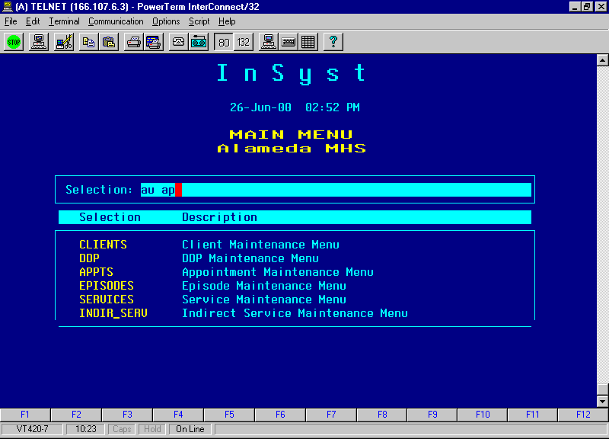

UEnter Plan Approval (TPR)-continued

At UC Approval Screen: Enter Staff #
Enter “A” to approve and “S” to skip .
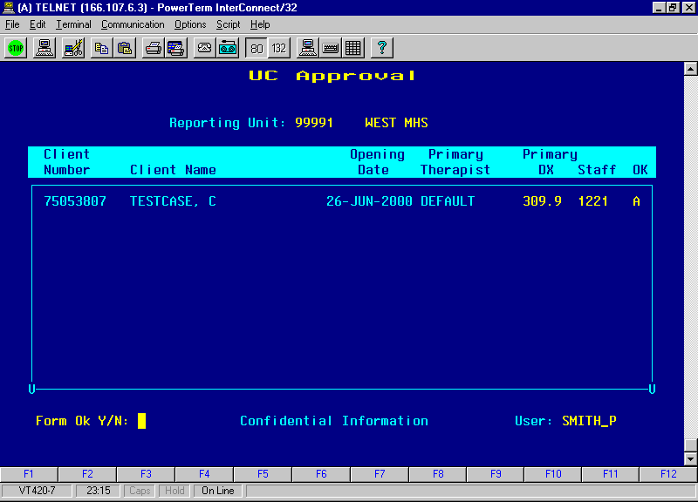
Enter Y and press Return

U
6 Month Review Cycles:
TPR/Chart Reviews are required every six months based on the month of episode opening. Upon completion of the TPR/Chart Review an action is entered in INSYST (Note: the action can be input up to two weeks prior to the end of the cycle):
From Main Menu type “AU MA” press return-

Enter AU MA and press Return
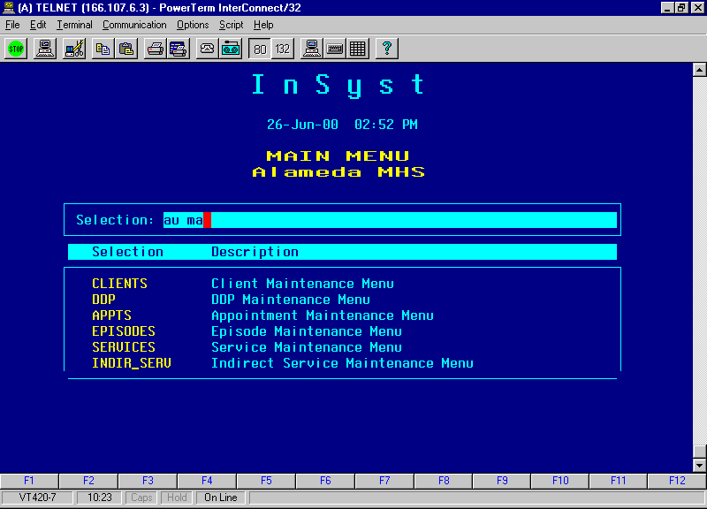

From Utilization Control Maintainence Screen type GOLD I (for insert)-
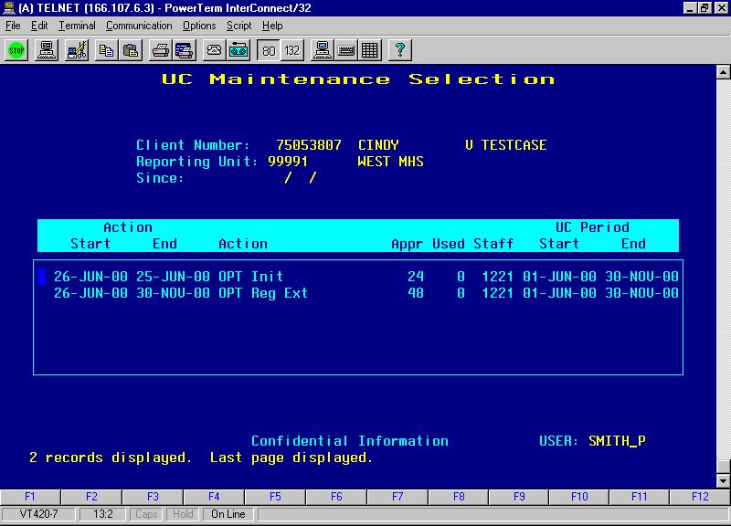

U6 Month Review Cycles:-continuedU

For 6 Month Cycle Reviews done by 1P^{stP} day of new cycle:

At Outpatient UC Entry Screen enter:

Enter Reporting Unit #,
Enter Client #
Enter Effective Date
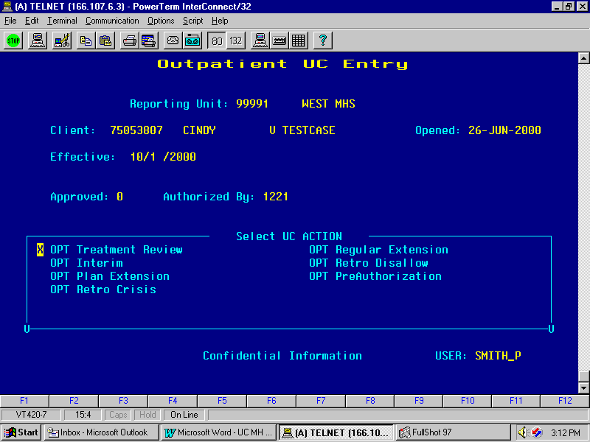
NEW
NEW
ALWAYS enter “0”
Enter approving Clinician #
ALWAYS mark “OPT Treatment Review” with an “X”

U
6 Month Review Cycles:-continuedU

For Late 6 Month Cycle Reviews:

For Cycle Reviews Unot Ucompleted by the 1P^{stP} day of new cycle period, use the date approved by the committee
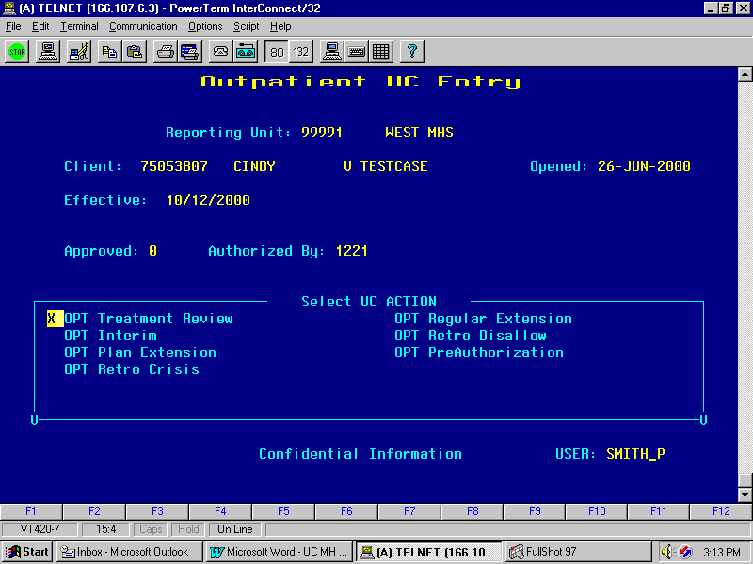
NEW

Appendix A
Special Key Sequences
The Gold key sequences, Control key combinations, and Special Function keys used in InSyst are listed below.

Gold Key Sequences
The Gold Key is the PF1 Key on Digital Equipment Corporation terminals, and is the NumLock key on PCs. Other keys may be used on other terminals.
To use Gold Key sequences, press the Gold Key, release it, then press the next key. For example, if the instructions say you should press Gold-E, it means you should press the Gold key, release it, and then press “E” and release it.
Gold Key sequences used in InSyst are:
- Gold-A: (All / Authorize) gives you additional functions in entry and maintenance screens, such as All Clients/Services, Supervisor Mode and Late Entry Mode.
- Gold-B: (Backup) makes the screen page back one page, to display records in a list that cannot fit on a single screen.
- Gold-C: (Client #) moves the cursor to the Client Number field on some screens.
- Gold-D: (Down Two) makes the screen page forward two pages, to display records in a list that cannot fit on a single screen.
- Gold-E: (Exit) exits from the current screen and returns to the menu, without saving data entered in the screen, or returns to the previous menu.
- Gold-F: (Face Sheet) request the menu to select Face Sheets, then press F6 to complete the request.
- Gold-H: (Home) moves the cursor to its home position on the current screen, the field on the screen where data entry began.
- Gold-I: (Insert) inserts a new record when you are using the Maintenance Selection screens.
- Gold-M: (More) makes the screen page forward one page, to display records in a list that cannot fit on a single screen.
- Gold-R: (Refresh) restarts the screen, with no values entered. This is useful if you made mistakes in data entry.
- Gold-S: (Save and Exit) leaves the current data entry or maintenance screen, and saves the data entered. This sequence retains the current Client and Reporting Unit, so it automatically displays it in the next screen you use.
- Gold-U: (Up Two) makes the screen page back two pages, to display records in a list that cannot fit on a single screen.

Control Key Combinations
To use Control Key combinations, continue holding down the Ctrl Key while you press the next key in the sequence. For example, if the instructions say to press Control/W, you should press the Ctrl Key, keep holding it down while you press “W”, and then release both.
Control Key combinations used in InSyst are:
- Control/H: (Hop Back) moves the cursor back one field.
- Control/J: (Junk) clears a field.
- Control/W: repaints or refreshes the screen. Use it if the screen display has been disturbed.
- Control/Z: ends an editing session in the Mail, Files, and Client Message utilities.

Appendix B
County / State / Country Codes
County Codes
Alameda | 01 | Placer | 31
Alpine | 02 | Plumas | 32
Amador | 03 | Riverside | 33
Butte | 04 | Sacramento | 34
Calaveras | 05 | San Benito | 35
Colusa | 06 | San Bernardino | 36
Contra Costa | 07 | San Diego | 37
Del Norte | 08 | San Francisco | 38
El Dorado | 09 | San Joaquin | 39
Fresno | 10 | San Luis Obispo | 40
Glenn | 11 | San Mateo | 41
Humboldt | 12 | Santa Barbara | 42
Imperial | 13 | Santa Clara | 43
Inyo | 14 | Santa Cruz | 44
Kern | 15 | Shasta | 45
Kings | 16 | Sierra | 46
Lake | 17 | Siskiyou | 47
Lassen | 18 | Solano | 48
Los Angeles | 19 | Sonoma | 49
Madera | 20 | Stanislaus | 50
Marin | 21 | Sutter | 51
Mariposa | 22 | Tehama | 52
Mendocino | 23 | Trinity | 53
Merced | 24 | Tulare | 54
Modoc | 25 | Tuolumne | 55
Mono | 26 | Ventura | 56
Monterey | 27 | Yolo | 57
Napa | 28 | Yuba | 58
Nevada | 29 | Unknown California County | 99
Orange | 30 | Not California County | 00

State Codes
Alabama | AL | Nebraska | NE
Alaska | AK | Nevada | NV
Arizona | AZ | New Hampshire | NH
Arkansas | AR | New Jersey | NJ
California | CA | New Mexico | NM
Colorado | CO | New York | NY
Connecticut | CT | North Carolina | NC
Delaware | DE | North Dakota | ND
District of Columbia | DC | Ohio | OH
Florida | FL | Oklahoma | OK
Georgia | GA | Oregon | OR
Hawaii | HI | Pennsylvania | PA
Idaho | ID | Rhode Island | RI
Illinois | IL | South Carolina | SC
Indiana | IN | South Dakota | SD
Iowa | IA | Tennessee | TN
Kansas | KS | Texas | TX
Kentucky | KY | Utah | UT
Louisiana | LA | Vermont | VT
Maine | ME | Virginia | VA
Maryland | MD | Washington | WA
Massachusetts | MA | West Virginia | WV
Michigan | MI | Wisconsin | WI
Minnesota | MN | Wyoming | WY
Mississippi | MS
Missouri | MO | Unknown State | UN
Montana | MT | Not US State | 00

Country Codes
AFGHANISTAN | AF | CHRISTMAS ISLAND | KT
ALBANIA | AL | CLIPPERTON | IP
ALGERIA | AG | COCOS (KEELING) ISLANDS | CK
AMERICAN SAMOA | AQ | COLOMBIA | CO
ANDORRA | AN | COMOROS | CN
ANGOLA | AO | CONGO | CF
ANGUILLA | AV | COOK ISLANDS | CW
ANTARCTICA | AY | CORAL SEA ISLANDS | CR
ANTIGUA AND BARBUDA | AC | COSTA RICA | CS
ARGENTINA | AR | COTE D'IVOIRE | IV
ARMENIA | AM | CROATIA | HR
ARUBA ISLANDS | AA | CUBA | CU
ASHMORE/CARTIER ISLANDS | AT | CYPRUS | CY
AUSTRALIA | AS | CZECH REPUBLIC | EZ
AUSTRIA | AU | DENMARK | DA
AZERBAIJAN | AJ | DJIBOUTI | DJ
BAHAMAS | BF | DOMINICA | DO
BAHRAIN | BA | DOMINICAN REPUBLIC | DR
BAKER ISLAND | FQ | ECUADOR | EC
BANGLADESH | BG | EGYPT | EG
BARBADOS | BB | EL SALVADOR | ES
BASSAS DA INDIA | BS | EQUATORIAL GUINEA | EK
BELARUS | BO | ERITREA | ER
BELGIUM | BE | ESTONIA | EN
BELIZE | BH | ETHIOPIA | ET
BENIN | BN | EUROPA ISLAND | EU
BERMUDA | BD | FALKLAND ISLANDS/MALVINAS | FK
BHUTAN | BT | FAROE ISLANDS | FO
BOLIVIA | BL | FEDERATED STATES OF MICRONESIA | FM
BOSNIA/HERZEGOVINA | BK | FIJI | FJ
BOTSWANA | BC | FINLAND | FI
BOUVET ISLAND | BV | FRANCE | FR
BRAZIL | BR | FRENCH GUIANA | FG
BRITISH INDIAN OCEAN TERRITORY | IO | FRENCH POLYNESIA | FP
BRITISH VIRGIN ISLANDS | VI | FRENCH SOUTHERN/ANTARCTIC | FS
BRUNEI | BX | GABON | GB
BULGARIA | BU | GAMBIA | GA
BURKINA | UV | GAZA STRIP | GZ
BURMA | BM | GEORGIA | GG
BURUNDI | BY | GERMANY | GM
CAMBODIA | CB | GHANA | GH
CAMEROON | CM | GIBRALTAR | GI
CANADA | CA | GLORIOSO ISLANDS | GO
CAPE VERDE | CV | GREECE | GR
CAYMAN ISLANDS | CJ | GREENLAND | GL
CENTRAL AFRICAN REPUBLIC | CT | GRENADA | GJ
CHAD | CD | GUADELOUPE | GP
CHILE | CI | GUAM | GQ
CHINA | CH | GUATEMALA | GT
GUERNSEY | GK | MALI | ML
GUINEA | GV | MALTA | MT
GUINEA-BISSAU | PU | MAN,ISLE OF | IM
GUYANA | GY | MARSHALL ISLANDS | RM
HAITI | HA | MARTINIQUE | MB
HEARD ISLAND/MCDONALD ISLANDS | HM | MAURITANIA | MR
HONDURAS | HO | MAURITIUS | MP
HONG KONG | HK | MAYOTTE | MF
HOWLAND ISLAND | HQ | MEXICO | MX
HUNGARY | HU | MIDWAY ISLANDS | MQ
ICELAND | IC | MOLDOVA | MD
INDIA | IN | MONACO | MN
INDONESIA | ID | MONGOLIA | MG
IRAN | IR | MONTENEGRO | MW
IRAQ | IZ | MONTSERRAT | MH
IRELAND | EI | MOROCCO | MO
ISRAEL | IS | MOZAMBIQUE | MZ
ITALY | IT | NAMIBIA | WA
JAMAICA | JM | NAURU | NR
JAN MAYEN | JN | NAVASSA ISLAND | BQ
JAPAN | JA | NEPAL | NP
JARVIS ISLAND | DQ | NETHERLANDS | NT
JERSEY | JE | NETHERLANDS | NL
JOHNSTON ATOLL | JQ | NEW CALEDONIA | NC
JORDAN | JO | NEW ZEALAND | NZ
JUAN DE NOVA ISLAND | JU | NICARAGUA | NU
KAZAKHSTAN | KZ | NIGER | NG
KENYA | KE | NIGERIA | NI
KINGMAN REEF | KQ | NIUE | NE
KIRIBATI | KR | NORFOLK ISLAND | NF
KOREA DEMOCRATIC REPUBLIC | KN | NORTHERN MARIANA ISLANDS | CQ
KOREA, REPUBLIC OF | KS | NORWAY | NO
KUWAIT | KU | OMAN | MU
KYRGYZSTAN | KG | PAKISTAN | PK
LAOS | LA | PALAU | PS
LATVIA | LG | PALMYRA ATOLL | LQ
LEBANON | LE | PANAMA | PM
LESOTHO | LT | PAPUA NEW GUINEA | PP
LIBERIA | LI | PARACEL ISLANDS | PF
LIBYA | LY | PARAGUAY | PA
LIECHTENSTEIN | LS | PERU | PE
LITHUANIA | LH | PHILIPPINES | RP
LUXEMBOURG | LU | PITCAIRN ISLANDS | PC
MACAU | MC | POLAND | PL
MACEDONIA | MK | PORTUGAL | PO
MADAGASCAR | MA | PUERTO RICO | RQ
MALAWI | MI | QATAR | QA
MALAYSIA | MY | REUNION | RE
MALDIVES | MV | ROMANIA | RO
RUSSIA | RS | URUGUAY | UY
RWANDA | RW | UZBEKISTAN | UZ
SAN MARINO | SM | VANUATU | NH
SAO TOME AND PRINCIPE | TP | VATICAN CITY | VT
SAUDI ARABIA | SA | VENEZUELA | VE
SENEGAL | SG | VIETNAM | VM
SERBIA | SR | VIRGIN ISLANDS | VQ
SEYCHELLES | SE | WAKE ISLAND | WQ
SIERRA LEONE | SL | WALLIS AND FUTUNA | WF
SINGAPORE | SN | WEST BANK | WE
SLOVAKIASI/SLOVENIA | LO | WESTERN SAHARA | WI
SOLOMAN ISLANDS | BP | WESTERN SAMOA | WS
SOMALIA | SO | YEMEN | YM
SOUTH AFRICA | SF | ZAIRE | CG
SOUTH GEORGIA/SANDWICH ISLANDS | SX | ZAMBIA | ZA
SPAIN | SP | ZIMBABWE | ZI
SPRATLY ISLANDS | PG | Unknown Country | 99
SRI LANKA | CE | COUNTRY NOT LISTED | 00
ST. HELENA | SH
ST. KITTS AND NEVIS | SC
ST. LUCIA | ST
ST. PIERRE AND MIQUELON | SB
ST. VINCENT/THE GRENADINES | VC
SUDAN | SU
SURINAME | NS
SVALBARD | SV
SWAZILAND | WZ
SWEDEN | SW
SWITZERLAND | SZ
SYRIA | SY
TAIWAN | TW
TAJIKISTAN | TI
TANZANIA | TZ
THAILAND | TH
TOGO | TO
TOKELAU | TL
TONGA | TN
TRINIDAD AND TOBAGO | TD
TROMELIN ISLAND | TE
TUNISIA | TS
TURKEY | TU
TURKMENISTAN | TX
TURKS AND CAICOS ISLANDS | TK
TUVALU | TV
UGANDA | UG
UKRAINE | UP
UNITED ARAB EMIRATES | TC
UNITED KINGDOM | UK
UNITED STATES | US

