Alameda County

Behavioral Health Care Services

Insyst

AOD

Mini Manual

BHCS – Information System Support Services

Phone: (510) 567-8181
FAX: (510) 567-8161
E-Mail: ISHelpDesk@acbhcs.org
BHCS Web Site: ACBHCS.ORG/PROVIDERS

Provider Relations (800) 878-1313

Contents

Chapter 1: Getting Started 3

Chapter 2: Basic Client Information 10

Chapter 3: Client Episodes 23

Chapter 4: Direct Services 44

Chapter 5: Utilities (Passwords and Printing) 59

Chapter 6: Reports 64

Appendix A: Special Key Sequences 77

10/25/2006

Chapter 1
Getting Started
This chapter includes basic instructions for logging on and using InSyst’s menus and screens.

Logging Onto the Computer
You must log onto the VAX computer system before beginning work.

To log onto the computer:
1. If you are using a terminal, press Return. If you are using a personal computer, start the terminal emulation program by selecting the INSYST1 or INSYST2 Icon on your Windows Desktop.
2. Your screen displays the prompt: USERNAME: Type your Username, and press Return.
3. Then the computer prompts you for your password. Type your password and press Return. To protect its secrecy, your password is not displayed on your screen.
4. InSyst displays its Logo and any notices or messages. Press Return to display your Main Menu.

Using Gold and Control Keys
When you work with InSyst, you often have to use Gold Key sequences and Control Key combinations.
The Gold Key is the PF1 Key on Digital Equipment Corporation terminals, and the NumLock key on PCs. Other keys may be used on other terminals.

To use a Gold Key sequence:
1. Press and release the Gold Key.
2. Press and release the other key in the sequence.
For example, if the instructions say, “Press Gold-E”, you should press and release the Gold key, and then and release press “E”.

To use a Control Key combination:
1. Press the Ctrl key and hold it down.
2. Press and release the other key.
For example, if the instructions say, “Press Control/H”, you should press the Ctrl key and hold it down while you press and release “H”.
Appendix A lists all Gold Key sequences and Control Key combinations.

Using Menus
An InSyst menu is a list of items that you may select. Figure 1.1 is shows a sample Main Menu. The Main Menu is different based on data input requirements. Below is an example of a Opening Main Menu for user who is entering data for both Mental Health Services and Alcohol and Other Drugs Services. Most users don’t have this menu option.
Figure 1.1: Main Menu
The menu structure is virtually the same for the MHS and the DAS systems. Some screens are different for the two systems, and this manual will explain both. The MHS Main Menu is shown in Figure 1.2.
After you make a selection from the Main Menu, the system displays a submenu. For example, if you choose UTILITIES in the Main Menu, you will move to the Utilities Menu, with options that you select to use InSyst utilities.
- Note: Based on your User Authorization all menu options may not be activated.
Figure 1.2: MHS Main Menu
All InSyst menus let you make selections in three ways: by using the list of options in the menu selection area, or by typing an alpha or numeric option directly in the command line.

To select a command in the Menu Selection Area:
- Press the Tab key and the blinking cursor will move from the Command Line into the list of items in the Menu Selection Area of the screen. Then move the cursor up and down through the menu using the Up and Down Arrow keys.
- When you have moved the cursor to the item you want, type “X” and press Return.
At the bottom corners of the Menu Selection Area there is often a flashing “V.” This indicates that there are more items on your menu than you can see at one time. Press the Down Arrow key and the menu will scroll to display more items.
If you want to return to the Command Line, press Enter.

To select an item from the Command Line:
1. Type the name or number of the item on the Command Line. The command line is the solid bar next to the word Selection, where the cursor is when you first display the menu. You may type the entire name of the item, or just enough make it distinct from the others. For example, if you want to choose SERVICES from the Main Menu, you may type either “SERVICES” or “SER”. You may also type the number of the selection. For example, if Client Records Maintenance is the first item on the menu, you can just type “1” to select it.
2. Press Return to display the screen or sub-menu you selected.

Leaving a Menu
Press Gold-E, or enter a hyphen (-) in the Command line to move back one menu to the previous menu. For example, if you are on the Files Menu, “-” will take you back to the Utilities Menu, and a second “-” will take you back to the Main Menu.

Menu Shortcuts
You can go directly from one menu to a screen that is under another menu, rather than moving through the menu system one menu at a time. In the command line of the current menu, enter the Menu names that you would normally enter in the command lines of one menu after another.
For example, to go from the Main Menu to the Episode Opening screen, you normally enter “EP” in the Main Menu to display the Episode Records Menu, and then enter “OP” to display the screen. As a shortcut, you can enter the command “EP OP” in the Main Menu command line (Figure 1.3).
Figure 1.3: Using Menu Shortcuts

Using Screens
InSyst’s menu system displays the data screens (Figure 1.4) that let you enter, look up, change and delete information.
In Screens, data is entered or displayed in areas called fields. For example, a screen may have a field for a client’s last name and another field for address. Most screens have special fields, called key fields, that identify each record, such as the client number field that identifies each client.
Each screen has a different function—e.g., to register a client, review a client’s account, or update episode information. Screens are assigned to you based on your responsibilities.

Figure 1.4: An InSyst Screen with a List
Here, we will look at the basic keys you must use with screens. For more information on special key sequences, see Appendix A.

Moving through Fields
Use these keys to move through a screen’s fields:
- Tab: Move the cursor to the next field to enter data. (If you fill a field entirely, the cursor will move to the next field automatically).
- Control/H: (F12) Move the cursor back one field.
- Return: Skip over optional fields and move to the next required field or to the prompt used to leave the screen.

Moving Through Lists
Many screens have lists, like the list of insurance companies shown in Figure 1.4 above. To move down one item in the list, press the Tab or Down Arrow key. To move up one item in the list, press the Up Arrow key.
If a list has more items than fit in one screen, you can page through it to see more items by pressing:
- Gold-M: (More) View the next page of information.
- Gold-D: (Down Two) Go forward two pages.
- Gold-B: (Backup) View the previous page of information.
- Gold-U: (Up Two) Go back two pages of information.
To speed up performance, lists usually include only two pages of information by default. If you have to see more items than this, you should request unlimited paging by pressing Gold-A before you display the list.

Leaving a Screen
To leave a screen, press:
- Return: In most cases, pressing Return moves the cursor to the prompt used to leave the screen. (In some cases, Return skips over optional fields to the next required field.)
- Gold-E: Exits from the current screen and returns to the menu, without saving data entered in the screen.
- Gold-S: Exits from the current screen, and saves the data entered. This sequence retains the current Client and Reporting Unit, so it automatically displays it in the next screen you use.

Client Confidentiality
InSyst helps your staff in maintain confidentiality, as required by federal, state, and local regulations.
Do not let anyone else use your account. You username is stamped on some records in the database.
Each registered user has a password. Do not give out your password for use by other staff or post it near your terminal.
Do not browse through records looking for friends, acquaintances or known persons. This is illegal. You must have a legitimate purpose for looking-up a person.
Do not release data without authorization. For more information, consult your Medical Records Department.

Logging Off the Computer
To log out of InSyst, enter the word “Exit” on the command line of any menu.

Never turn off your terminal until you have seen a message confirming that you are logged off. The message includes your name, the date and time that you log off the computer.

Chapter 2
Basic Client Information

The Client Number
Before you can work with any client information, the client must have a client number. If a client is new to your program, you must determine whether the client has a number, by using the Client Locator screen, described below. If you cannot find the client number, assign a new client number using the Client Registration Screen, described later in this chapter.

Locating Clients
The Client Locator Screen lets you find out if someone has ever been a client and lets you display information about clients

To use the Client Locator Screen:
1. Choose CLIENTS from the Main Menu.
2. Choose LOCATOR from the Client Maintenance menu to display the Client Locator screen (Figure 2.1).

Figure 2.1: Client Locator Screen

Client Information Area
The top section of the screen is the Client Information Area, where you enter criteria to search for a client, and where information is displayed when the client is found.

To search for a client:
1. Make an entry in one or more fields of the Client Information Area.
2. Press Return at any time to search for a client matching the information you have entered.
The Client Information Area has the following fields:
- Client Name: Enter the client’s full name or only the first few letters of the client’s name. For example, if you enter “And” as the last name, you will find clients with the names Anders, Anderson, Andrews, etc.
- Client Number: If you know the Client Number, the fastest way to look up the client is to press Gold-C to move to the Client Number field and enter the client’s number.
- Social Security Number: If you do not have a Client Number, the Social Security Number is the fastest way to find the client. If you have the client’s Social Security Number, press the Tab key to skip the other fields and enter the SSN here. You do not need to enter “-” between the numbers.
- Note: If you enter the Social Security Number and Client Name, the computer searches on the Social Security Number and returns the client information if it finds a match. This may not be the client name you have entered, if another client has used that Social Security Number. If there is no match on Social Security Number, the search is based on name.
If there is an exact match, all fields on the top half of the screen are filled with information about the client (Figure 2.2).
If there is no match, the system displays the message: Client/Clients not found.
If there are several possible matches, they are listed in the Client Selection Area of the screen, described below.
Figure 2.2: An Exact Match in the Client Information Area

Client Selection Area
The second section of the screen is the Client Selection Area. If there is more than one possible match, records beginning with the first possible match are listed alphabetically here (Figure 2.3).

To use the Client Selection Area:
1. Move through the list using the methods described in the section on Moving Through Lists in Chapter 1.
Figure 2.3: Possible Matches in the Client Selection Area
2. Type “X” next to the client you want, and press Return. Data on that client is displayed in the Client Information Area.
You can select multiple clients on a page by putting “X” next to each, and then pressing Return. Then you display data on them by using the Previous and Next options in the Menu Selection Area (described below).
Aliases are displayed in the Client Selection Box with an asterisk (*) next to the name. They are selected like other names in the list, but the computer displays the client’s real name in the Client Information Area.
If you find the target client in this list, note the client number, so you can use it to work with the client. If you do not find the target client, you must register the client into the system.
- Note: Before registering a new client, be sure you have tried all possible spellings of the client’s name and aliases. Press Gold-R to restart the screen and search with other spellings of the client’s name. If necessary, press Gold-A before doing the new search, so the list is not limited to 8 names.

Menu Selection Area
The lowest portion of the Locator screen is the Menu Selection Area, where you can enter commands to find more information on the client who is displayed in the Client Information Area.
As with any InSyst menu, you may select a menu item by entering the first letters of your menu choice (For Example, Figure 2.4 illustrates the choice of “E” for Episodes), or by using Tab key to move to the item you want and typing an “X” next to it.
Figure 2.4: Selecting a Menu Item
The menu gives you the following options:
- EPISODE Mini Open Episode Status: Gives you a short listing of all programs (or reporting units) at where the client is currently admitted.
- FINANCIAL Mini Financial Status: Displays current account information and charges for the client.
- STATUS Client Status Summary Report: Takes you to the Client Status Summary Report Screen, which displays the client’s current open episodes, closed crisis episodes, and current account information.
- NEXT Display Next Client: If you selected multiple clients in the Client Selection Area, this option will display data on the next one in the Client Information Area.
- PREVIOUS Display Previous Client: If you selected multiple clients in the Client Selection Area, this option will display data on the previous one in the Client Information Area.
Some of these options display data in the same area that you used for client selection, as you can see in Figure 2.4, where message status is displayed there.

Registering a New Client
If you cannot find new clients using the Client Locator Screen, you must register them to give them client numbers before you can open episodes and enter services for them.

To register a client:
1. Choose CLIENTS from the Main Menu.
2. Choose REGISTER from the Client Maintenance Menu to display the Client Registration screen (Figure 2.5). 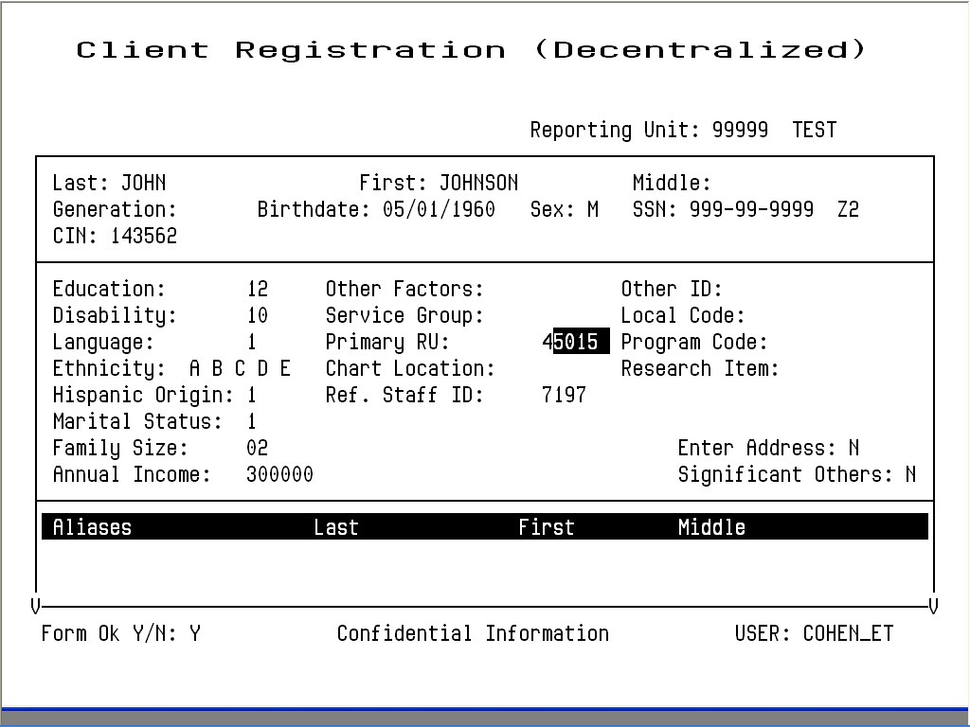
Figure 2.5: Client Registration Screen
- Note: Because the information entered in the Client Registration screen establishes the client’s identity, it is best to ask the client for a Driver’s License, Social Security Card, or other document and copy the information from it. Three critical pieces of information must be entered correctly: client name, birth date, and Social Security Number.
3. Enter data in the following fields:
- RU: Enter the Reporting Unit Number for the program where you are registering the client. This field establishes whether you are using decentralized or centralized registration. With decentralized registration, the system automatically assigns a client number and you can enter episodes and services for the client. With centralized registration, you can register a client and enter episodes, but you cannot to enter services until the registration has been evaluated by a central registration auditor. After you have entered the Reporting Unit, the screen title changes to Client Registration (Centralized) or Client Registration (Decentralized).
- Last Name: Enter a last name with up to 16 letters. Leave out apostrophes, dashes and blank spaces. For example “O’Connor” should be typed “OCONNOR”.
- First Name: Enter a first name with up to 12 letters.
- Middle Initial: Enter one letter as a middle initial, or press the Tab key or space bar to skip this field if there is no middle initial.
- Client Generation: Enter a generation title that is part of the client’s name, such as Jr., Sr., or the Roman Numerals II, III, etc.
- Birthdate: Enter the birth date in MM/DD/YYYY format.
- Sex: Enter “F” for female, “M” for male, or “U” for unknown, or “Z3” for other
- Social Security Number: Enter a nine-digit Social Security Number. It is best to copy this key information directly from the client’s Social Security Card if possible. If the client does not have one, enter all 9’s in this field. Enter “Z0”, “Z2” or “Z4” in the field to the left of SSN, if Social Security Number is all 9’s.
- Client Index Number: Enter a nine-digit Client Index Number.
- Education Enter the number of the highest grade completed. For example, if the client has completed high school, enter “12”. If the highest grade is greater than 20, enter “20”. Enter “Z0” or “Z4” if client declined to state or unable to answer.
- Disability Add the number codes for all of the client’s physical disabilities, and enter the total in this field. InSyst’s standard disability codes are listed in Appendix C of this manual, but your local agency may use different codes. Add the number codes for all of the client’s physical disabilities, and enter the total in this field. Enter “Z0” or “Z4” if client declined to state or unable to answer.
- Language Enter the code for the language the client prefers to speak, as reported by the client. InSyst’s standard language codes are listed in Appendix C of this manual, but your local agency may use different codes.
- Ethnicity Enter up to five (5) Ethnicity codes. The codes are listed on the back of the Client Registration form.
- Hispanic Origin
- Marital Status: Enter the Marital Status code. InSyst’s standard codes are listed in Appendix C, but your agency may use different codes. (Note that Code 1, Never Married, is used for a single person who does not live with girlfriend/boyfriend and has never been married.)
- Enter Address: This is not a data field; it is a question. The system is defaulted with “Y”, the system will jump to the Address Screen, described later in this chapter. Once you are done with that screen, the system will return you to the Registration Screen.
- Enter Significant Other This is not a data field; it is a question. The system is defaulted with “N”, the system will jump to the Significant Other Screen when set to “Y”, described later in this chapter. Once you are done with that screen, the system will return you to the Registration Screen.
- Aliases: If the client has ever used aliases, enter them here. As you add information, this section of the screen scrolls upward to allow more information to be entered. You may enter up to six aliases via the Client Registration Screen, and enter more through the Client Maintenance screen if necessary.
Birth Last Name: Enter a last name with up to 16 letters. Leave out apostrophes, dashes and blank spaces. For example “O’Connor” should be typed “OCONNOR”.
Birth First Name: Enter a first name with up to 12 letters or enter “Z2”.
Birth_County: Enter clients’s birth county or “Z3”.
Birth_State: Enter clients’s birth state or “Z3”.
Mother’s First Name: Enter a first name with up to 12 letters.
Driver’s license Number: Enter client’s driver’s license number or “Z0”, “Z2”, “Z4”.
Driver’s license State: Enter client’s driver’s license state or “Z0”, “Z2”, “Z4”.
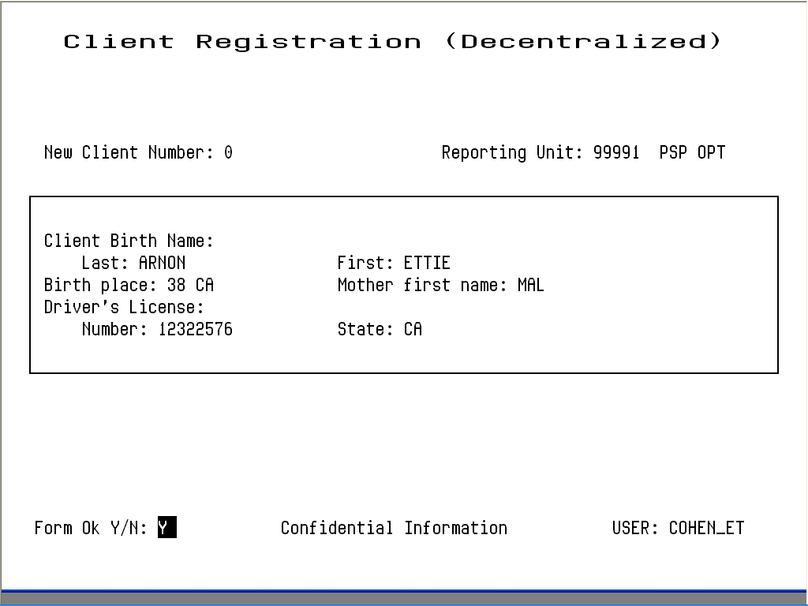
Figure 2.6: Client Registration Screen after Registering a Client

Error Messages
If there is a Social Security Number in the system that is the same as the one you just entered, it displays an error message and it does not let you continue. If you’re sure that the number you have entered is correct, refer the case to your supervisor.
If there is a client in the system with the same name and birth date you have just entered, it displays an error message and does not let you continue. Refer the case to your supervisor.
If two different clients do have the exact same name and birth date, a supervisor may use the Gold-A sequence to override the match, so registration can occur. You cannot override a Social Security Number match.

Maintaining Client Records

To maintain client records:
1. Choose CLIENTS from the Main menu.
2. Choose MANAGEMENT from the Client Maintenance Menu to display the Client Maintenance Screen (Figure 2.7).
3. Use the fields at the top of the screen to identify the client and maintenance type:
- Client Number: Enter the number of the client whose record you want.
- Maintenance Type: If the client number is valid, you can enter the Maintenance Type “L” (for Lookup) or “U” (for Update).
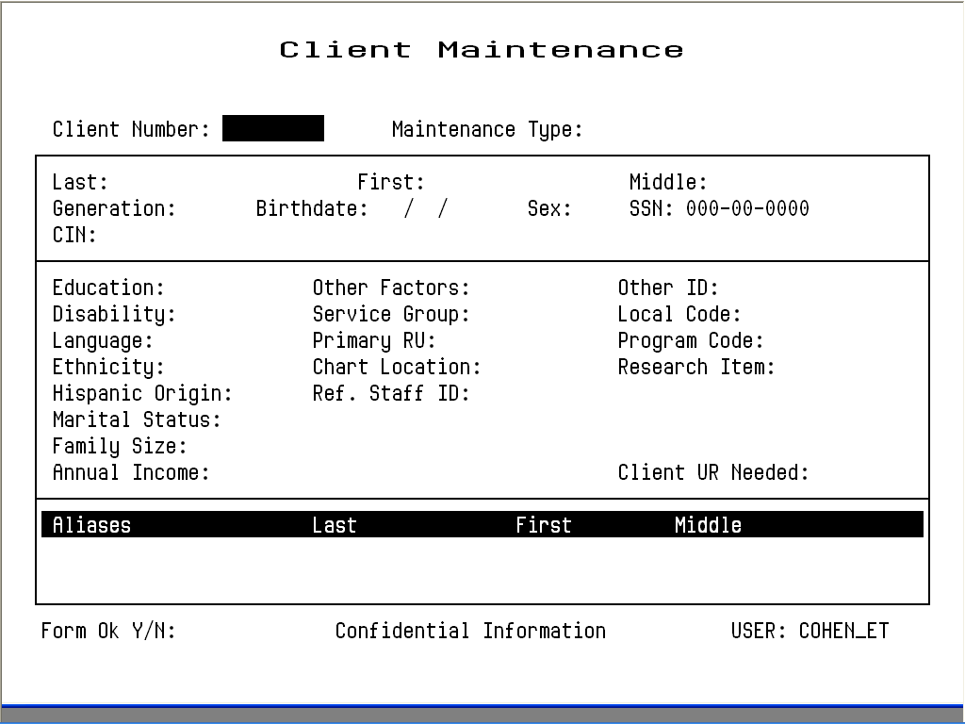
Figure 2.7: Client Maintenance Screen

Client Lookup
If you enter “L”, InSyst displays the Client Lookup Screen (Figure 2.8). This screen only lets you view information, and so it can be used by people who are not authorized to change client information. 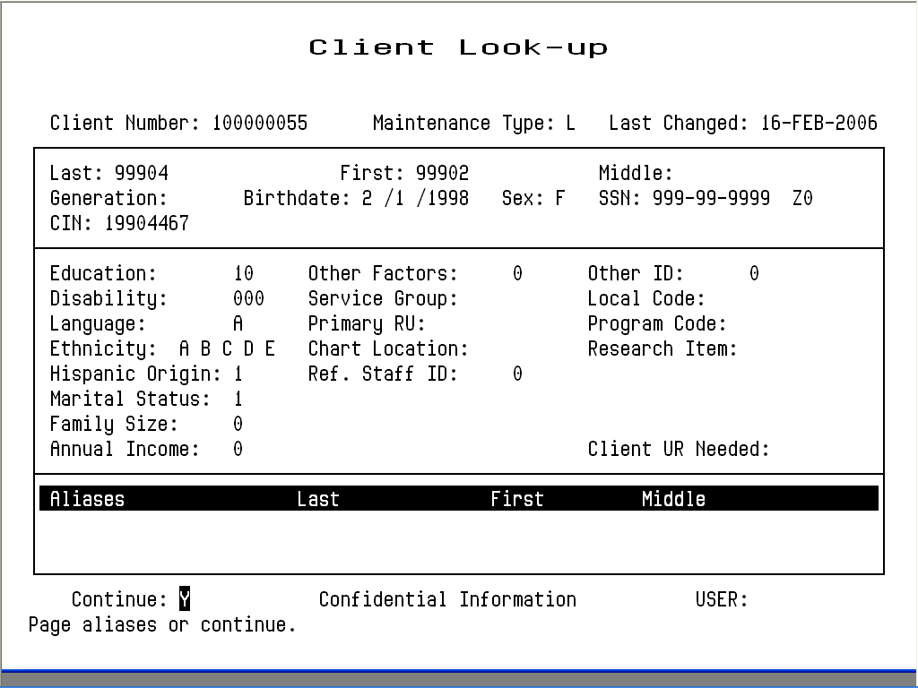
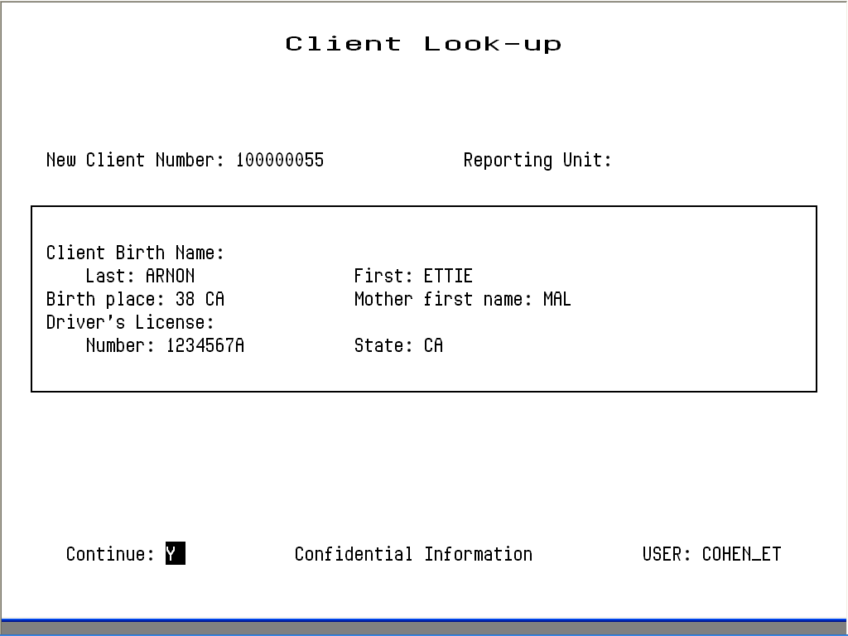
Figure 2.8: Client Look-up Screen
If the client has aliases listed, you may use Gold key sequences to page through them, as described in the section on Moving Through Lists in Chapter 1.
When you are done, enter “Y” to continue looking up more clients, or press Gold-S to leave the Maintenance Screen and save the client number, so it is entered automatically in the next screen you use.

Client Update
If you enter “U”, InSyst displays the Client Update Screen (Figure 2.10).

To modify client data:
1. Press Tab to move through the fields, and edit them as necessary.
2. Tab to the Form OK prompt, and enter “Y” to save the changes, or “N” to discard them.
The data in all these fields was described in the section on the Client Registration Screen, earlier in this chapter.
The Client Number cannot be changed.

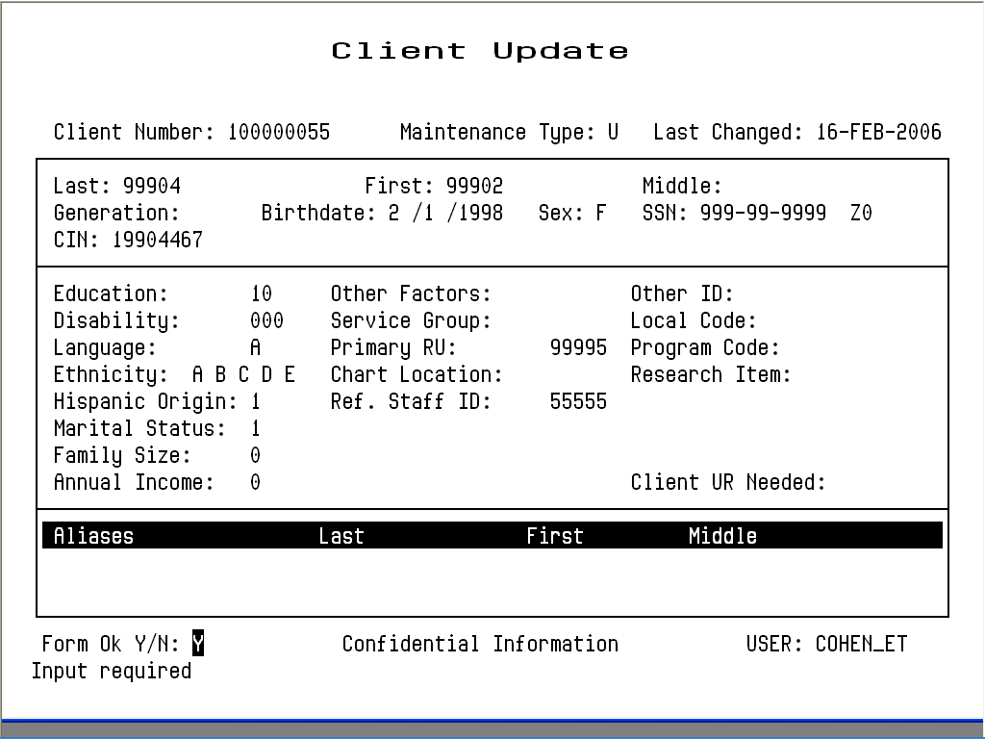
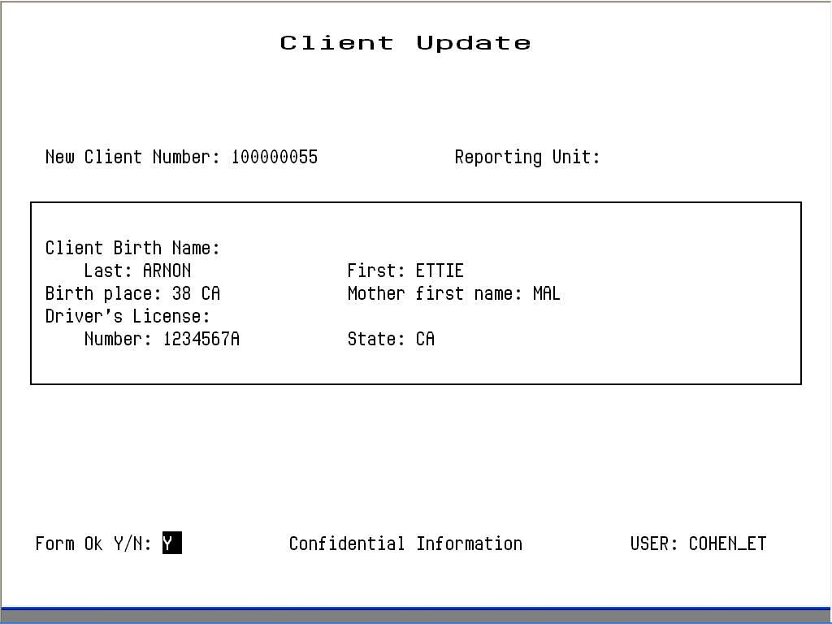
Figure 2.10: Client Update Screen
The Registration Approved field only applies to systems using centralized registration, and it can only be changed by the Central Registrar. The Client UR Needed field can only be changed by authorized staff.
Aliases cannot be changed, but any user can add new aliases or can delete an alias by entering “D” on its line.
Client Last Name, First Name, Middle Initial, Social Security Number, Birthdate, Sex can only be changed by a Supervisor. If you are authorized as a supervisor, you can press Gold-A to display the Client Update Screen in Supervisor mode (Figure 2.11).

Entering a New Client Address
Any authorized user can enter a new address for a client with an open episode.

To enter a new address:
1. Choose ADDRESS from the Client Maintenance Menu to display the Address Maintenance Selection Screen, as described above.
2. Press Gold-I (I stands for Insert) to display the Client Address Insert Screen (Figure 2.15).
3. Enter data in the following fields:
- Client Number: Enter the number for the client whose address you want to enter. If you are already viewing a list of the client’s addresses when you press Gold-I, the Client Number is entered automatically.
- Reporting Unit: Enter the Reporting Unit Number for the program that has an open episode for the client. The Effective Date of the address you are entering must fall within this episode.
- Effective Date: By default, the Effective Date is today’s date. Only Supervisors can alter it.
- Street Number: Enter a street number with up to five (5) digits.
- Street Direction: If the address has one, enter a street direction, such as “N”, “NE”, “E”, “SE”, “S”, “SW”, “W”, “NW”.
Figure 2.15: Client Address Insert Screen
- Street Name: Enter a street name with up to twenty characters. (Do not enter “Street”, “Road”, or other street type here.)
- Street Type: Enter an abbreviation for the street type, such as “St”, “Bl”, “Rd.”, “Av”.
- Apartment: Enter up to four characters. Do not enter the symbol “#”, and do not enter a period at the end.
- City: Enter a city name with up to twenty characters.
- State: Enter the two letter abbreviation for the state name.
- Zip Code: Enter the first five numbers of the Zip Code, and the cursor moves to the plus-four digits, which you can enter if available.
- CalOMS Zip Code: Enter “XXXXX” or “ZZZZZ” if Zip Code is all 9’s.
- Phone Number: Enter the telephone number, if available. If you do not want to enter the Area Code, you must type three blank spaces in its place.
- Extension: Enter an extension for the telephone number, if there is one.
- County of Responsibility: If you do not make an entry here, InSyst will use your county’s code when it reports to state client data systems. To report to the state that another county is responsible, enter the two-digit county code in this field. (This section is generally used by California Mental Health Programs.)
4. Enter “Y” at the Form OK prompt to validate and save the data.

Chapter 3
Client Episodes
An Episode is a period of treatment for a client at a program. Before you can enter services for a client, there must be an open Episode for the client in the program providing the service.

Opening New Episodes, Substance Abuse Programs
Before services for a client can be entered into the system, an Episode must be opened.

To open an episode:
1. Choose EPISODES from the Main Menu.
2. Choose OPEN from the Episode Maintenance Menu to display Panel 1 of the Episode Opening Screen (Figure 4.14).

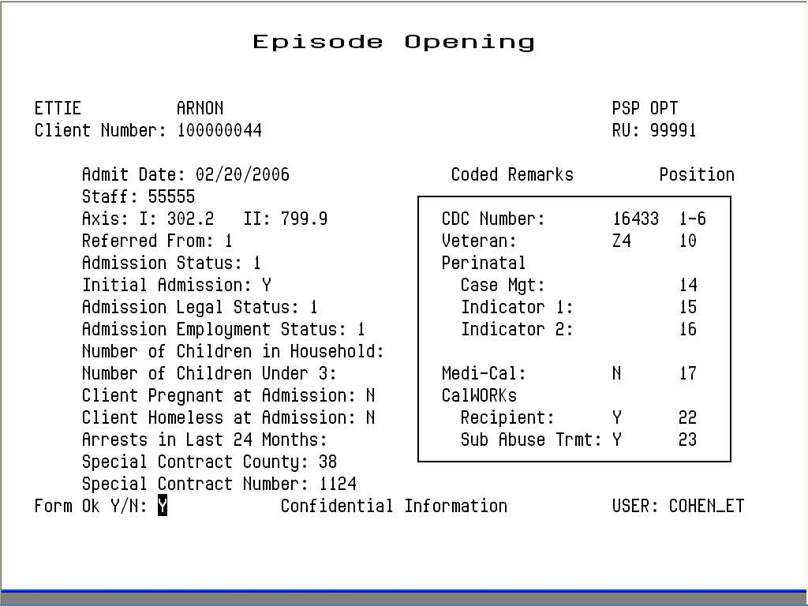
Figure 4.14: Episode Opening Screen, Panel One
3. Use the fields at the top of this panel to identify the record:
- Reporting Unit: Enter the reporting unit number for your program.
- Client Number: Enter the client number. If necessary, use the Client Locator Screen, described in Chapter 2, to find the correct client number.
4. The system does not let you open an episode, if the client already has an open episode at this reporting unit. After the identifying fields are validated, you enter data in the following fields:
- Admit Date: Enter the admission date. The current date is the default. You cannot enter future dates or dates when the program is not open.
- Staff: Enter the primary staff identification number.
- Diagnosis I and II: Enter codes for the primary and secondary diagnoses. The default for Diagnosis II is No Diagnosis, code 799.9. See the back of the Episode form for the most common codes.
- Referred From: Enter the referral code. You can enter a Reporting Unit number, an Agency Code, or a generic code to indicate self or other or a type of local agency. Ask your system manager about these codes.
- Admission Status Enter the client’s Admission Status using the codes in Table 4.3. (Categories 2 through 6 are considered Co-Dependents.)
Code | Meaning
1 | Substance Abuser
2 | Spouse of Substance Abuser
3 | Adult Child of Substance Abuser
4 | Minor Child of Substance Abuser
5 | Parent of Substance Abuser
6 | Other Co-Dependent of Substance Abuser
Table 4.3: Admission Status Codes
- Initial Admission: If this is the first time the client has ever been to a Substance Abuse program, enter “Y”. If this is a transfer from another program, enter “N”.
- Admission Legal Status: Enter the client’s legal status, using the codes in Table 4.4.
- Employment Status: Enter the client’s current employment status. Ask your system manager for a list of these codes.
- Client Is Currently Pregnant: Enter “Y” or “N” to indicate whether the client is pregnant. Enter “N” if the client is male.
- Client Is Homeless At Admission: Enter “Y” or “N” to indicate whether the client is homeless.
- # of Arrests in Last 24 Months: Enter the number of times the client has been arrested in the last twenty-four months.

- Special Contract County: Enter CalOMS Special Contract County or enter “Z2”.
- Special Contract Number: Enter the CalOMS Special Contract Number assigned by the state, if applicable or enter “Z2”.
- Coded Remarks:
- CDC Number: Enter the client’s California Department of Correction identification number or enter ”Z0”, “Z1”, “Z2” or “Z4”.
- Veteran: Enter “Y” if client is a U.S. veteran, “N” if not or enter “Z0” or “Z4”.
- Medi-cal Beneficiary: Enter “Y” if client is Medical Beneficiary, “N” if not or enter “Z4”.
- CalWORKs Recipient: Enter “Y” if client is CalWORKs recipient, “N” if not or enter “Z1”.
- CalWORKs Sub Abuse Treatment: Enter “Y” if client is undergoing substance abuse treatment under CalWORKs, “N” if not or enter “Z1”.
- # of Prior Admits to any substance abuse treatment program: Enter a number from 0 to 9. If the client has been admitted to programs more than nine times, enter 9.
- Medication Prescribed: Enter the medication prescribed to this client. The codes are 1 = None, 2 = Methadone or LAAM, 3 = Other.
- Has This Client Used Needles During the Past Year: If the primary or secondary route of administration is by injection with a frequency of use Used in Past Year, you should answer this “Yes”.
- Problem - Primary, Secondary, Tertiary: Enter the Primary, Secondary and Tertiary Problems, using the Substance Problem codes shown on the back of the Episode Opening/Closing/Annual Update forms or enter “Z1” or “Z3” (for Primary and Secondary only). For clients admitted for methadone treatment, the Primary Drug should be 01 or 15. You must use a different code for each problem. Secondary and Tertiary fields may be left blank. Validation of Primary and Secondary problems against tables Primary_Problem_Master and Secondary_Problem_Master.
- Drug Name - Primary, Secondary : Enter the Primary and Secondary drug name.
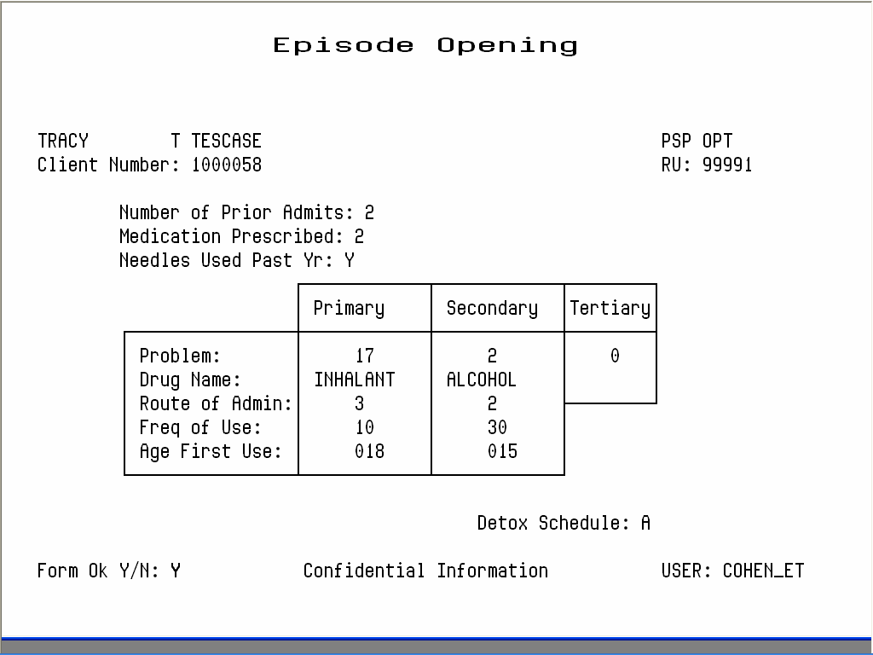

Figure 4.15: Episode Opening Screen, Panel Two
Table 4.5: Substance Problem Codes
- Route of Administration - Primary & Secondary: Enter the method that the client uses to administer the substances entered as Primary and Secondary Problems, using the codes shown in Table 4.6.
Code | Meaning
1 | Oral
2 | Smoking
3 | Inhalant
4 | Injection (IV or intramuscular)
5 | Other/Unknown
Table 4.6: Route of Administration Codes
- Frequency of Use - Primary and Secondary: Enter the frequency of use for the substances. Allowed value 0 – 30 or “Z2”. This field requires leading zeroes.
- Age of First Use - Primary & Secondary: Enter the age when the client first used the substances entered as the Primary and Secondary Problem. The age must be at least 5 years. This field requires leading zeroes.
- Emergency Methadone Admission: For Methadone Maintenance clients only, enter “Y” or “N” to indicate whether the client is being admitted as an exemption to methadone regulations. That is, the client would not be eligible for admission under the regular Title 9 criteria which specify a two year history of addiction and 2 prior treatment failures.
- Detox Schedule: For Methadone Maintenance clients only, enter a the number, 1 through 4, for the client’s detox schedule, as defined by the program or county.
For heroin detoxification programs, if a client has been open within 90 days preceding the opening date, the system will display an error message saying “Detox Hold”. Only someone with supervisor authorization for Episodes may override this (by pressing Gold-A after entering the reporting unit and client number).
- Alcohol Frequency: Enter the number of days the client has used alcohol in the past 30 days. Allowed value is 0 – 30 or “Z2”. This field requires leading zeroes.
- IV Use: Enter the number of days in which the client has injected in the past 30 days. Allowed value is 0 – 30 or “Z0”, “Z4”. This field requires leading zeroes.
- Paid Days Work: Enter the number of days the client has been paid for working in the past 30 days. Allowed value is 0 – 30 or “Z0”, “Z4”. This field requires leading zeroes.
- Number of Arrests: Enter the number of days the client has been arrested in the past 30 days. Allowed value is 0 – 30 or “Z4”. This field requires leading zeroes.
- Days in Jail: Enter the number of days the client has been in jail in the past 30 days. Allowed value is 0 – 30 or “Z4”. This field requires leading zeroes.
- Days in Prison: Enter the number of days the client has been in prison in the past 30 days. Allowed value is 0 – 30 or “Z4”. This field requires leading zeroes.
- Days of 12 Steps/Other: Enter the number of days the client has participated in the following social support activities in the past 30 days.
12 -Step Meetings
Other Self Help Meetings
Religious /Faith Recovery or Self-Help Meetings
Attending Meetings of organizations other than those listed above
Interactions with Family Member and/or Friend Support of Recovery
Allowed value is 0 – 30. This field requires leading zeroes.
- Days Living with Substance User: Enter the number of days the client has lived with someone who uses alcohol or drugs in the past 30 days. Allowed value is 0 – 30 or “Z0”, “Z4”. This field requires leading zeroes.
- Conflict Days with Family: Enter the number of days the client has had a serious conflicts with family in the past 30 days. Allowed value is 0 – 30 or “Z0”, “Z4”. This field requires leading zeroes.
- Emergency Room Visits: Enter the number of days the client has used the emergency room for physical health problem in the past 30 days. Allowed value is 0 – 99 or “Z4”. This field requires leading zeroes.
- Hospital Overnights: Enter the number of days in the client has stayed overnight in a hospital for physical health problem in the past 30 days. Allowed value is 0 – 30 or “Z4”. This field requires leading zeroes.
- Days of Physical Problem: Enter the number of days in the client has experienced physical health problem in the past 30 days. Allowed value is 0 – 30 or “Z4”. This field requires leading zeroes.
- Outpatient Emergency Services: Enter the number of days in the client has received outpatient emergency services for mental health needs in the past 30 days. Allowed value is 0 – 99 or “Z4”. This field requires leading zeroes.
- Hospital/Psychiatric Facility Visits: Enter the number of days in the client has stayed form more than 24 hours in a hospital or psychiatric facility for mental health needs in the past 30 days. Allowed value is 0 – 30 or “Z4”. This field requires leading zeroes.
- Prescribed Medication Taken: Has the client taken prescribed medication for mental health needs in the past 30 days? Enter Y, N or “Z4”.

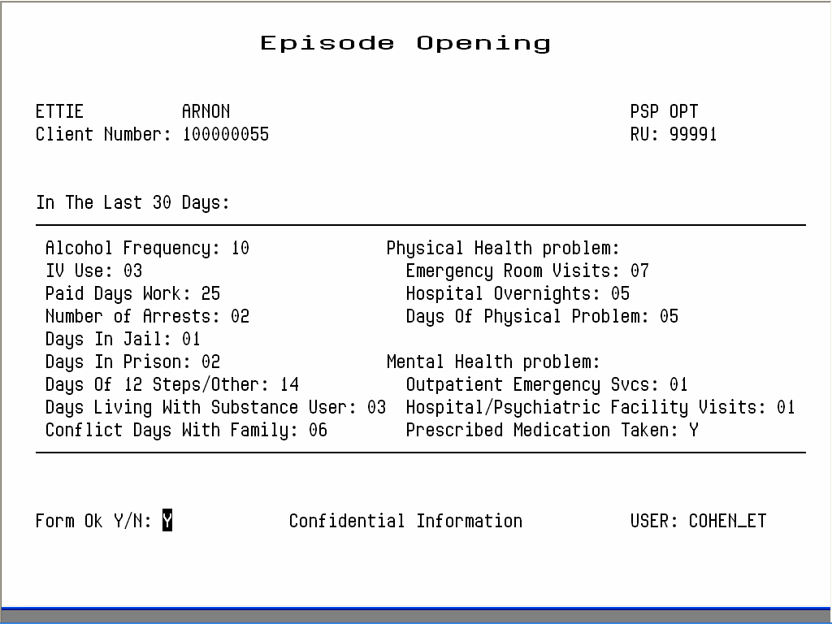
Figure 4.16 Episode Opening Screen, Panel 3

- Consent for Future Contact: Is there a consent form allowing future possible contact signed by the client on file within your agency? Enter Y or N.
- Treatment Waiting Days: Enter the number of days the client has been on a waiting list before being admitted to this treatment program. Enter a value between 0 – 999 or “Z1”, “Z4”. This field requires leading zeroes.
- Enrolled in Job Training: Is the client currently enrolled in a job training program? Enter Y, N or “Z0”, “Z4”.
- Enrolled in School: Is the client currently enrolled in school. Enter Y, N or “Z0”, “Z4”.
- Diagnosed with Tuberculosis: Has the client been diagnosed with Tuberculosis? Enter Y, N or “Z0”, “Z4”.
- Diagnosed with Hepatitis C: Has the client been diagnosed with Hepatitis C? Enter Y, N or “Z0”, “Z4”.
- Diagnosed with sexually Transmitted Disease: Has the client been diagnosed with a sexually transmitted disease? Enter Y, N or “Z0”, “Z4”.
- Hiv/Aids Tested: Has the client been tested for HIV/AIDS? Enter Y, N or “Z0”, “Z4”.
- Hiv/Aids Result: Does the client have the result of the HIV/AIDS test? Enter Y, N or “Z0”, “Z4”.
- Prior Mh Diagnosis: Has the client ever been diagnosed with mental illness? Enter Y, N or “Z1”.
- Children Aged 17 or Less: Enter the number of children the client has, aged 17 or less. Allowed value is 0 – 30 or “Z4”. This field requires leading zeroes.
- Children Aged 5 or Less: Enter the number of children the client has, aged 5 or less. Allowed value is 0 – 30 or “Z4”. This field requires leading zeroes.
- Children in CPS Placement: Enter the number of children the client has who are living with someone else due to child protection court order. Allowed value is 0 – 30 or “Z4”. This field requires leading zeroes.
- Children in Placement with no Parental Rights: Enter the number of children the client has who are living with someone else due to child protection court order AND for whom the client’s parental rights have been terminated. Allowed value is 0 – 30 or “Z4”. This field requires leading zeroes.
- Parolee Services Network: Enter “Y” if client is a parolee in the Parolee Services Network, “N” if not or enter “Z4”.
- FOTP Parolee: Enter “Y” if client is a parolee in the Femal Offender Treatment Program, “N” if not or enter “Z4”.
- FOTP Priority Status: Enter client’s FOTP Priority Status. Allowed value is 1, 2, 3 or “Z2”, “Z4”.
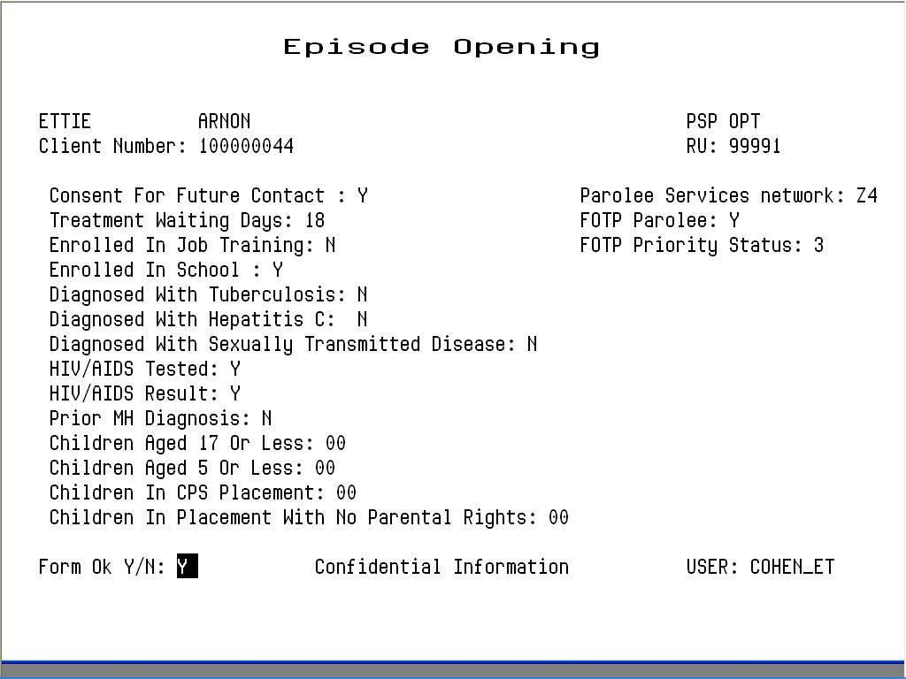

Closing Episodes, Substance Abuse Programs
The Episode Closing screen is similar to the Episode Opening Screen. Instead of Admit Date, it has Discharge Date. Instead of Referred From, it has Referred To. It omits the fields Diagnosis, Arrests and Prior Admits, which are collected at Episode Opening only. It adds fields, such as Client Adherence to Tx Plan, that are only collected at Episode Closing.

To close an episode:
1. Choose EPISODES from the Main Menu.
2. Choose CLOSE from the Episode Maintenance Menu to display the Episode Closing screen (Figure 4.18).

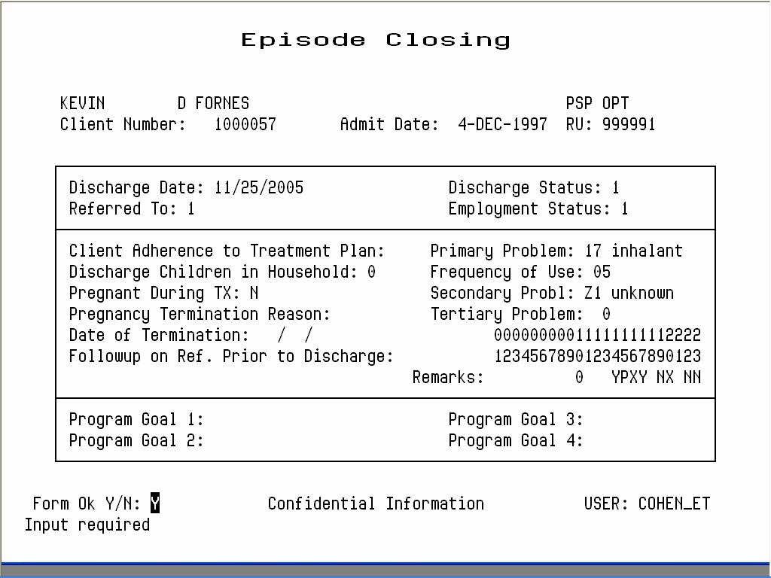
Figure 4.18: Episode Closing, Panel 1

3. Use the fields at the top of the screen to identify the Episode:
- Client Number: Enter a Client Number.
- RU: Enter the Reporting Unit number for the program.
4. The system displays an error message, if it cannot locate an open episode for that client in that program or if you are not authorized to close episodes in that program. If it finds the episode and you can close it, it displays the Admit Date. Enter data in the following fields:
- Discharge Date: Enter the discharge date. The current date is the default. You cannot enter a future date or a date before the opening date. Validation against table Discharge_Reason_Master
- Referred To: Enter a Reporting Unit number if the client was discharged to another program, or a specific Agency Code assigned by your system, or a generic code to indicate self or other or a type of local agency. For information on referral codes, contact your system manager.
- Discharge Status: Enter a Discharge Status Code from back of the Episode Opening/Closing/Annual Update forms.
- Employment Status: Enter the two-digit code that represents the client’s employment status at discharge. Validation against table Employment_status_Master.
- Client Adherence to Tx Plan: Enter “Y” or “N”.
- Discharge Children in Household: Enter the number of children living with the client at discharge.
- Client Pregnant During Treatment: Enter “Y” or “N” to indicate whether the client became pregnant while in treatment or enter “Z1”. Enter “N” for males.
- Pregnancy Termination Reason: If applicable, enter the code for how a pregnancy terminated during the client’s treatment. The codes are: 1 = Abortion, 2 = Birth-live, 3 = Birth-dead, 4 = Miscarriage.
- Date of Termination: If applicable, enter the date when pregnancy terminated during treatment.
- Primary, Secondary and Tertiary Problems (Admission Status = 1 only): Update these fields if necessary. See the Episode Opening documentation for valid codes. Validation of Primary and Secondary problems against tables Primary_Problem_Master and Secondary_Problem_Master.
- Drug Name - Primary, Secondary : Enter the Primary and Secondary drug name.
- Follow-up on Referral Prior to Discharge: Enter “Y” or “N” to indicate whether the client followed up on a referral prior to discharge.
- Program Goals: This field is defined by each county. Ask your system manager for more information.
5. Enter “Y” at the Form OK prompt to save your entries. If data is invalid, the system displays error messages and returns the cursor to the field that should be corrected.
6. Episode Closing panel 2 will be displayed now (Figure 4.19). Enter the following data fields:
- Alcohol Frequency: Enter the number of days the client has used alcohol in the past 30 days. Allowed value is 0 – 30 or “Z2”.
- IV Use: Enter the number of days in which the client has injected in the past 30 days. Allowed value is 0 – 30 or “Z0”, “Z4”.
- Paid Days Work: Enter the number of days the client has been paid for working in the past 30 days. Allowed value is 0 – 30 or “Z0”, “Z4”.
- Number of Arrests: Enter the number of days the client has been arrested in the past 30 days. Allowed value is 0 – 30 or “Z4”.
- Days in Jail: Enter the number of days the client has been in jail in the past 30 days. Allowed value is 0 – 30 or “Z4”.
- Days in Prison: Enter the number of days the client has been in prison in the past 30 days. Allowed value is 0 – 30 or “Z4”.
- Days of 12 Steps/Other: Enter the number of days the client has participated in the following social support activities in the past 30 days.
12 -Step Meetings
Other Self Help Meetings
Religious /Faith Recovery or Self-Help Meetings
Attending Meetings of organizations other than those listed above
Interactions with Family Member and/or Friend Support of Recovery
Allowed value is 0 – 30.
- Days Living with Substance User: Enter the number of days the client has lived with someone who uses alcohol or drugs in the past 30 days. Allowed value is 0 – 30 or “Z0”, “Z4”.
- Conflict Days with Family: Enter the number of days the client has had a serious conflicts with family in the past 30 days. Allowed value is 0 – 30 or “Z0”, “Z4”.
- Emergency Room Visits: Enter the number of days the client has used the emergency room for physical health problem in the past 30 days. Allowed value is 0 – 99 or “Z4”.
- Hospital Overnights: Enter the number of days in the client has stayed overnight in a hospital for physical health problem in the past 30 days. Allowed value is 0 – 30 or “Z4”.
- Days of Physical Problem: Enter the number of days in the client has experienced physical health problem in the past 30 days. Allowed value is 0 – 30 or “Z4”.
- Outpatient Emergency Services: Enter the number of days in the client has received outpatient emergency services for mental health needs in the past 30 days. Allowed value is 0 – 99 or “Z4”.
- Hospital/Psychiatric Facility Visits: Enter the number of days in the client has stayed form more than 24 hours in a hospital or psychiatric facility for mental health needs in the past 30 days. Allowed value is 0 – 30 or “Z4”.
- Prescribed Medication Taken: Has the client taken prescribed medication for mental health needs in the past 30 days? Enter Y, N or “Z4”.
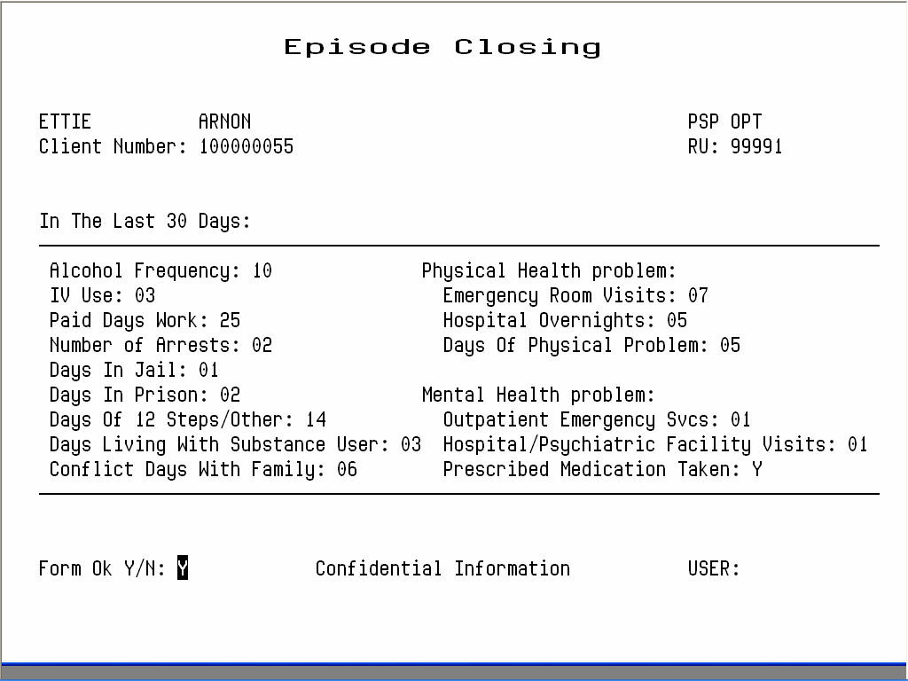
Figure 4.19 Episode closing, Panel 2
7. Enter “Y” at the Form OK prompt to save your entries. (Values “Z0” through “Z4” are converted to 99900 through 99904 before being written into the database). If data is invalid, the system displays error messages and returns the cursor to the field that should be corrected.
8. Episode Closing panel 3 will be displayed now (Figure 4.20). Enter following data fields:
- Consent for Future Contact: Is there a consent form allowing future possible contact signed by the client on file within your agency? Enter Y or N.
- Enrolled in Job Training: Is the client currently enrolled in a job training program? Enter Y, N or “Z0”, “Z4”.
- Enrolled in School: Is the client currently enrolled in school. Enter Y, N or “Z0”, “Z4”.
- Hiv/Aids Tested: Has the client been tested for HIV/AIDS? Enter Y, N or “Z0”, “Z4”.
- Hiv/Aids Result: Does the client have the result of the HIV/AIDS test? Enter Y, N or “Z0”, “Z4”.
- Prior Mh Diagnosis: Has the client ever been diagnosed with mental illness? Enter Y, N or “Z1”.
- Children Aged 17 or Less: Enter the number of children the client has, aged 17 or less. Allowed value is 0 – 30 or “Z4”.
- Children Aged 5 or Less: Enter the number of children the client has, aged 5 or less. Allowed value is 0 – 30 or “Z4”.
- Children in CPS Placement: Enter the number of children the client has who are living with someone else due to child protection court order. Allowed value is 0 – 30 or “Z4”.
- Children in Placement with no Parental Rights: Enter the number of children the client has who are living with someone else due to child protection court order AND for whom the client’s parental rights have been terminated. Allowed value is 0 – 30 or “Z4”.
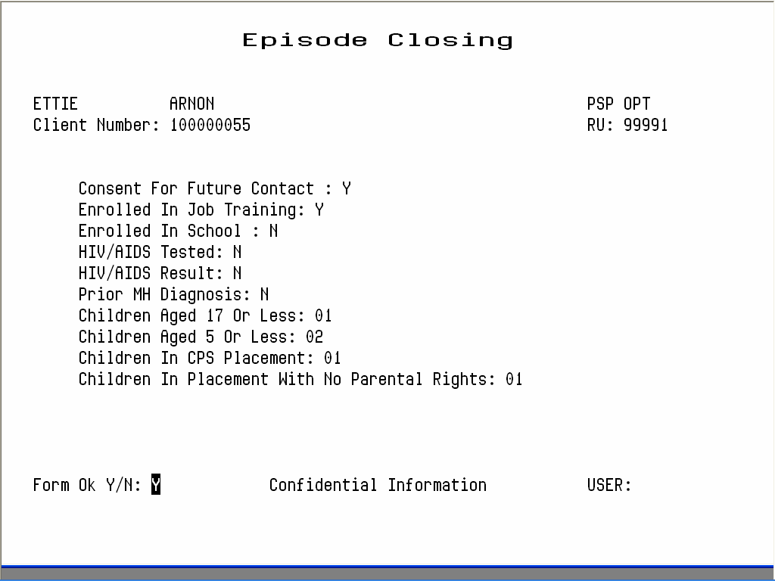
Figure 4.20: Episode Closing, Panel 3

Maintaining Episodes, Substance Abuse Programs

To maintain Episode records:
1. Choose EPISODES from the Main Menu.
2. Choose MANAGEMENT from the Episode Maintenance Menu to display the Episode Maintenance Selection screen (Figure 4.21).

Figure 4.21: Episode Maintenance Selection Screen
3. To find Episodes, enter either a client number or CGN number (County Generated Number). To limit the search, you may also enter a reporting unit number or admit date. (Enter a full date, just a month, a month and day, or just a year; if you do not include the year, the system assumes the current year.)
4. The screen displays episodes, open or closed, that match the criteria you entered, listed in chronological order with the most recent first. If there are more records that it can display at one time, page through the list using the Gold Keys or Special Function Keys, described in Appendix A and B.
5. Select episodes for maintenance by using the Tab key or the Down Arrow key to move down the list and entering “L” (lookup), “U” (update), or “D” (delete) next to the episodes you want to maintain (Figure 4.22). Then press Return.
Figure 4.22: Episode Maintenance Selection Screen with Episodes Listed

Episode Lookup
If you entered “L”, the system displays the Episode Look-up Screen, Panel 1 (Figure 4.23), Panel 2 (Figure 4.24) - if Admission Status is 1 – , panel 3 (Figure 4.25) and panel 4 (Figure 4.26). You can view the data for the Episode but cannot change it.
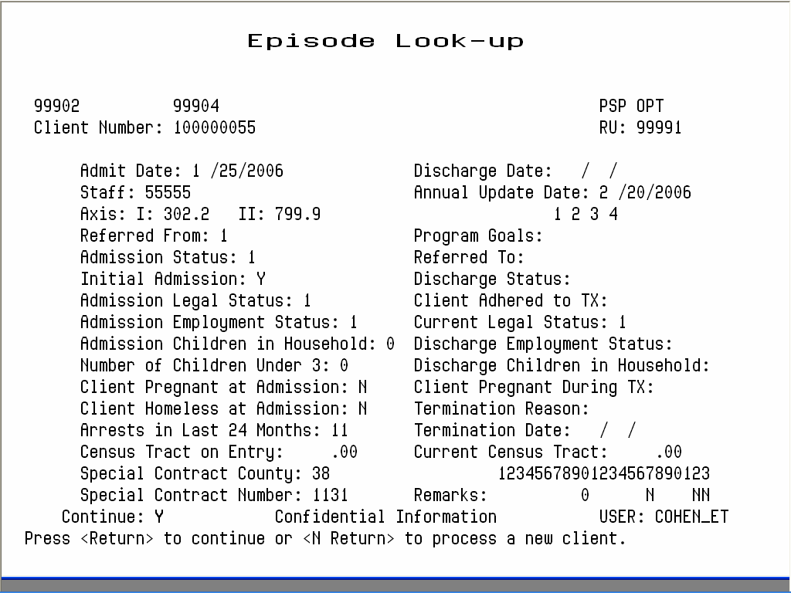
Figure 4.23: Episode Look-up Screen, Panel One

Figure 4.24: Episode Lookup Screen, Panel Two

Most of the data here is taken from the Episode Opening and Closing screens; for explanations see the documentation on these screens earlier in this chapter. This screen may also contain five additional fields, which are used by selected drug programs only:
- Census: Census tract numbers are based on client address and cannot be changed. This field is in Panel 1.
- TAR: A Treatment Authorization Request number (for detox Medi-Cal clients only). This field is in Panel 2.
- Pick-up Schedule: “Y” is displayed next to days of the week when a Methadone Maintenance client is scheduled to pick-up dose(s) at the clinic. This field is in Panel 2.
- Detox Schedule: This number (1 - 4) represents the prescribed methadone dosing schedule for a Methadone detox client. This field is in Panel 2.
- Testing Schedule: This number (1 - 4) represents urine testing schedule for a Drug client. This field is in Panel 2.

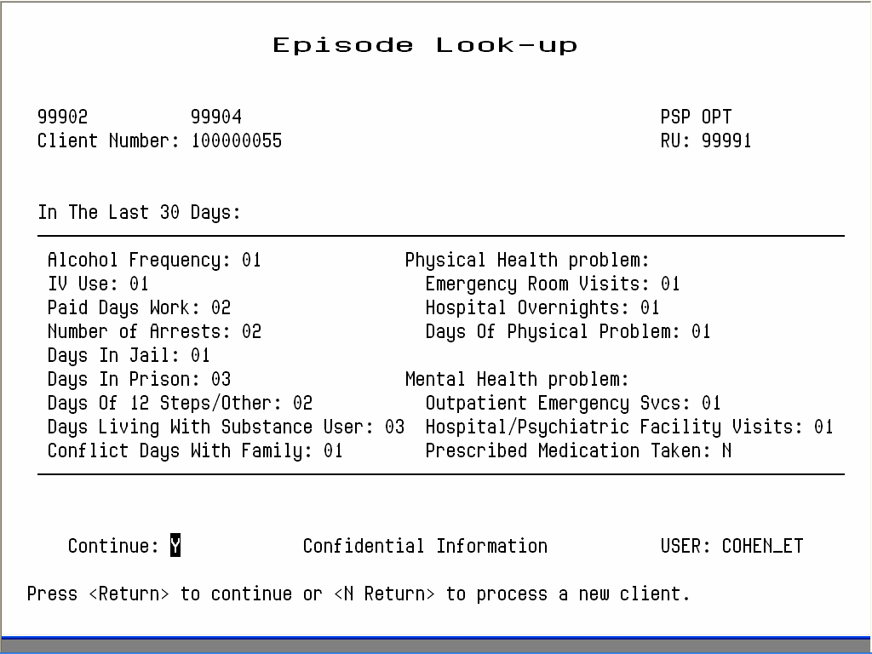
Figure 4.25: Episode Lookup Screen, Panel Three

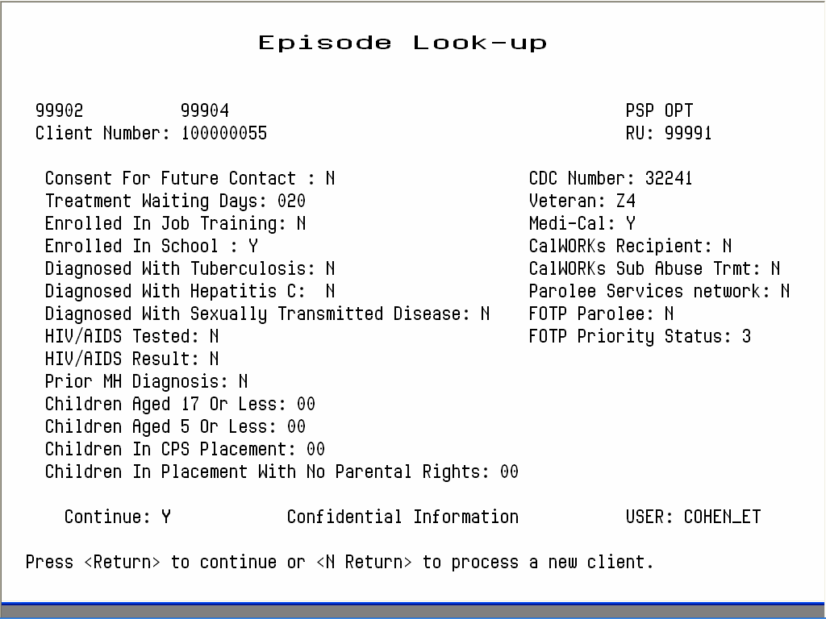
Figure 4.26: Episode Lookup Screen, Panel Four

Press Return to display the next record for maintenance, or enter “N” to go back to the Client Episode Maintenance Selection Screen.

Episode Delete
If you entered “D”, the system displays the Episode Deletion Screen (Figure 4.27). If you are authorized, you can enter “Y” at the prompt and enter “Y” again at the confirm prompt to delete the episode. Then press Return to display the next episode selected for maintenance.
If services have been recorded for this Episode, the system displays an error message saying it may not be deleted. Refer these cases to your Supervisor.

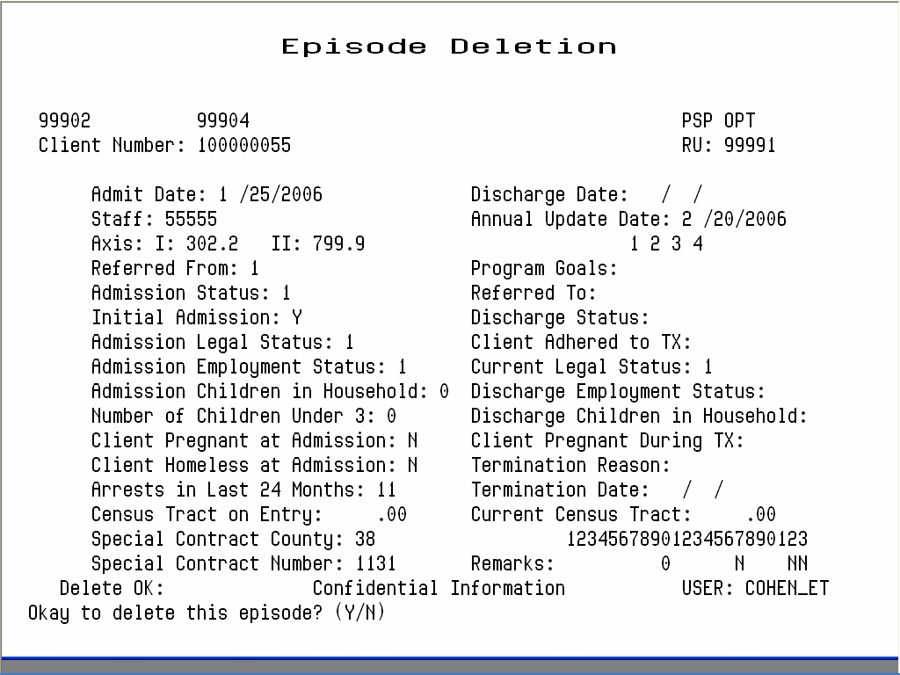
Figure 4.27: Episode Deletion Screen

Episode Update
If you entered “U” and you are authorized to update Episode information for the specified program, the system displays the Episode Update Screen, Panel 1 (Figure 4.28), Panel 2 (Figure 4.29) - if Admission Status is 1 – , panel 3 (Figure 4.30) and panel 4 (Figure 4.31).
Only Supervisors can change Admit Date, Discharge Date and CADDS Form Serial Number (if entered manually).
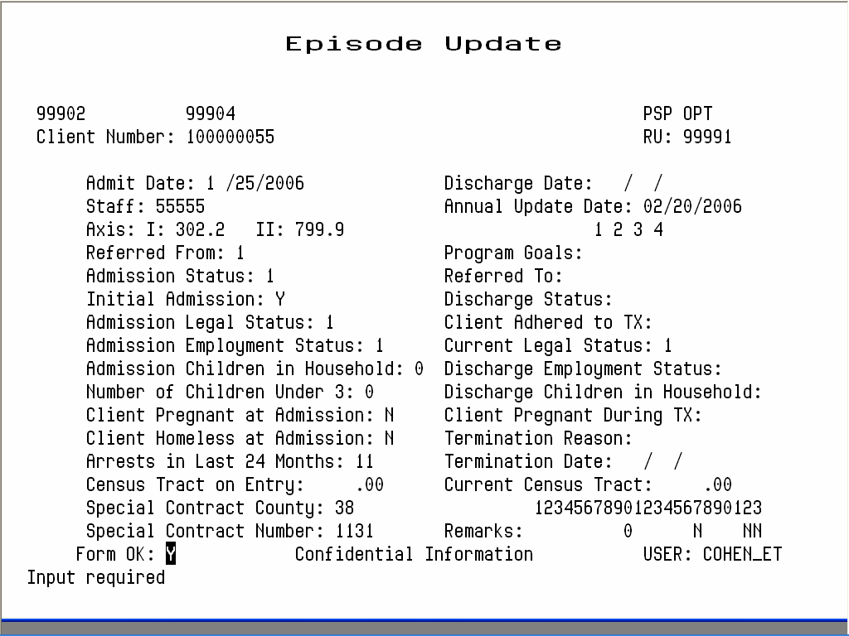
Figure 4.28: Episode Update Screen - Panel One

Most of the data here is taken from the Episode Opening and Closing screens; for explanations see the documentation on these screens earlier in this chapter. This screen may also contains five additional fields, used by selected drug programs only, Census, TAR, Pick-up Schedule, Detox Schedule and Testing Schedule. These are described in the documentation on the Episode Lookup screen, above.

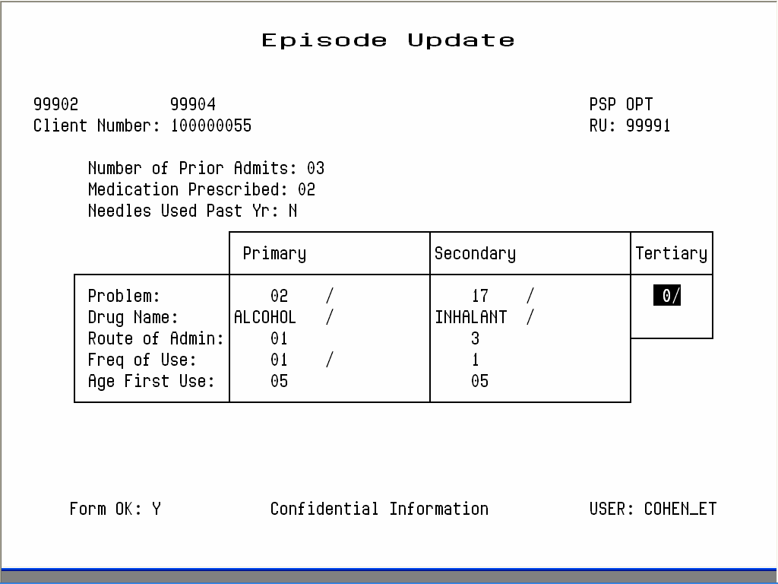
Figure 4.29: Episode Update Screen - Panel Two

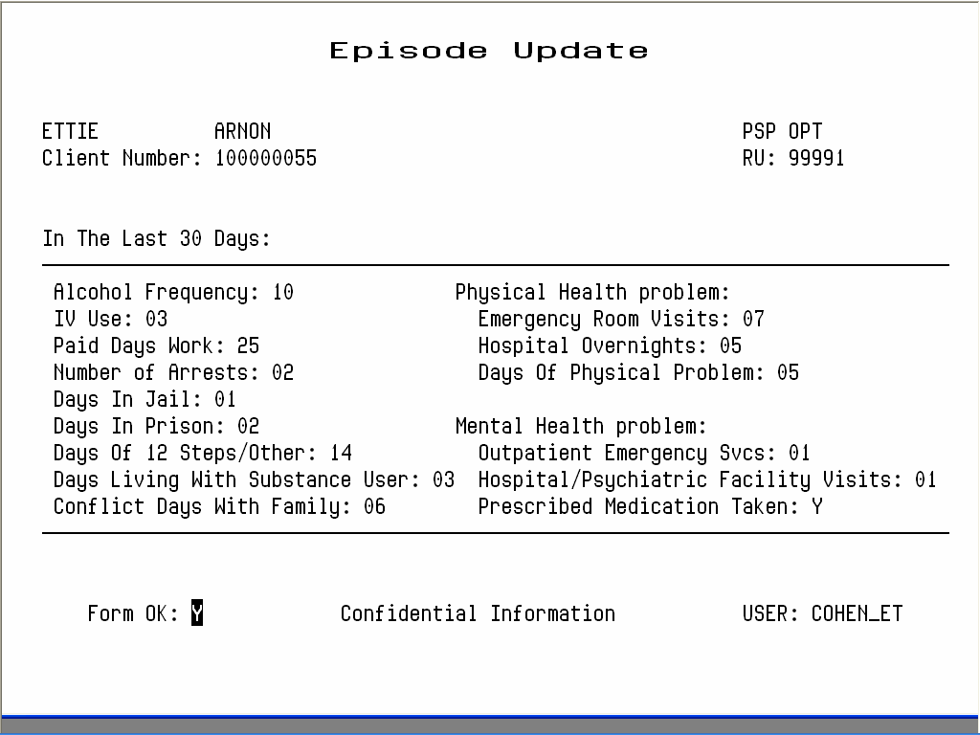
Figure 4.30: Episode Update Screen - Panel Three
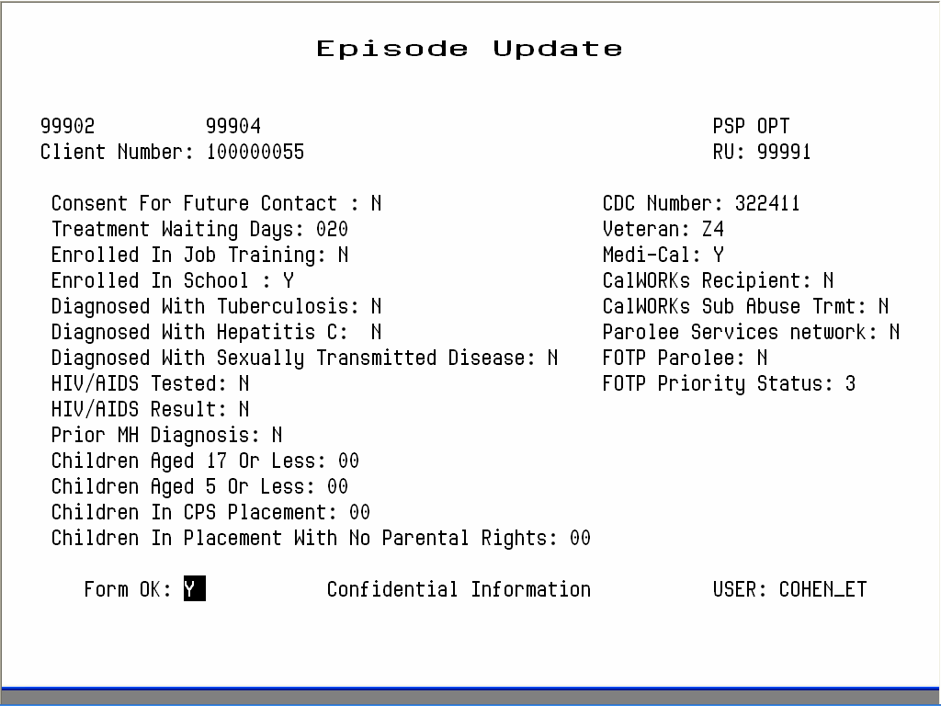
Figure 4.31: Episode Update Screen - Panel Four

CDC number, Veteran, Medi-Cal, CalWORKs Recipient and CalWORKs Sub Abuse Treatment are described in Episode Opening Panel One.
To confirm your entries, press Return to go to the Form OK prompt, and enter “Y”. If you entered any invalid data, the system displays an error message and returns the cursor to the field you must correct.

Episode Update, Supervisor Authorization
Only Supervisors can change episode opening and closing dates, and CADDS Form Serial Numbers (if they have been entered manually). They can also remove Episode delete information and, in effect re-open an episode.

To display the Episode Update Screen in Supervisor mode:
1. Display the Episode Update screen as described above.
2. Press Gold-A. The screen title changes to Episode Update Supervisor.
If you have selected a closed episode to update, the cursor will be positioned at a special field available only to supervisors, called Re-open Episode. To remove Episode Closing information and reopen a closed episode, enter “Y” here.

Chapter 4
Direct Services
This chapter covers the different ways to record services provided by programs directly to clients. It ends with a section on substance abuse services, which use some additional data entry screens. All of these screens are on the Service Maintenance Menu.
Before services can be recorded, the client must be registered and there must be an Episode open for the client in the program providing the service on the date being recorded. See Chapter 2 for information on registering clients, and see Chapter 4 for information on opening episodes.

Entering New Direct Services
InSyst gives you based on your User Authorization and Program Site several ways of entering services:
- Single Service Entry for all programs
- Weekly Service Entry for Methadone and Residential Programs
- Multiple Service Entry to enter the same information for a number of services
Single Service entry is most common, and the other methods can sometimes save you time in data entry.

Single Service Entry
Most programs enter services daily using single service entry.

To do single service entry:
1. Choose SERVICES from the Main Menu.
2. Choose SINGLE from the Service Maintenance Menu to display the Single Service Entry Screen (Figure 5.1).

Figure 5.1: Single Service Entry Screen
3. Enter data in the following fields:
- RU: Enter the reporting unit number for your program and press Return. The system validates the number and displays the program’s name.
- Client Number: Enter the Client Number. When all the data has been entered, the system will display the name of the client. At that time, review the client name to be sure you are entering services for the correct client.
- Date: Enter a date in the format MM/DD/YY. You cannot enter a future date. You must enter a date when the client’s episode is open and the program operates.
- Procedure: Enter a three-digit procedure code. It must be a valid procedure for the program.
- Staff: Enter a staff identification number. The staff number will be validated for authorization to perform the services you are entering.
- Co-Staff: If there was co-staff, enter the staff identification number. You may only enter one co-staff in this system.
- Staff Duration: Enter the number of hours and minutes this staff person spent in this service. Enter up to twenty-three hours and up to fifty-nine minutes in the two portions of this field. There is a fixed minimum and maximum time for some services.
- Co-Staff Duration: If there was co-staff, enter the time they spent on the service, in the same way as Staff Duration.
- Number in Group: Enter a number from 1 to 99 indicating how many clients were involved in the service. The default is 01, for an individual service. If you are recording group services, enter the number of clients in the group. (For example, if Staff Person A and B have a group with 10 members that met today for 1 hour with all members present, enter 10 here. InSyst will record a service for each client number, with the staff numbers of A and B, the procedure code for a group, a group count of 10, and the time each staff person spent in the service. Each client will be billed correctly for the group service, and each staff person will be credited correctly for the time spent in the service.)
- Location: Enter a location code from 1 to 6: 1 = Office, 9 = Residential. The default is 1 for Office.
You MUST use location “9” entering Residential Services on the Multiple or Single Entry screens.
4. When you are done, enter “Y” at the Form OK prompt. The system validates the data and displays the client’s name. If there are incorrect values in any field, it will display an error message and return the cursor to that field.
5. Once the data is correct, the system will ask for confirmation before saving it (Figure 5.2). Enter “Y” at the Confirm prompt to save the entry.

Figure 5.2: Single Service Entry Screen with Data
After service entry has ended, the cursor returns to the Client Number field. You may enter a new Client Number and Date to continue entering services. If you want to enter services for another reporting unit, press Gold-P to move to the RU field.

Special Authorizations for the Single Service Entry Screens
Authorized personnel can use these special features of the Single Service Entry Screen.
- Late Entry: Press Gold-A once to invoke Late Entry authorization. For example, if data entry for April is closed on May 5, Late Entry authorization lets you enter services after that time.
- Supervisor: Press Gold-A twice to invoke Supervisor authorization, which lets you override system validations in the Staff, Co-Staff, Group Count, Staff Duration, Co-Staff Duration and Location fields, but not episode boundaries. This is useful for recording unusual services.
- Supervisor and Late Entry: Press Gold-A three times to invoke both Supervisor and Late Entry authorization.

Weekly Service Entry
Use this screen to enter one week of services at a time for all of the clients in your program. It is used by programs that have one primary procedure code and only one possible unit of time for the service. Residential Programs and certain types of Day Treatment programs are authorized to enter data on a weekly basis rather than a daily basis.
If an episode is open in a Residential or Day Treatment program, the client’s name and number are automatically listed in the Weekly Service Entry Screen, after Report PSP 125 is run for the week.
- Note: Programs that use the Weekly Service Entry Screen must use the Reports menu to produce Report PSP125 each week before data can be entered. This report creates the data displayed in the Weekly Log Screen, and also produces a paper log with the same data, which can be used for data entry. For more information, see the Reports Manual.
LATE ENTRY (Gold-A) CANNOT BE USED WITH WEEKLY SCREENS, this services must be entered using the Single or Multiple Entry Screens.

To do weekly service entry:
1. Choose SERVICES from the Main Menu.
2. Choose WEEKLY from the Service Maintenance Menu to display the Weekly Service Entry Screen (Figure 5.8).
3. Enter search criteria in the fields at the top of the screen:
- Start Date: Enter the first day of the week in the format MM/DD/YY. Your Operations Staff defines start date options in a Systems Option File. The Start Date must be a Sunday or a Monday. Data entry can be done on the last work day of the week or after the week is past.
- RU: Enter the Reporting Unit Number for your program.
Figure 5.8: Weekly Service Entry Screen
4. If a valid Start Date and Reporting Unit are entered, the Weekly Service Entry Screen lists all clients open in that program for that week in alphabetical order, ten at a time. For each record in the list, enter data in the following fields:
- Procedure Code: This field displays the default procedure code for the reporting unit. In most cases this is the only procedure code allowed, except for “000” to indicate that no service was given. There are a few programs that also have other Procedure Codes. You may accept one day’s procedure code by pressing Tab, or accept a week’s procedure codes by pressing Return to move to the end of the line. (When the services records are recorded, they use the default time for the procedure code entered.)
- OK: This field lets you confirm that the information for this client is correct. Enter “W” to Write the services, “S” to Skip the line, or “D” to Drop the client from this Entry Screen. (If you enter “S”, all of the services for that client will be skipped. To write some services for the client but not all, enter “000” for the day the client is to be skipped, and enter “W” in the “OK” field.)
5. Enter “Y” at the Form OK prompt to save the data (Figure 5.9). The system validates the data, and if there are any errors, it returns the cursor to the field that must be corrected and displays an error message.
6. If there are more clients in the program, press Return to display the next 10 clients.
The screen lets you record services only for the days the client was open in the program. If a client is opened in the program on Wednesday, the screen will not allow you to enter services for the client for Sunday, Monday, or Tuesday.
If a client’s registration status is pending, this is noted on the screen and you cannot enter services for that client until the registration has been approved. See the Client Maintenance section in Chapter 2 of this User Manual for information on pending registrations.
Figure 5.9: Weekly Service Entry Screen, Service Entry
If you have used “S” to skip all of the services for one or more clients, you can still use the Weekly Service Entry Screen to record those services by leaving the screen and then displaying it again to begin data entry. The clients you originally skipped are listed on the screen.
If you have skipped some services for clients, but not all, those clients will not appear again on the Weekly Service Entry screen for that week. To enter services for them, use the Single Service Entry Screen, described earlier in this chapter.
If you are unsure which services have been recorded and which have not, press Gold-S to leave the screen saving the current Reporting Unit Number. Choose SERVICES from the Main Menu, and then choose MANAGEMENT from the Service Maintenance Menu. When the screen prompts you, enter a Client Number and press Return, to display services for that client in the program. Then return to the Weekly Service Entry Screen to continue service entry.

Multiple Service Entry
The Multiple Service Entry Screen makes it easy to enter repetitive data—for example, to enter a number of services for one client or one staff person, or to enter all of one type of service for a day. It lets you create user-defined defaults that enter the repetitive data automatically.

To do multiple service entry:
1. Choose SERVICES from the Main Menu.
2. Choose MULTIPLE from the Service Maintenance Menu to display the Multiple Service Entry screen (Figure 5.10). This screen resembles the Single Service Entry screen.

Figure 5.10: Multiple Service Entry Screen
3. To identify the program you are doing data entry for, enter:
- Reporting Unit: Enter the Reporting Unit Number for the program, and the screen displays its name. (To enter services for a different program during the same session, press Gold-P to move the cursor back the RU field, or press Gold-R to restart the screen.)
4. The cursor moves to the Defaults box (Figure 5.11). Data you enter here will be repeated for every service you enter in the list below, until you enter new defaults. You can enter default data for one or more of the following fields:
- Client Number: Enter a client number.

Figure 5.11: Multiple Service Entry Screen, Entering Defaults
- Service Date: Enter a date in the format MM/DD/YY.
- Procedure: Enter a three-digit procedure code. The field accepts only direct service procedure codes that are valid for your program.
- Staff: Enter a staff identification number. It will be validated for authorization to perform the services you enter.
- Duration: Enter the number of hours (up to 23) and minutes (up to 59) the staff person spent in this service. Counties set fixed time ranges for some services.
- Co-Staff: Enter the Co-staff identification number, if there is one. It will also be validated for authorization to perform the services you enter. (Your screen may not include this column.)
- Number in Group: Enter a number from 1 to 99 indicating how many clients were involved in the service. The default is “01” for an individual session.
- Location: Enter the location code, from the following options: 1 = Office, 9= Residential. Use the location where the most basic component of the service occurred. The default is “1” for office.
- After you have entered defaults, enter “Y” at the Form OK prompt (Figure 5.12). The system validates data and prompts you to correct any errors.

You MUST use location “9” entering Residential Services on the Multiple or Single Entry screens.

Figure 5.12: Multiple Service Entry Screen, Defaults Entered
6. Now, you can use the defaults to enter up to 20 services using the default information. The information you entered in the default box is displayed automatically as you enter data in the screen’s service entry lines (Figure 5.13). You can modify the default data, if necessary, or just press Tab to accept the default value and move to the next field. At the end of each line you want to save, you must enter “W” to write the service.
Figure 5.13: Multiple Service Entry Screen, Data Entry Using Defaults
7. When you are done entering service data, press Return to move to the Form OK prompt and enter “Y” to accept the data. After the system validates the data, enter “Y” at the Confirm prompt to save the data.
The screen is cleared and the cursor moves back to the defaults line, so you can enter additional services or change the defaults.
You can imagine how useful this screen would be, for example, if you had to enter the same service for a client for a large number of service dates. You could just change the date and accept the defaults for all the other fields.

Maintaining Direct Services

To maintain direct services:
1. Choose SERVICES from the Main Menu.
2. Choose MANAGEMENT from the Service Maintenance Menu to display the Service Maintenance Selection Screen (Figure 5.15).
3. To display a list of services, enter:
- Client Number: You must enter the number of the client who received the services.
- Reporting Unit: To narrow the search, you may also enter a Reporting Unit number.
- Service Date: To narrow the search, you may also enter a complete date or a partial date that is just a month or year. If you leave out the year, the system uses the current year.
Figure 5.15: Service Maintenance Selection Screen
4. The Screen displays the Client Name and all the services for the client that match the criteria entered, listed with the most recent services first (Figure 5.16). Move through the list using the methods described in the section on Moving Through Lists in Chapter 1. Enter “L” (lookup), “D” (delete), or “U” (update) next to the services you want to maintain (Figure 5.17).

Figure 5.16: Service Maintenance Selection Screen with Services Listed
5. You may select up to 24 services. When you are done, press Return to display them for maintenance.

Figure 5.17: Service Maintenance Selection Screen, Selecting Services for Maintenance

Direct Service Lookup
If you entered “L” next to a service, it is displayed in the Service Look-up screen (Figure 5.18). The data cannot be changed.

Figure 5.18: Service Look-up Screen
In addition to the data in the Service Maintenance selection screen, this screen displays:
- Last Changed: The date that the displayed record was last modified by a user or system program.
- Cost: The amount charged for the displayed service.
- Service Stamp: The date that the service was originally entered into the system.
Press Return to display the next record selected in the Service Maintenance Selection Screen. Type “N” and press Return to go back to the Service Maintenance Selection Screen.

Direct Service Delete
If you entered “D” next to a service, it is displayed in the Service Delete Screen (Figure 5.19). If you are authorized, you can enter “Y” at the Delete OK prompt and “Y” again at the confirm prompt to delete the service.

Figure 5.19: Service Delete Screen
If a service has been posted in the billing system, the service may not be deleted unless you have the correct authorization. If this occurs, tell your supervisor.

Direct Service Update
If you entered “U” next to a service, it is displayed in the Service Update Screen (Figure 5.20).
If a service has not been processed and you are authorized, you can Tab through the fields and edit them:
- You can change Staff, Co-Staff, Duration, Number in Group, and Location.
- You cannot change Client Number, Reporting Unit Number, Last Changed Date, Service Cost, or Service Stamp.
- If you have supervisor authorization, you can change Service Date and Procedure.
If the service has already been billed to the client or to a third party payor, you cannot change some fields through this screen without making an adjustment to the client’s account. If a service cannot be changed through this screen, the cursor automatically moves to the Form OK prompt.
You can press Return at any time to move to the Form OK prompt. Enter “Y” to save the changes. The system validates the data before saving it.

Figure 5.20: Service Update Screen

Late Entry, and Supervisor Authorization
Late Entry and Supervisor Authorization are available in all three of the Maintenance Screens.
In the Update screen (Figure 5.21), Supervisor Authorization lets you change Service Date and Procedure.
In the Lookup and Update Screens, Supervisor Authorization lets you view these additional fields:
- Posting Status: The service status within the billing system.

Figure 5.21: Service Update Screen, Supervisor Mode
- Original FRC: All payor sources (Medicaid, Medicare, County, Insurance, Patient) that can be billed for this type of service in your system.
- Potential FRC: All payor sources (Medicaid, Medicare, County, Insurance, Patient) that can be billed for this particular service.
- Tried FRC: Payor sources (Medicaid, Medicare, County, Insurance, Patient) that you have tried to bill for the service.
- Actual FRC: Payor sources (Medicaid, Medicare, Short-Doyle, Insurance, Patient) that have actually been billed for the service.
- Episode Stamp: The Episode to which the Service is attached. Episodes can be positively identified by their Key Entry Date which is referred to here as Episode Stamp.
- Clearances: The Clearances Flagword in the database. This code will identify which systems have processed this service (POSTING, BILLING, CDS, UR, POE).
- Screen Source: The screen used to enter the service.
In the Delete Screen, the Supervisor Authorization lets you delete a service that has been posted by the billing system. In this case, the Delete Screen deletes the service and also writes an adjustment to the client’s account. Supervisor Authorization alone does not allow you to delete a service that has been claimed to a payor source: you must also have additional authorization.

To use late entry and Supervisor authorization:
1. Display the Service Lookup, Delete or Update screen.
2. Press Gold-A to display the screen in Late Entry mode, to enter data for a time period whose deadline has passed.
3. Press Gold-A a second time to display the screen in Supervisor mode.
4. Press Gold-A a third time to display the screen in both Supervisor and Late Entry mode.

Chapter 5
Utilities
Use the Utilities Menu to send and receive e-mail, manipulate files, manage the printer queue, and maintain your logon password.

INSYST is no longer used as it has been replaced with Internet E-Mail.

Passwords
When you log on to the computer system, you must enter your Username and your Password. Passwords are vital to system security. Passwords expire every six (6) weeks. Two or three days earlier, you will receiving warnings that your Password is about to expire.
- Warning! If you log on to the system after your Password has expired you will be prompted for a new Password. If you bypass these prompts, you will not be able to log on again and will need call the Support Services at (510)567-8181

To change your Password:
1. Choose UTILITIES from the Main Menu.
2. Choose PASSWORD from the Utilities Menu to display the Password Menu. This has only two options: Primary Password and Secondary Password.
You may have only one password, the Primary Password. If you choose, you can also create a Secondary Password.

Printer and Queue Management
The Department assigns a name to the printer attached to your terminal, such as PQ_CHILDRENS, or SONOMA. The queue refers to the waiting line for the printer. If there are no items to be printed, the queue is empty. When you print an item, it is sent to your printer queue.
The Printer and Queue Management menu lets you manage print jobs.

Show Queue

To view the printer queue:
1. Choose UTILITIES from the Main Menu.
2. Choose PRINTER from the Utility Menu.
3. Choose SHOW from the Printer and Queue Management Menu to display the Show Queue Screen.
4. Use the field at the top to identify the queue:
- Queue Name: Enter the name of a print queue, or press Return to select your print queue. The screen lists all the jobs waiting in your queue to be printed, in the order that they will be printed. (Figure 15.9).
5. After viewing the Queue, press Return to go back to the Printer and Queue Management Menu.
The statuses of jobs in the queue are:
- Pending: a job waiting to be printed.
- Holding: a job put on hold, or delayed. In some cases, a time can be associated with this status, e.g. “holding until 15-Jun-1987 02:00”.
- Printing: a job now printing.
- Paused: a job delayed in the midst of printing.
- Aborted: a job deleted in the midst of printing.
Figure 15.9: Show Queue Screen

Start Printer Queue
Use Start Printer Queue to print everything that waiting to be printed is printed, in the order that it is listed. If there is nothing to be printed, the printer readies itself.

To start the printer queue:
1. Choose UTILITIES from the Main Menu.
2. Choose PRINTER from the Utility Menu.
3. Choose START from the Printer and Queue Management Menu to display the Start Printer Queue screen (Figure 15.10). It has the following fields:

Figure 15.10: Start Printer Queue Screen
- Queue Name: To start your printer, enter its name here, or just press Return to accept the default printer.
- Form Mounted: This is not currently implemented. The only forms in use are standard 8 1/2 by 11 sheets of paper.
- Characteristics: This is not currently implemented. Your printer will print as designated by the document.
4. After you have indicated which printer you are using, the system displays the message shown in Figure 15.11. Make sure the paper is properly aligned. Then type “C” to Continue, “S” to Stop printing, or “R” to retry the page.

Figure 15.11: Start Printer Queue Screen Asks for Confirmation
The system continues printing all jobs on the queue.

To stop the printer:
1. Press the Spacebar key. Do not press Spacebar more than once. Do not turn off your printer. If several people are using the computer system, it can take a couple of minutes to stop printing.
2. After you have stopped the printer, the system displays a message asking what it should do with the current print job. You must choose one of the options within 30 seconds, or the system will continue printing the current job. You have the following options:
- Delay: Moves the current job to the end of the queue. The next job begins printing. When the delayed job starts printing again, it begins on the page it was printing when the Delay command was given.
- Delete: Deletes the current job without it being completed. The job is removed from the printer queue. The next job begins printing.
- Restart: Restarts the current job at the beginning.
- Stop: Stops the printer. When you start the printer again, the job continues printing.
- Wait: Stops the printer temporarily.
- Continue: Continues printing the current job to continue printing where it left off.

Restarting Stopped Print Jobs
If you use the Stop Command while printing a file, the printer is stopped and you are returned to the menu.

To continue printing that job:
1. Choose START from the Printer and Queue Management Menu.
2. Use the Start Printer Queue screen to start the printer, as described above.
3. The system displays the prompt: Stop before next entry. Press Return to accept the default “N” to print all jobs on the queue, or enter “Y” to print only this job and stop again.
4. The system displays the prompt: Continue printing this entry. Press Return to continue the job.

Chapter 6
Reports
Reports available are based on your User Authorizations and Program Site. The main two types of Reports available are Caseload and Service.

To run a report:
1. Choose REPORTS from the Main Menu.
2. Choose one of the submenu options of the Report Menu (Figure 17.1). As you can see, this menu lets you choose submenus with reports that are used for different purposes.

Figure 17.1: A Typical Report Menu
3. Choose the report from the submenu.
Your local Operations Staff controls how these submenus are organized, and you should ask them which menus you should have and where specific reports are.
The standard InSyst package includes these submenus for reports:
- Caseload Reports: contains reports on the management of the workload at the clinic level: staff caseload reports, clinic caseload reports, productivity reports, etc.
- Service Reports: contains staff productivity, service audit and program productivity reports.

Running Reports
Once you select a report from one of the Reports Menu, you may be prompted for information needed to produce the report. First the system will ask you questions about when the report will be created, or where the report will be printed. After that, it will ask you questions that control the content of the report, such as client number, reporting unit number, or date range that it will report on.
The following example (Figure 17.2) shows the dialogue similar to what you may see on the screen when you produce a report. The symbol <RETURN> means that pressing Return will accept the default answer to the question.
REPORT_PSP118
This report may only be run in “BATCH” mode
Specify when the report generation should start up:
time = hold until specified date/time (DD-MMM-YYYY:HH:MM)
<RETURN> = start up immediately
?
Specify print destination
NOPRINT = do not print report (save as disk file)
queue name = name of printer queue (e.g.. COMMON)
<RETURN> = print on the default printer: pq_myprinter
?
Specify number of copies
number = number of times to print this report
<RETURN> = 1 copy
?
Specify print setup/form
examples:
CONDENSE = print 132 columns on 80 column paper
DRAFT = print in normal ‘FAST’ mode
LETTER = print in slower ‘LETTER QUALITY’ mode
<RETURN> = print using the default
?
Send mail notification when report has completed?:
YES/NO = send mail/do not send mail
<RETURN> = do not send mail
?
Parameters selected:
Send to batch (release terminal)
,start report generation immediately
,use printer: CHANATE
,print 1 copy of report
,default printer form/setup
,no mail notification
OK to continue? <Y/N> Y
Enter Case Number for Episode History Report
? 10000015
Submitting report REPORT_PSP118 to run in batch mode on REPORT_MHS$BATCH
Job REPORT_PSP118 SMITH (queue REPORT_MHS$BATCH, entry 1) started on REPORT_MHS$BATCH
Jobname Username Entry Blocks Status
------- -------- ----- ------ ------
REPORT_PSP118 SMITH
SP_SNMHS_RPT 1 Executing
On batch queue REPORT_MHS$BATCH
****************************** all done *******************************
press <RETURN> to return to Menu
Figure 17.2: Sample Report Dialogue
- Note: You can terminate your report request at any time by typing Control/Z. The report dialogue will terminate itself if you do not respond after a short time.
After you finished the dialog, the system displays all the options you have chosen and displays the prompt: OK to continue. Enter “Y” to produce the report, or if an option is incorrect, enter “N” to use the dialog again.

Report Dialog Questions
This section explains some questions the system may ask you. Which questions are displayed depends on the report and your level of authorization. Here is an explanation of some questions commonly used in dialogs.

Specify when the report generation should start up:
Enter a date and time, such as 19-SEP-1997:18 (September 19th at 6:00 PM), or just a time, such as 19 (today at 7:00 PM).
Some reports can be run at any time during the day. Some reports that use system resources heavily, can only be run in the evening or weekends. If you try to run a report immediately, the system may display a message with the times you can run the report.

Automatically distribute reports to program printers?:
Some reports are automatically sent to the correct printer for each reporting unit. Instead of the printer section of the dialogue show above, the dialog might say:
Automatically distribute reports to program printers?:
YES/NO = distribute reports/do not distribute reports
<RETURN> = distribute reports
?
If you select this option, the system will send the needed version of the report to the printer for each reporting unit.

Specify print destination
Enter a printer name. If the report is set up to print at the printer assigned to the person requesting it, this printer’s name will be displayed as the default. If the report is set up to print at a specific printer, this question is not asked.

Specify number of copies
Enter a number to print more than one copy of the report.

Send mail notification when report has completed?:
Enter Yes to have the system send you e-mail message when the report is completed and ready for printing. Because you generally are only notified of mail messages when you log on, this option may not be effective for most users.

Enter the Reporting Unit Number for your program
Enter the six digit reporting unit number for your program reporting units. Never enter “*” as this will request the report for EVERY reporting unit in the County.

Enter a starting date for the report
For service and productivity reports, you enter a date range. At this prompt, enter the first day of the range.

Enter an ending date for the report
For service and productivity reports, you enter a date range. At this prompt, enter the last day of the range.

Enter a client number
For client oriented reports, enter the client number.

Report PSP 100
Primary Staff Caseload Report

Report Description:
This report shows all clients currently assigned to each clinician in a reporting unit. It lists client name and number, episode opening date, age, primary diagnosis, last service date, and primary physician if one has been assigned. It also lists other reporting unit and staff who have open episodes for each client. It provides a total count for each staff member.

Running the Report:
Operations Staff should use the Report menu to run this report regularly—monthly or more frequently as needed—and to send the output to each Reporting Unit’s printer. If you do not receive this report regularly, contact your local Operations Staff.

Using the Report:
This report gives clinicians a list of all clients for whom they are primary therapist, with basic information on each client.
Review it for accuracy. It is very important to keep the clients’ Primary Therapist up to date, so reports go to the correct staff person.

Output File:
MHS_OUTPUT_REPORT:
STAFF_CASELOAD_PSP100.******_LIS.

Primary Staff Active Caseload 20-May-1993
Page 1
Report PSP 100
Vineland County Mental Health
VLD OUTPATIENT (89027)

Caseload for: AGUILAR ADELIA
Cases active as of: 3-Jan-1993

A Last Other
Client G Primary Service RU
Client Name Number Opening Date E Diagnosis Date Physician Staff

RHONDA BARTLETT 000987605 2/08/85 39 308.30 9/29/92 BRYSON

PAULINE BERGGREN 009876284 5/27/92 64 295.62 2/04/93 DAVIS
Also Open At: VLD CMT 5/20/92 295.62 11/03/92 AGUILAR
Also Open At: VLD ADT 6/04/92 295.62 1/28/93 MERCADO

LINDA BOEDING 000987787 8/18/92 53 295.92 9/18/92 BRYSON

LOUISE BORDEN 000988871 5/07/91 25 296.60 1/22/93 STAFF
Also Open At: VLD CMT 12/07/92 296.60 2/04/93 AGUILAR

ELLA BRINKLEY 000656648 10/06/92 47 296.60 1/20/93 BRYSON

THOMAS BUTTERFIELD 000656614 7/02/92 45 296.45 2/24/93 BRYSON
Also Open At: VLD CMT 11/01/92 296.45 11/02/92 AGUILAR

CHRIS CARADCHECK 006566642 10/01/90 25 295.32 7/09/92 WILLIAMS
Also Open At: VLD CMT 1/03/91 295.32 1/04/93 AGUILAR

MARY COX 000656689 9/05/90 23 300.40 12/15/92 BRYSON

FRANK EDDINGTON 000656566 8/11/92 32 295.32 1/13/93 BRYSON

GARY FOWLER 007878003 3/06/90 30 295.30 DAVIS
Also Open At: WSOP 3/18/92 296.44 9/11/92 NOLAN

JENNIFER GERBIL 000788534 2/04/92 25 295.90 1/18/93 STAFF

MARY HARDESTY 008775670 12/06/90 42 295.70 2/09/93 WILLIAMS
Also Open At: VLD CMT 12/06/90 295.70 AGUILAR
Also Open At: VLD ADT 1/28/91 295.32 1/25/93 MERCADO

IRIS HARRIS 000788895 8/31/90 77 290.20 11/17/92 STAFF
Also Open At: CMT-SUPPORT 11/02/90 290.20 AGUILAR
Also Open At: VLD CMT 6/05/90 290.20 1/13/93 AGUILAR

JESUS HERRERA 008788254 9/08/92 35 295.92 2/18/93 BRYSON

KIMBERLY HILLEY 008788083 6/29/92 30 296.46 2/11/93 DAVIS

DAVID HUMPHRIES 000878833 3/01/89 51 296.40 1/12/93 STAFF
Also Open At: VLD CMT 6/27/91 296.70 7/13/92 AGUILAR
Also Open At: VLD ADT 10/13/92 296.70 1/12/93 MERCADO
*************************
Confidential Information
*************************

Report PSP 121
Program Caseload Report

Report Description:
This report lists all the clients with open cases for each reporting unit. It includes client number, name, opening date, age, primary diagnosis, and primary staff.

Running the Report:
Operations Staff runs this report monthly or more frequently if needed. It is routed to each Reporting Unit’s printer. If you do not receive this report, contact local Operations Staff.
Users can also run this report using the Report menu.
It prompts you to enter a Reporting Unit (or enter “*” for all units) and to enter a target date. The report finds all clients open on the target date.

Using the Report:
The report is used as a management tool by program managers, to balance the work among staff or to quickly review the types of client being served. It is also used to direct the distribution of other reports, such as the Utilization Review reports.
The report might also show that it is necessary to improve the data entry process. Any duplicate clients should be reported to Operations Staff.

Output File:
MHS_OUTPUT_REPORT:
PROGRAM_CASELOAD_PSP121.******_LIS

Program Caseload 25-Dec-1992
Page 1

Report PSP121
Day Treatment (99433)
Cases active as of: 25-Dec-1992

A
Client Opening G Primary Primary Account
Client Name Number Date E Diagnosis Staff Physician Status

SHEILA A_CLIENT 90200122 7/24/92 21 295.92 ANDERSON MILLER 748828
PHILLIP B_CLIENT 90200192 12/01/86 21 296.70 ARGOUNT ROBERTSON 752885
JAMES C_CLIENT 90000015 7/01/92 26 295.40 ARGOUNT ROBERTSON 756104
MICHAEL D_CLIENT 90000001 9/01/92 31 295.35 ANDERSON MILLER 1029321
MAXINE CLIENT 95700048 9/11/92 28 295.92 ANDERSON MILLER 1033654
IRENE CLIENT 90000045 9/01/92 22 295.40 ANDERSON STAFF 1038133
BERNADETTE CLIENT 91900031 9/01/86 38 295.90 ARGOUNT ROBERTSON 1010425
ANDREW CLIENT 90000070 9/24/92 55 296.60 ANDERSON MILLER 756612
MIKE CLIENT 02390198 7/10/92 22 302.20 ARGOUNT STAFF 0
JOSEPH CLIENT 00390027 4/10/86 57 295.92 ARGOUNT MILLER 320539
0
RICK CLIENT 90000047 8/05/92 31 295.90 ANDERSON MILLER
JOANNE CLIENT 90200199 7/01/86 44 295.70 ARGOUNT ROBERTSON 647054
STEFANIE CLIENT 90900015 4/01/92 21 799.90 ARGOUNT MILLER 1000268
ROSEMARY CLIENT 90200060 7/15/86 45 295.62 ARGOUNT ROBERTSON 459088
LINDA CLIENT 97400024 3/01/92 38 295.95 ARGOUNT STAFF 0
ROGER CLIENT 90200070 6/01/92 22 296.60 ARGOUNT STAFF 455572
PAULINE CLIENT 90000073 12/10/92 51 V71.09 ANDERSON ROBERTSON 1012258
DONNA CLIENT 95700065 9/11/92 30 295.70 ANDERSON ROBERTSON 1026356
HORTENSIA CLIENT 90100185 4/30/92 57 295.32 ARGOUNT STAFF 604091
SAMUEL CLIENT 90300033 5/22/86 32 295.32 ARGOUNT MILLER 1016237
MANUEL CLIENT 90000032 7/29/92 21 295.40 ANDERSON MILLER 463778
DENNIS CLIENT 00100691 8/07/92 36 295.30 ANDERSON ROBERTSON 1007220

TOTAL OPEN CASES FOR Day Treatment 39

************************
Confidential Information
************************

Report PSP 131
Reporting Unit Service Summary by Provider

Report Description:
This report shows the total services by type for the specified reporting unit during the specified time period.

Running the Report:
Use the Report menu to run this report as needed. You are prompted to enter the reporting unit, time period, and printer. Enter Reporting Unit number.

Using the Report:
Use this report as a planning tool, to audit service entry and program productivity. .

Output File:
MHS_OUTPUT_REPORT:
RU_SERVICE_SUMMARY_PSP131.******_LIS
REPORT_PSP131_FILE.LIS
Service Summary 16-Dec-1992
Direct and Indirect Services Page 1

Report PSP131
Reporting Period: From 01-Nov-1992 to 30-Nov-1992

Service Site Service Total Total Hours

WESTSIDE OUTPATIENT (832021)

310 Collateral 10 13.80
330 Assessment 84 123.40
340 Individual 318 330.50
350 Group 176 581.50
360 Medication 218 102.80

Sub Total for Direct Services 806 1152.10

421 Community Client Contact 3 3.33

Sub Total for Indirect Services 3 3.33

Total Services for 832021 809 1155.43

Report MHS 707
Service Audit Report

Report Description
This shows all services (based on services stamp) entered into the computer for each clincian for the day of the report run. Information includes service date, clinican, client served, procedure, number in group, service duration, service location, and co-staff. “# in Group” and Co-staff” contain an asterisk for non-group procedures.

How to Get the Report
The report generated and queued to your printer automatically the day after services are input.

How to Use the Report
Review for accuracy. The report is intended as a data entry management tool to assist a manager in making sure all the services performed in a clinic are being entered on a timely basis. If service entry is abnormally low, an audit of the data collection and service entry process may be needed. If there is incorrect information, episode and service updating may be required.

File Directory: MHS_OUTPUT_REPORT

File Name: SERVICE_AUDIT_MHS700.******_LIS
ALCOHOL AND OTHER DRUG 15-Mar-2001
Service Audit Report Page 1

REPORT DAS707
Provider: ST. MARY'S ODF COUNTY (000860)
Input Date: 14-Mar-2001

Service Audit Date: 1-Mar-2001
Primary Therapist: RON BUTLER Staff #: 60235

Case # Client Name Procedure #Group HH:MM Location Co-staff

010001619 BATISTE JOSEPH 354 ** 1:30 1 *****
010002996 WILSON DIANA 354 ** 1:30 1 *****
010004013 WIGFALL WILLIAM 354 ** 1:30 1 *****
010007424 MOODY MARCIA 354 ** 1:30 1 *****
010011177 WATERS WARNELL 343 ** 1:00 1 *****
010019130 HUTCHISON CHARLES 354 ** 1:30 1 *****
Service Detail Report For Mode 15, 50, and 60 Programs 8-Apr-2001
Page 1402

Report DAS700A
ALAMEDA COUNTY
H.A.A.R.T.-CV - MNT Core (810450)
From: 1-Mar-2001
To: 31-Mar-2001

_____________________________________________________________________________________________________________________________
Client Name: MOHAMMED ABBOUSHI Birth Date: 1-Dec-1955 Sex: M Ethnicity: Other
Case #: 10002370 SSN: 377669009 Account Number: 10002370
Medicaid : 377669009 04/2001 Address: No address.

Disgnosis codes for the following services: Dx I: 304.00 OPIOID DEPENDENCE
Dx II: 799.90 DIAGNOSIS DEFERRED- AXIS I/II
Dx III: Unknown label

Primary Co
Service Proc Service Staff Staff Cost of Tmt
Date code Procedure Primary Staff Time Co - Staff Time Service Loc

3/01/2001 704 DAILY SCHUMAN (60036) 00:08 (0) 00:00 9.08 1
3/02/2001 704 DAILY SCHUMAN (60036) 00:08 (0) 00:00 9.08 1
3/03/2001 704 DAILY SCHUMAN (60036) 00:08 (0) 00:00 9.08 1
3/04/2001 704 DAILY (0) 00:08 (0) 00:00 9.08 1
3/05/2001 704 DAILY (0) 00:08 (0) 00:00 9.08 1
3/06/2001 791 NTP - INDIVIDUAL COU DUGAS (60449) 00:30 (0) 00:00 38.34 1
3/06/2001 704 DAILY (0) 00:08 (0) 00:00 9.08 1
3/07/2001 704 DAILY (0) 00:08 (0) 00:00 9.08 1
3/08/2001 704 DAILY (0) 00:08 (0) 00:00 9.08 1
3/09/2001 704 DAILY (0) 00:08 (0) 00:00 9.08 1
3/10/2001 704 DAILY (0) 00:08 (0) 00:00 9.08 1
3/11/2001 704 DAILY (0) 00:08 (0) 00:00 9.08 1

EXHIBIT A
Special Key Sequences
The Gold key sequences, Control key combinations, and Special Function keys used in InSyst are listed below.

Gold Key Sequences
The Gold Key is the PF1 Key on Digital Equipment Corporation terminals, and is the NumLock key on PCs. Other keys may be used on other terminals.
To use Gold Key sequences, press the Gold Key, release it, then press the next key. For example, if the instructions say you should press Gold-E, it means you should press the Gold key, release it, and then press “E” and release it.
Gold Key sequences used in InSyst are:
- Gold-A: (All / Authorize) gives you additional functions in entry and maintenance screens, such as All Clients/Services, Supervisor Mode and Late Entry Mode.
- Gold-B: (Backup) makes the screen page back one page, to display records in a list that cannot fit on a single screen.
- Gold-C: (Client #) moves the cursor to the Client Number field on some screens.
- Gold-D: (Down Two) makes the screen page forward two pages, to display records in a list that cannot fit on a single screen.
- Gold-E: (Exit) exits from the current screen and returns to the menu, without saving data entered in the screen, or returns to the previous menu.
- Gold-F: (Face Sheet) request the menu to select Face Sheets, then press F6 to complete the request.
- Gold-H: (Home) moves the cursor to its home position on the current screen, the field on the screen where data entry began.
- Gold-I: (Insert) inserts a new record when you are using the Maintenance Selection screens.
- Gold-M: (More) makes the screen page forward one page, to display records in a list that cannot fit on a single screen.
- Gold-R: (Refresh) restarts the screen, with no values entered. This is useful if you made mistakes in data entry.
- Gold-S: (Save and Exit) leaves the current data entry or maintenance screen, and saves the data entered. This sequence retains the current Client and Reporting Unit, so it automatically displays it in the next screen you use.
- Gold-U: (Up Two) makes the screen page back two pages, to display records in a list that cannot fit on a single screen.

Control Key Combinations
To use Control Key combinations, continue holding down the Ctrl Key while you press the next key in the sequence. For example, if the instructions say to press Control/W, you should press the Ctrl Key, keep holding it down while you press “W”, and then release both.
Control Key combinations used in InSyst are:
- Control/H: (Hop Back) moves the cursor back one field.
- Control/J: (Junk) clears a field.
- Control/W: repaints or refreshes the screen. Use it if the screen display has been disturbed.
- Control/Z: ends an editing session in the Mail.

10/27/04

